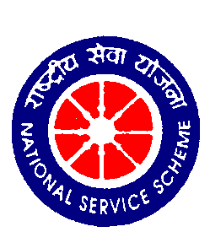
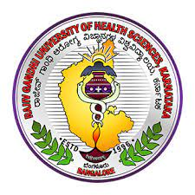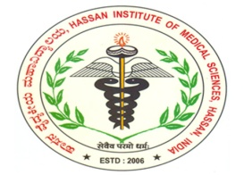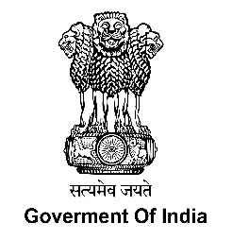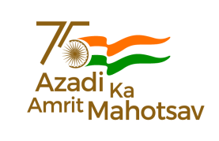
Ministry of Youth Affairs and Sports
National Service Scheme
Regional Directorate of NSS, Bengaluru
Jointly organizes
Rajiv Gandhi University of Health Sciences, Bengaluru

NSS – NATIONAL INTEGRATION CAMP - 2022

Date: 22ndto 28th May 2022

REPORT

Venue: Hassan Institute of Medical Sciences, Hassan-573201.

NSS- National Integration Camp-2022
Camp Official: Smt. Nichitha Kumari NSS PO, HIMS, Hassan
Mobile:9448719765
Instructions to the volunteers
- Always wear college/ University Identity card
- Maintain high standards of discipline and have a responsible behavior as the camp is aimed at promoting volunteerism and citizenship.
- Maintain punctuality and fraternity as per the programme schedule.
- Do join all the activities of the camp and take keen interest in all opportunities provided to exhibit your talents.
- Participants of various states are expected to present their cultural programs as per schedule/directions of cultural committee.
- Utilize in case of necessary medical facilities available in the camp.
- You are expected to have a good deal of integration and exchange of ideas about your state.
- Don’t damage any property and don’t waste food and water.
- Submit your T. A. claims through your contingent leader to camp immediately on the day of registration.
- Smoking or intoxication of any kind is strictly prohibited in the camp.
- You are responsible for your valuables
- Do not leave the campus without the permission of the camp officials.
- Violation of any of the instructions mentioned will be viewed seriously.
- On 21st all participants will be randomly segregated into five groups and each group will be asked to pick a chit for topic selection for street play and the group will remain same for museum visit also.
- Your whole hearted co-operation is solicited to make the camp successful and memorable one.

Time | Event
5:30 am | Wake up
6:00 to 6:30 am | Flag hoisting
6:30 to 7:30 am | Yoga/Meditation
7:30 to 8:30 am | Breakfast
8:30 to 9:00 am | Break
9:00 am to 1:00pm | Shramadan/Training/Visit
1:00 to1:30 pm | Break
1:30 to 2:30 pm | Lunch
2:30 to 4:00 pm | Afternoon session
4:00 to 5:00 pm | Preparation for cultural programme
5:00 to 5:30 pm | Snacks
5:30 to 8:30 pm | Cultural programme
8:30 to 9:30 pm | Dinner
9:30 to 10:00 pm | Meeting with contingent leaders
10:00 pm | Light off
NSS- National Integration Camp-2022
Shramadan/Training/Visit: -9.00am to 1.00 pm
S.N | Date | Event
1 | 23.05.2022 | First Aid & Disaster Management Training:By Dr.VLS Kumar,Trainer,IRC, Shivamogga
2 | 24.05.2022 | Life skill education:By Dr.Pradeep B S,NIMHANS, Bengaluru
3 | 25.05.2022 | Shramadana
4 | 26.05.2022 | Visit to Gandhi National Memorial trust, Arsikere & talk on Gandhi &Youth By Prof. B. Shivaraju
5 | 27.05.2022 | Visit to historical places
Afternoon session: 2:30 to 4:00pm
S.N | Date | Event
1 | 23.05.2022 | National Integration:By Dr.AUmashankar,National Youth Awardee,AP
2 | 24.05.2022 | Street play: Instruction: The venue will be given on 24th morning.  - National Integration,  - Digital India,  - Climate changes & its impact,  - India against the pandemic Covid-19  - Conservation of resources.
3 | 25.05.2022 | Visit to HIMS, Museum
4 | 26.05.2022 | Visit to SDM Ayurveda College
Cultural:5.30-8.30pm: All the 15 teams, 10 teams of different states and 5 teams from Karnataka are participating every day from 22-05-2022 to 26-05-2022. Time slot is 10 minutes for each team.
SN | Date | State | Theme
1. | 22.05.2022 | Participants | Folk/Tribal Dance/Indian Classical Dance/Skit /Mimicry/mime/one act play/ Traditional dresses and costumes of Indian states
2. | 23.05.2022
3. | 24.05.2022
4. | 25.05.2022
5 | 26.05.2022
6 | 27.05.2022 | HIMS&SDM College students

SLNO. | NAME OF THE COMMITTEE | MEMBERS & CONTACT NO.
1 | TRANSPORTATAION COMMITTEE | - Dr. Purushottam R:-9980007690  - Mr. Ravi:-7795606018  - Mr. Akash D Swamy:-9513181989
2 | ACCOMODATION COMMITTEE | - Dr .Sudhanva:-9480202815  - Mr.Chandrashekar Y D:-9964937509  - Mr .Ganesh Singh M:-9164429929
3 | WELCOME COMMITTEE AND REGISTRATION | - Dr .Vittal B G:-8904595910  - Dr. Sandhya B:-9448246029  - Ms. Kumari Sandal:-9036866807
4 | FOOD COMMITTEE | - Dr. Prakash B S:-9448762573  - Mrs. Shilaja K G:-9986536195  - Mr. Adnan Ahmed:-8951879108
5 | FLAG HOISTING & YOGA COMMITTEE | - Dr. Lohith:-9886749168
6 | STAGE PROGRAMME COMMITTEE | - Mr. Nesara Gowda:-9353267321  - Mr. Karthik S Gowda:-9008849566
7 | SHRAMADHAN/TRAINING/VISIT | - Dr .Mamata C N:-7975325238  - Dr. Kavyashree G:-6360639454  - Mr. Dushyanth C B:-9148772265
8 | ACADAMIC ACTIVITIES | - Dr. Shashidhar M R:-9902944452  - Mr.Manthesh:-9606608506
9 | CULTURAL COMMITTEE | 1. Dr. Shreelatha C Y:-9035295352  2. Ms.Ruchita Shastry:-9482761918
10 | HEALTH AND WELFARE COMMITTEE | - Dr. Mutthuraj:-9916624810  - Ms. Ayushi Nayak:-9480469570
11 | REPORT AND PHOTOGRAPHY COMMITTEE | - Dr. Nagesh K A:-9448392696  - Ms.Chinmayee V K:-8618979617
12 | FINANCE COMMITTEE | 1. Mrs.Veena H K:-7353981617  2. Mrs. Jayamma:-9845573325  3. Ms. Bhavya:8746963682
13 | LIGHTINGS, INVITATION FLEX AND BANNER COMMITTEE | - Mr. Mohan:-9972964068  - Mr. Kiran S B:-8892944471  - Mr.Mounesh Panchal:7348994274

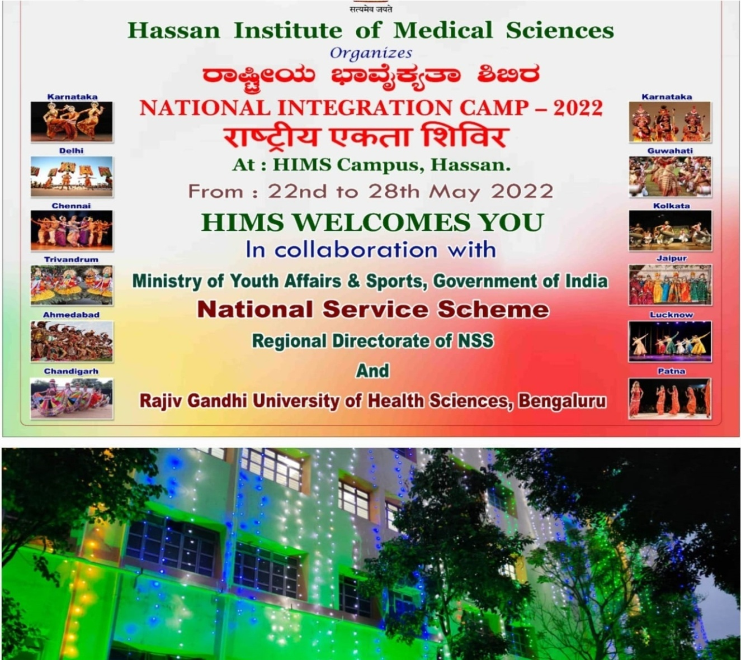
The town Hassan takes its name from the presiding deity at the Hasanamba temple. Noted for its enchanting natural scenic beauty, Hassan is a veritable treasure house of Hoysala architecture and sculpture, the best of which are the Belur and Halebidu temples, studded with its monuments, Sharavanabelagola.
Amidst all these beautiful works stands, Hassan Institute of Medical sciences, established in 2006. This year we had a great privilege to conduct the “NATIONAL INTEGRATION CAMP-2022” jointly organized by Rajiv Gandhi University of Health sciences, NSS cell, Under the Regional Directorate of NSS, Bengaluru, Ministry of Youth affairs and sports, GOI.
National Integration Camps are organized every year at different places all over the country by NSS to foster the feeling of national integration and greater understanding of different cultures by the youth of the country for a stronger bonding and a better nation building.
Date: 22-05-2022 Day: Sunday
On 22nd May there was a grand procession at 2.45 pm in the HIMS campus which will be inaugurated by Shri. Kantaraju, CEO, Zillah Panchayat, Hassan. In the procession all the participants displayed the culture and traditions-representing their state along with Dollukunita from Kannada and Sanskriti department, Government of Karnataka.
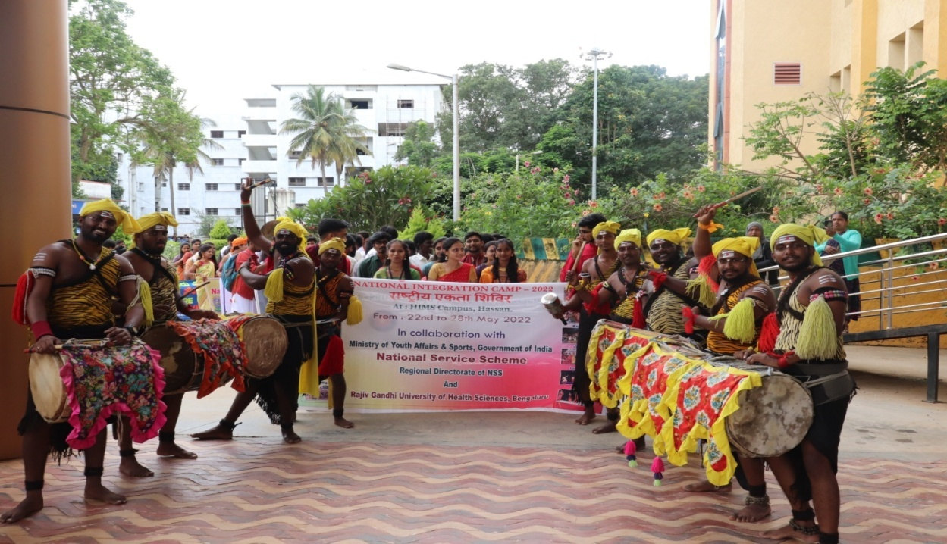
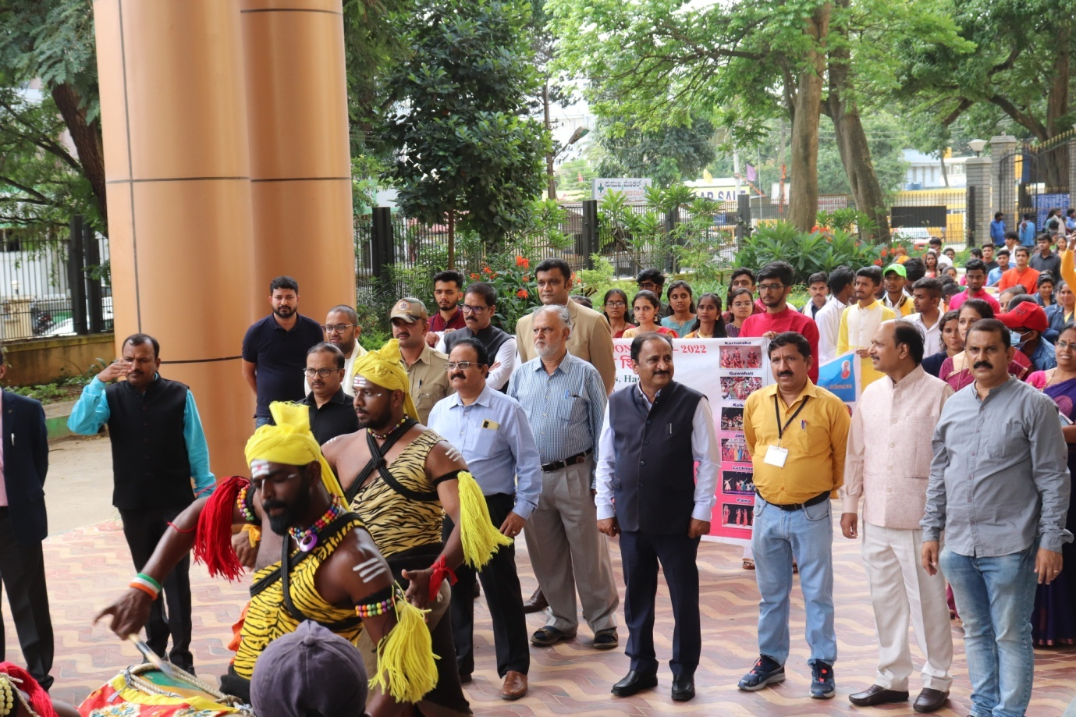
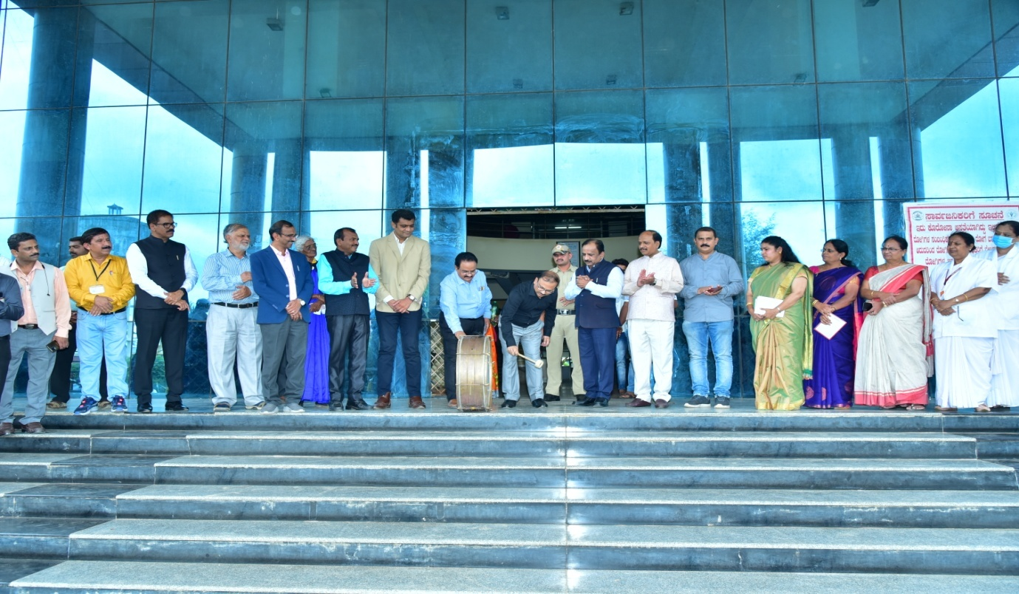
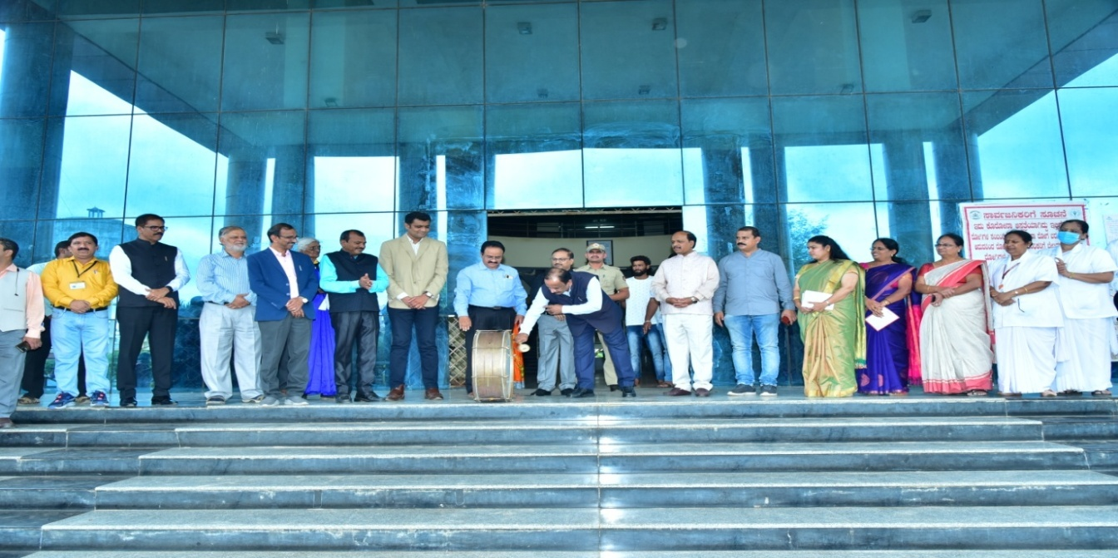
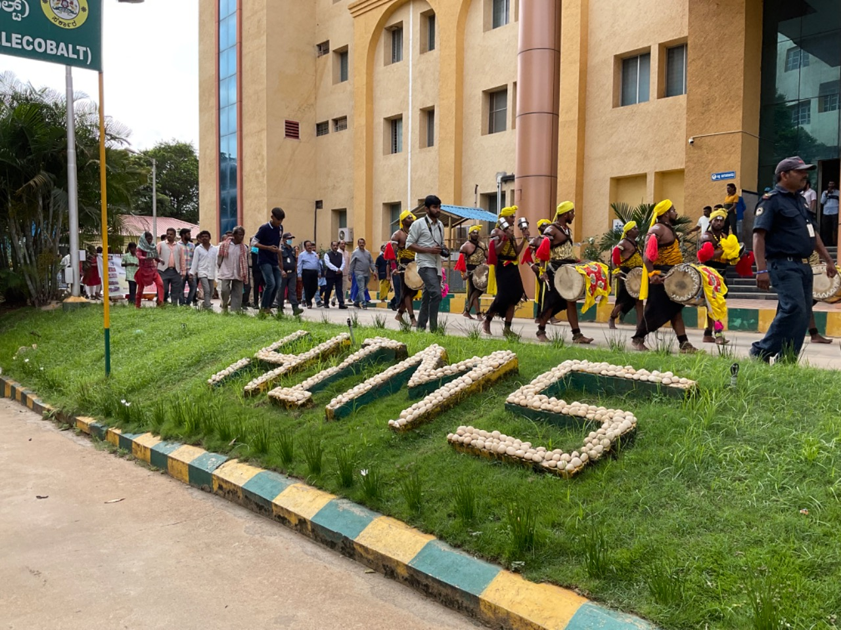
After the procession, there was inaugural ceremony in the auditorium, in the presence of the dignitaries, Shri. R. Girish, the honorable district commissioner and district magistrate of Hassan, Dr. B. C. Ravikumar, Director of HIMS Hassan, Shri. Pratap Lingaiah, NSS Officer,Karnataka State, Shri. Yellappa Uppin,Youth officer, Regional directorate, Govt. of India, Shri Kantaraju, CEO, Zillah Panchayat, Hassan, Dr. Prasanna N Rao, Principal, SDM college of Ayurveda, Hassan, Shri Vinod Chandra, Senior Assistant Director,Vartha Elake, Hassan, Dr.Nagesha K R, Principal, HIMS, Hassan, Smt. Nichitha Kumari, NIC Camp officer, HIMS, Hassan and Dr. Lohith Kumar. B. Camp co-officer, NIC-2022, Hassan.
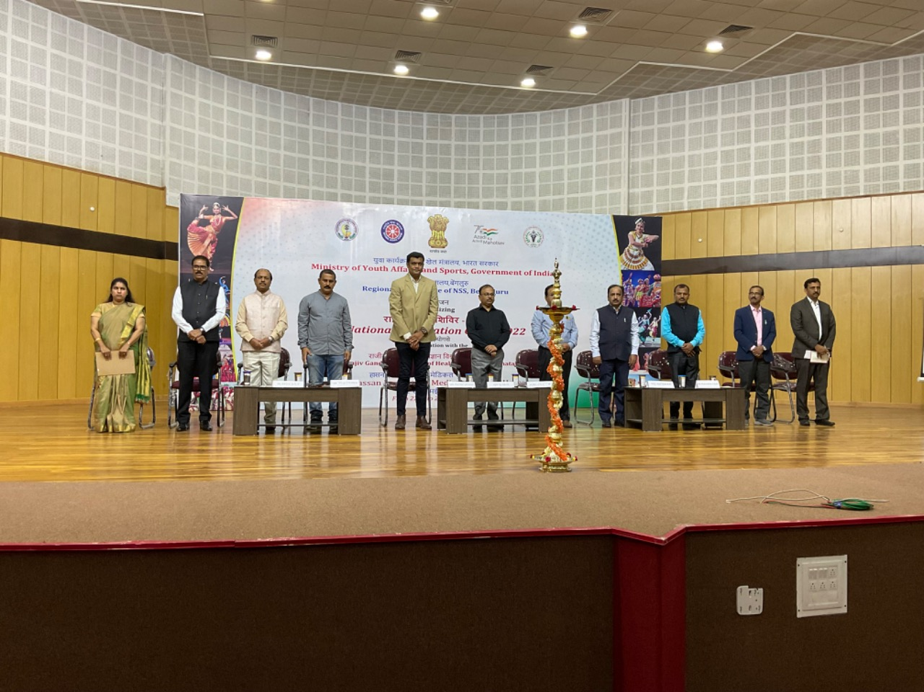
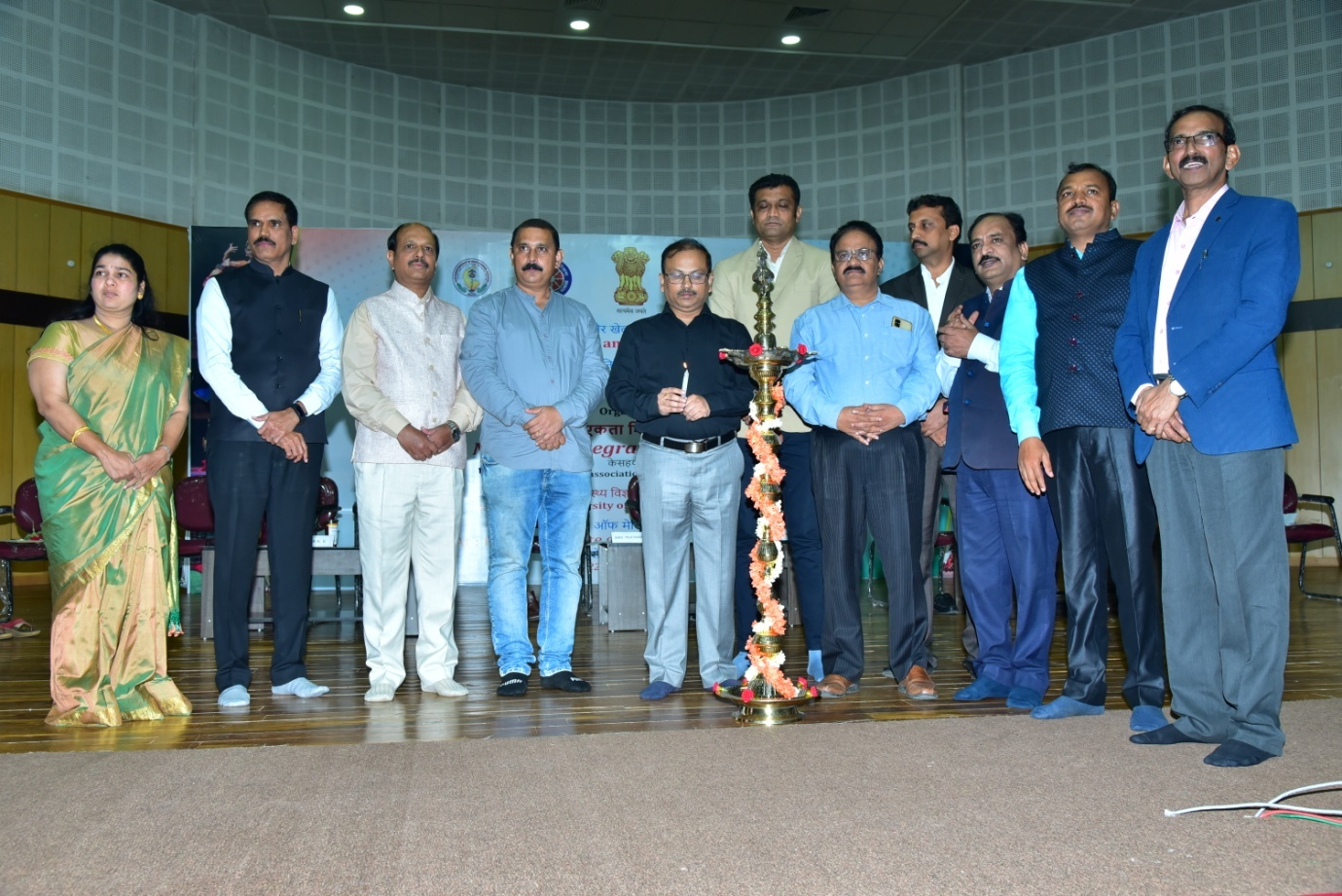
The dignitaries spoke about the importance of NSS and NIC in building a strong nation and the contribution of HIMS, NSS unit for the betterment of the society. They told about the importance of integration of culture and traditions, and how exactly NIC will serve the cause.
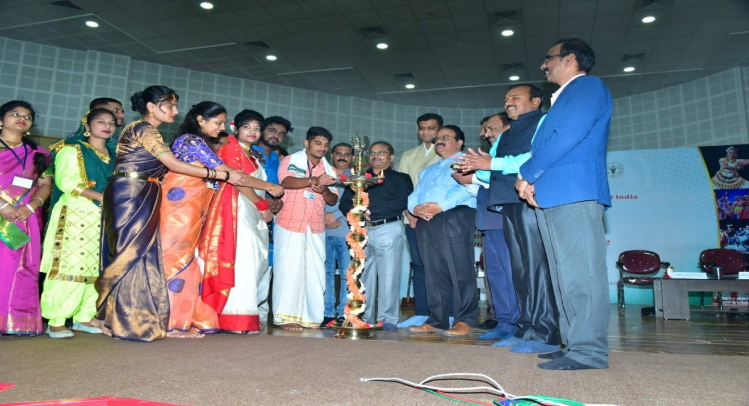
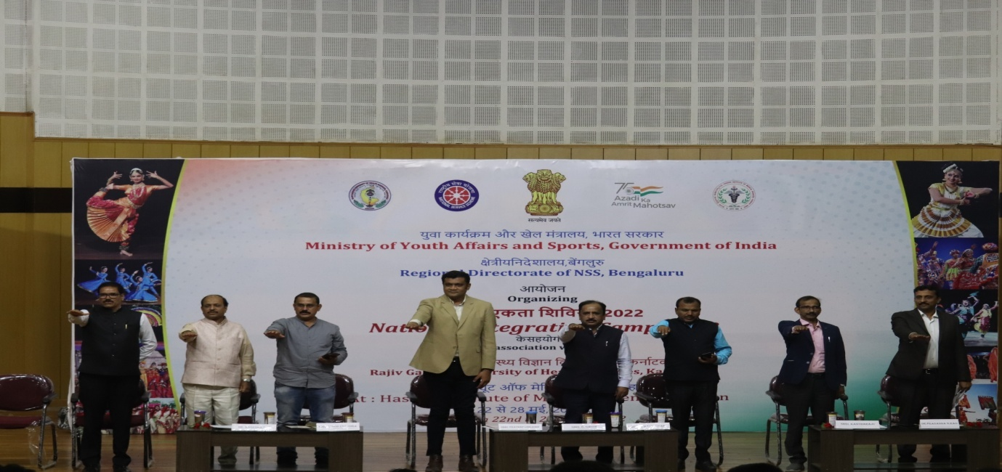
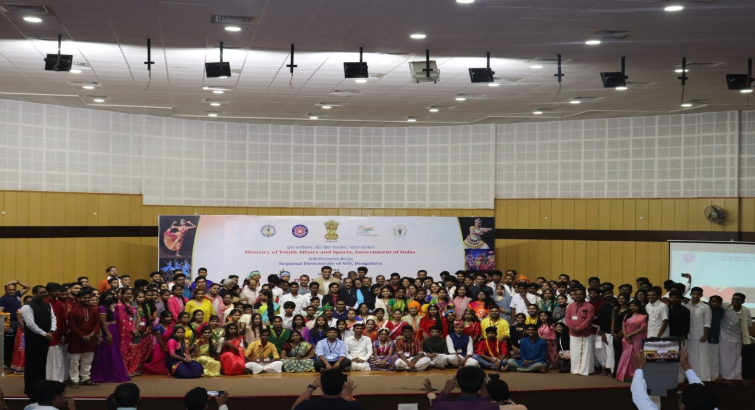
The formal function was followed by cultural programs of the NIC participants of different states.
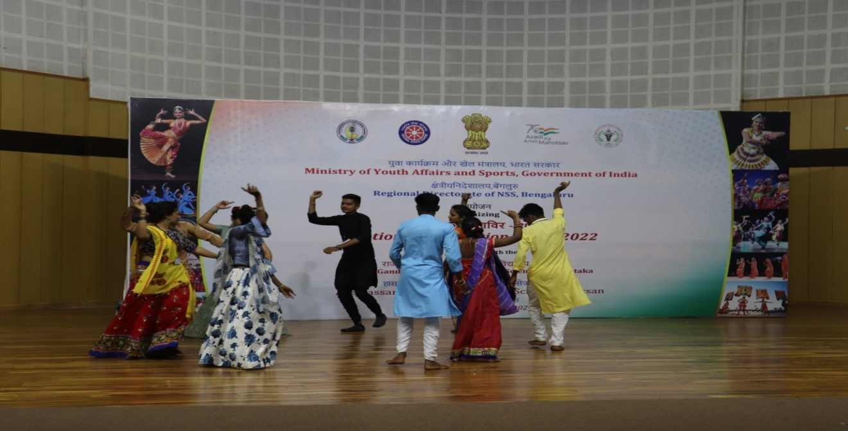
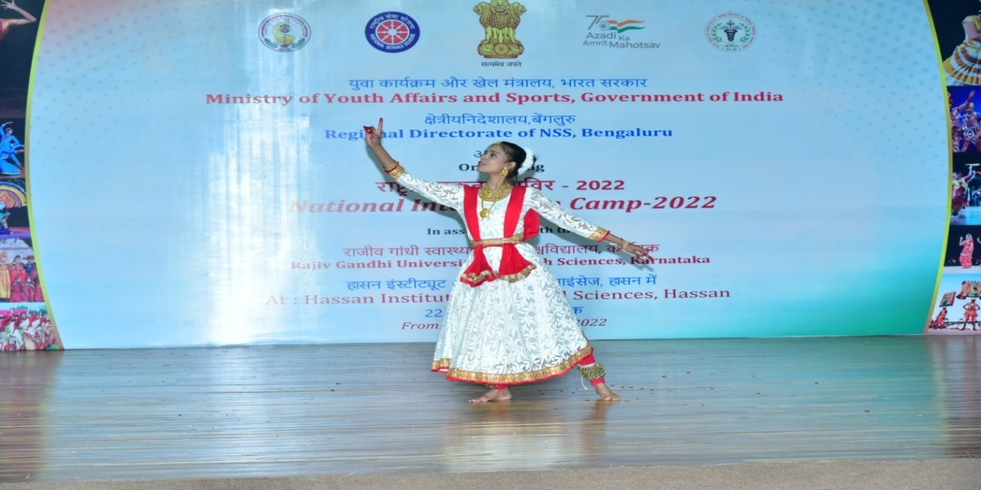
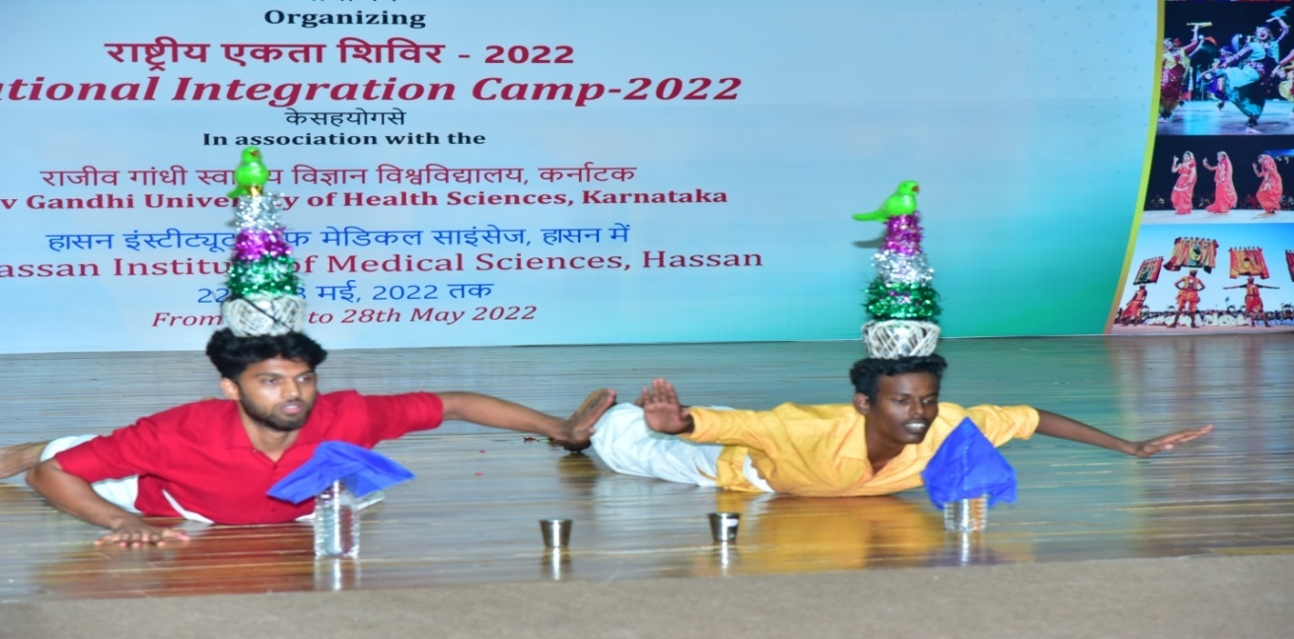
Date: 23-05-2022 Day: Monday
As we start the 2nd day of the camp, students were divided into 5 teams namely Brahmaputra, Narmada, Krishna, Yamuna, Kaveri. Today team Brahmaputra conducted the flag hoisting program. Mr. H P Mohan, Chairperson of Indian Red Cross Society, Hassan, was the chief guest for the day and he spoke on “the importance of NIC camp in our life, the sense of discipline and oneness it imbibes in us. He also spoke about unity in diversity in our country”.
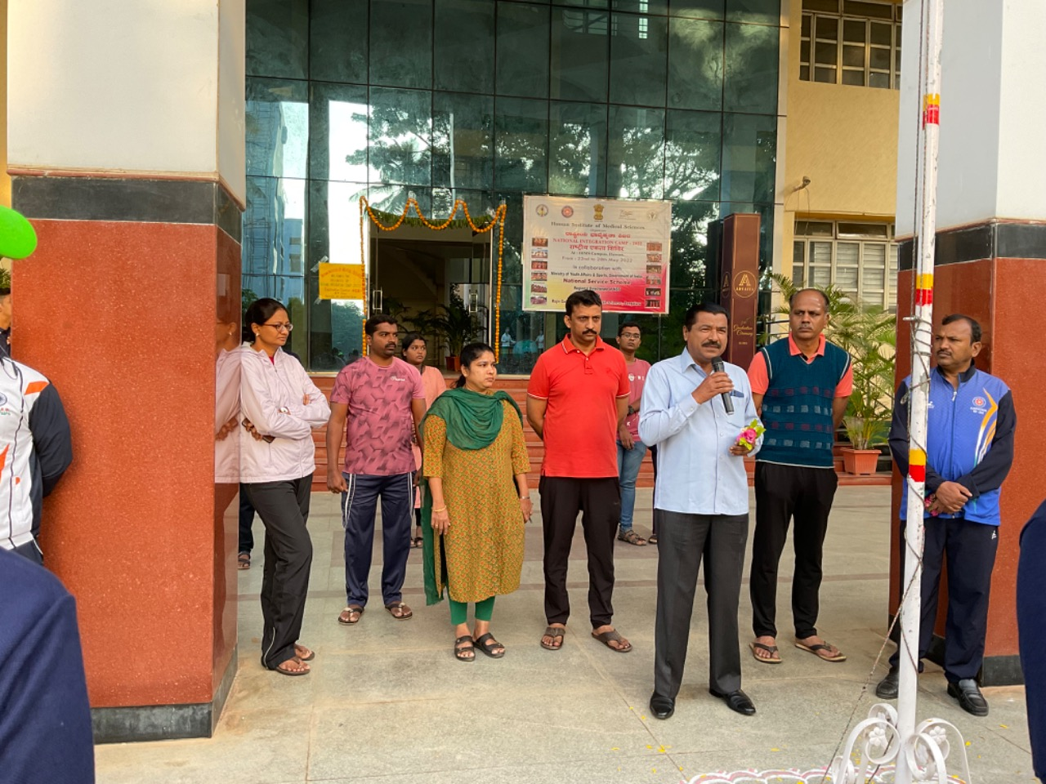
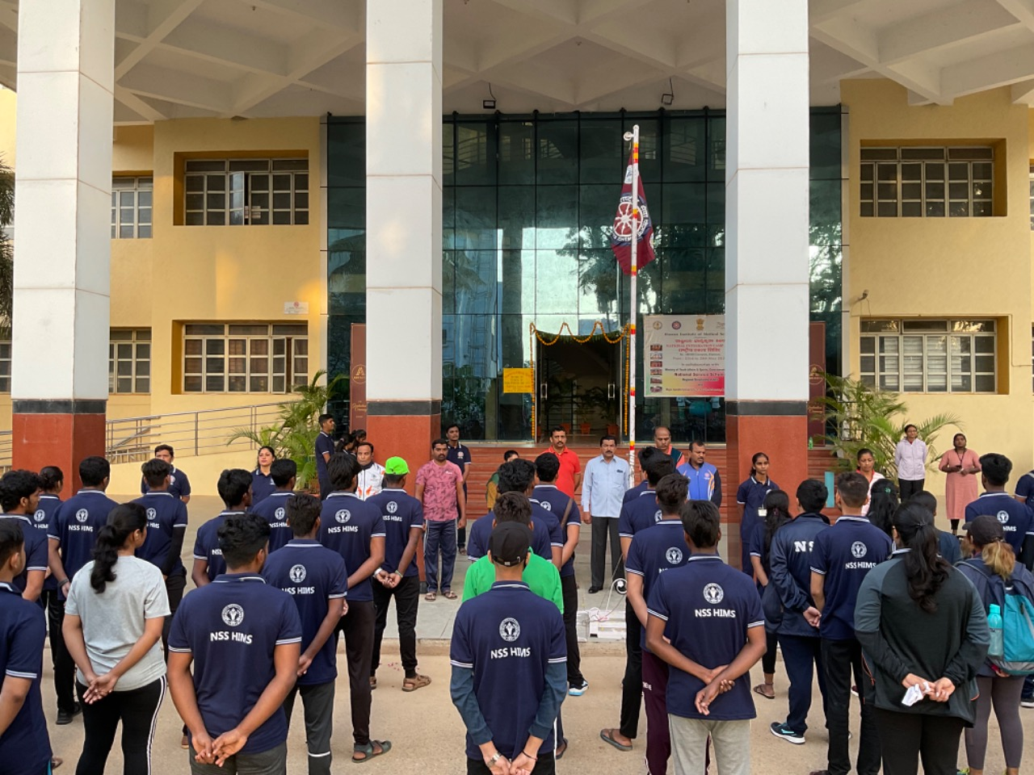
The yoga session was conducted by Dr. Guru Basavaraj, Assistant Professor, SDM Ayurveda College, Hassan.
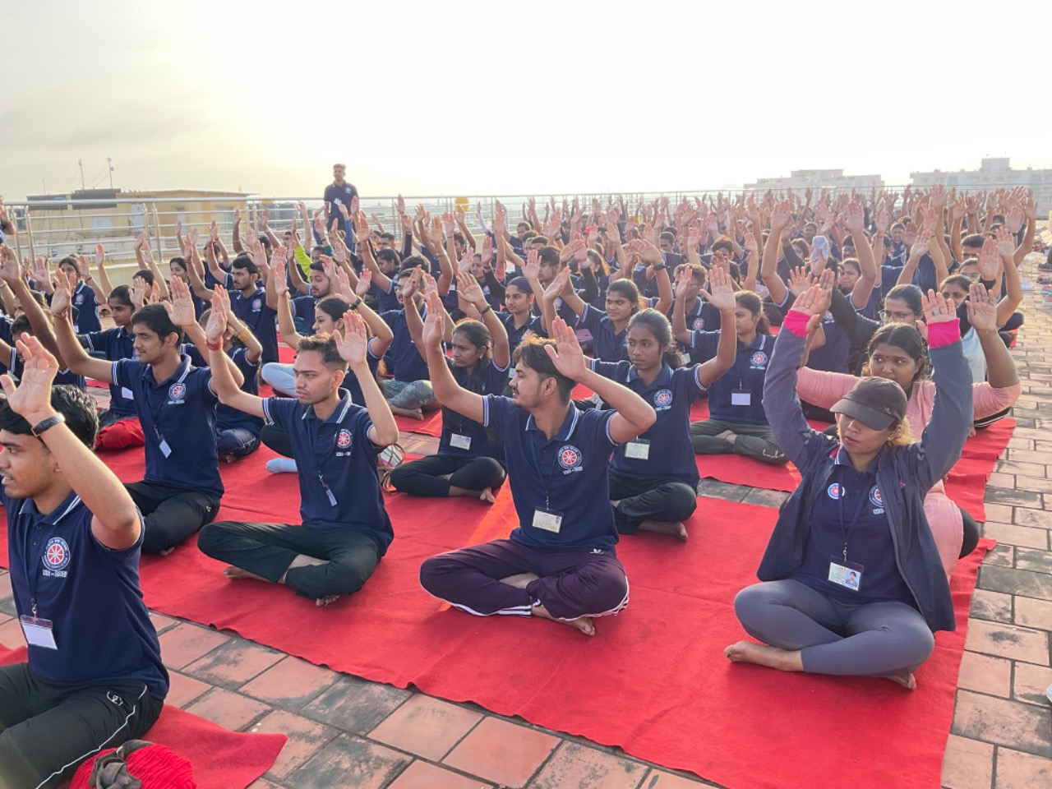
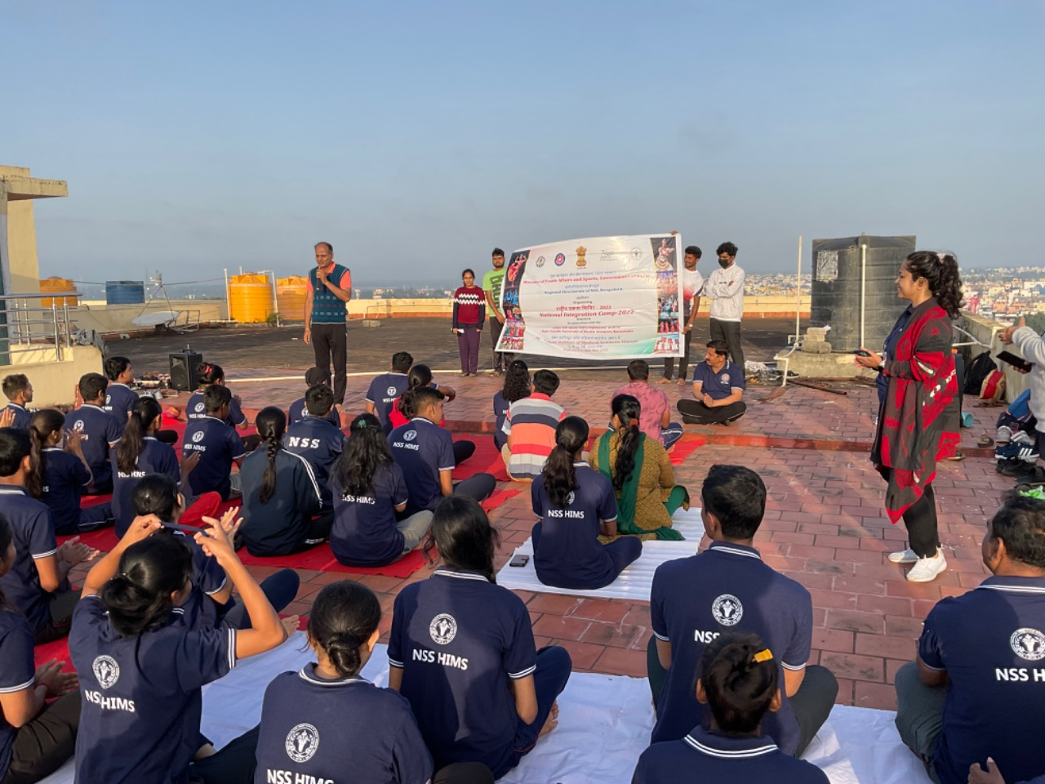
In the Educational session, Dr. VLS Kumar, Master trainer on disaster management and emergency medicine, former Vice Chairman of Indian Red Cross Society, Shivamogga, National and south Asian Regional Disaster Response team member, Resource person for GOK, Administrative trainer for class A & B government officials. He spoke regarding the disasters in our country and pros and cons in the situation. There was also a demonstration session on bandage dressing, different positions to lift the injured, proper use of fire extinguisher, CPR and other life saving emergency skills. The session was also graced by the presence of Sri H P Mohan, Chairman IRCS hassan, Sri Shabeer Ahmed, Secretary IRCS hassan, Sri.Jayendra Kumar H D, treasurer IRCS Hassan, Sri Akhil Pasha, Sri Shivananda H M, Smt. Kanchana Mala,Smt. K.T Jayshree,Smt. Nirmala and Shri.Yelappa Uppin.
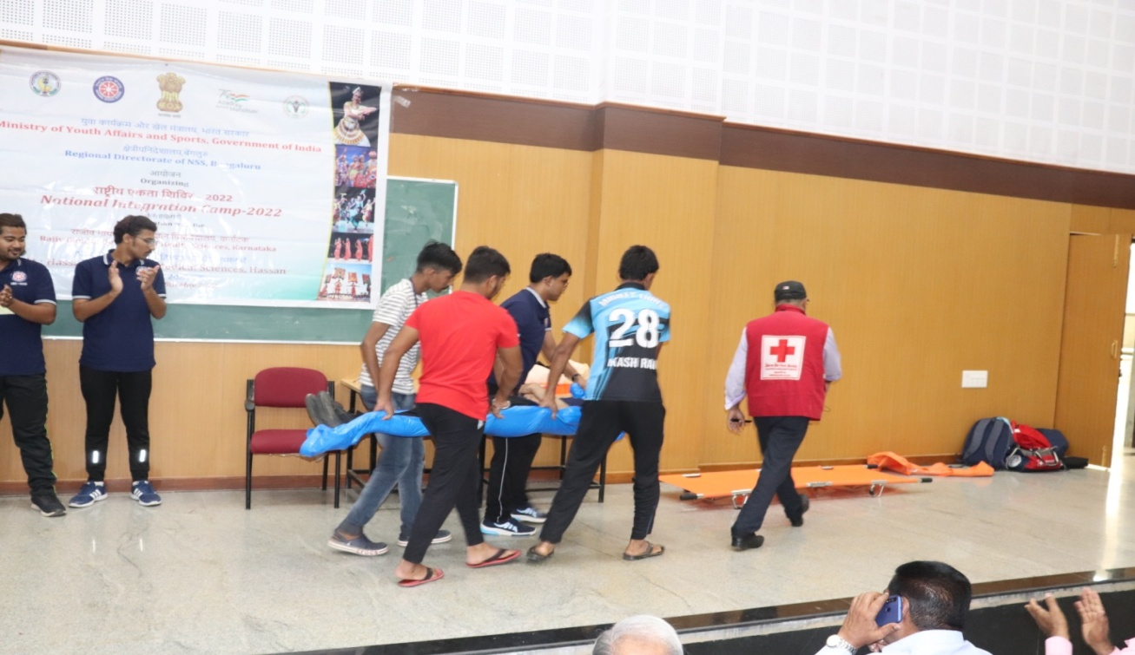
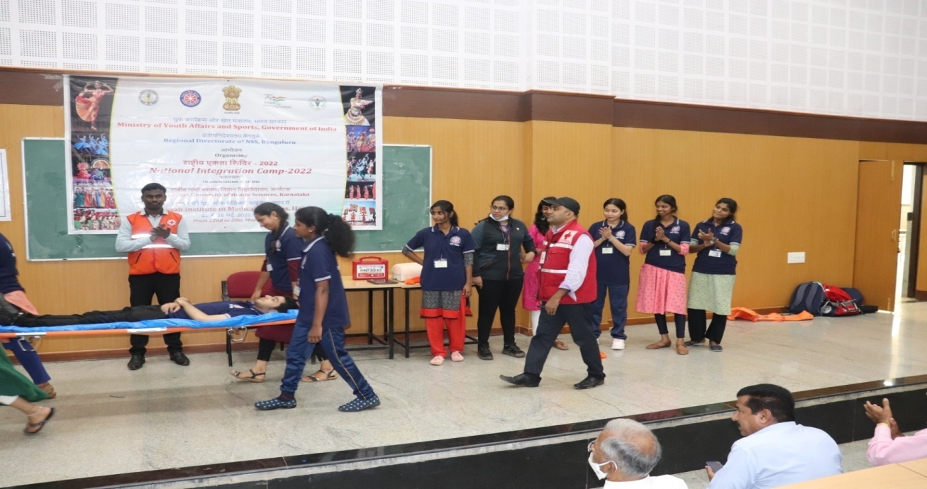
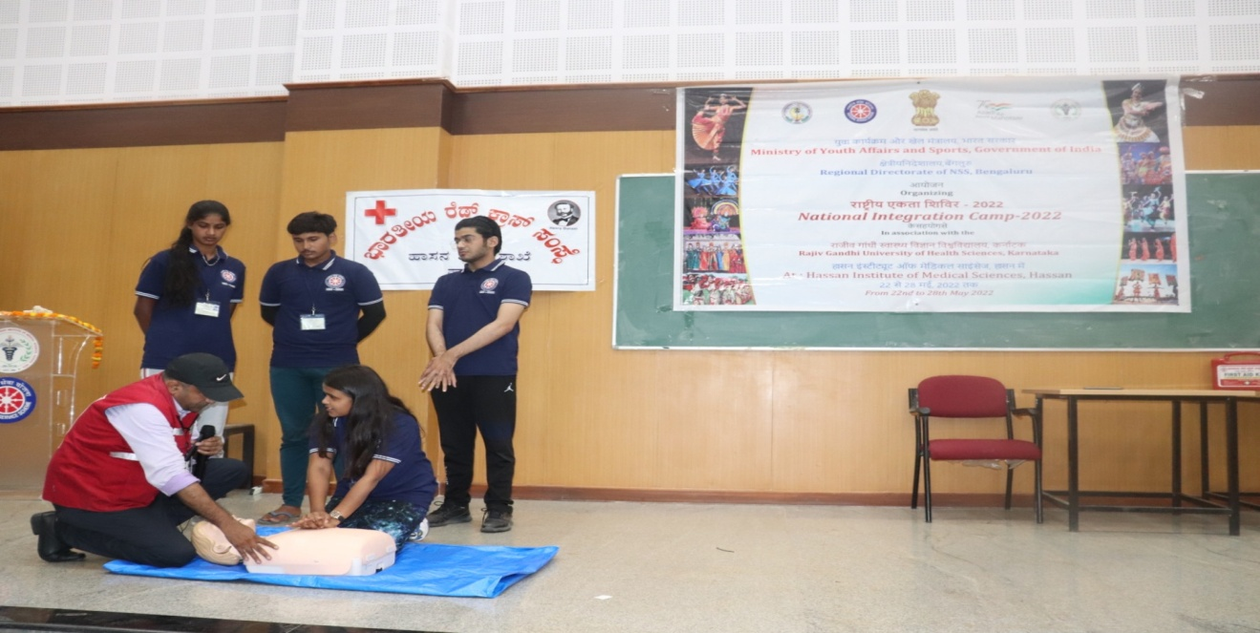
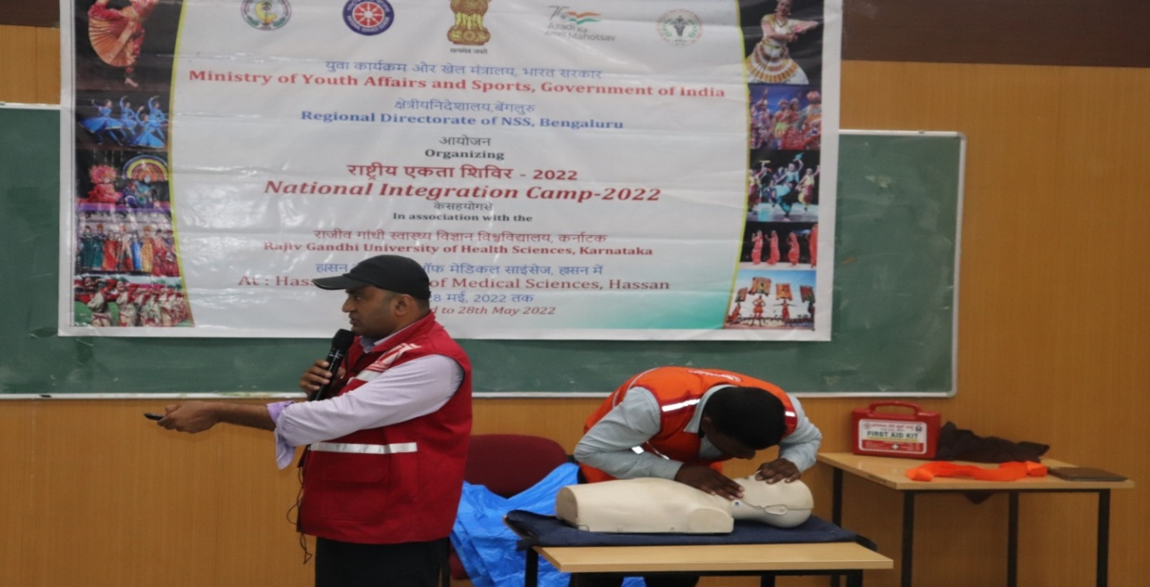
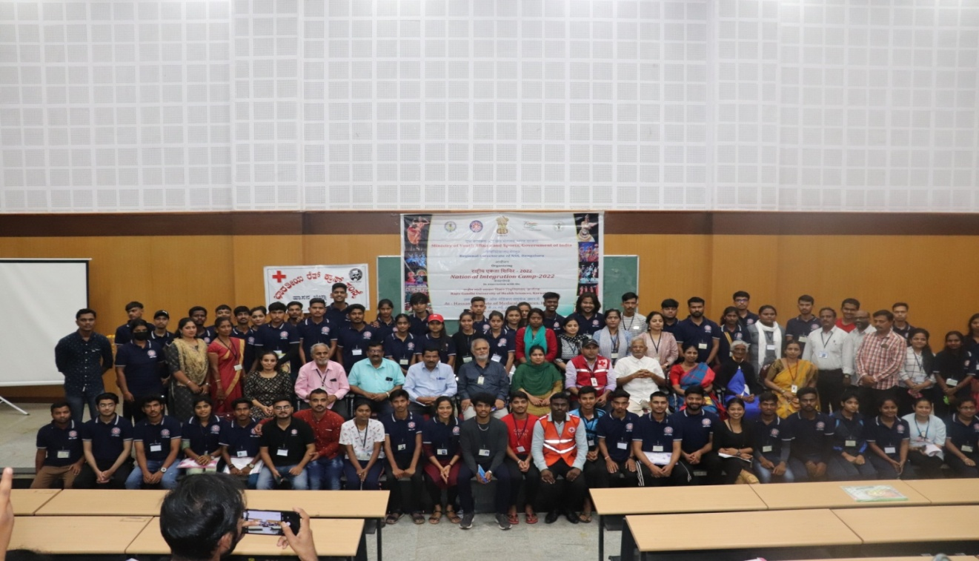
After the lunch we had an interactive session on “National integration” by Dr. Umashankar, National Youth Awardee, he spoke regarding the national integration and its importance and the rights provided by the government.
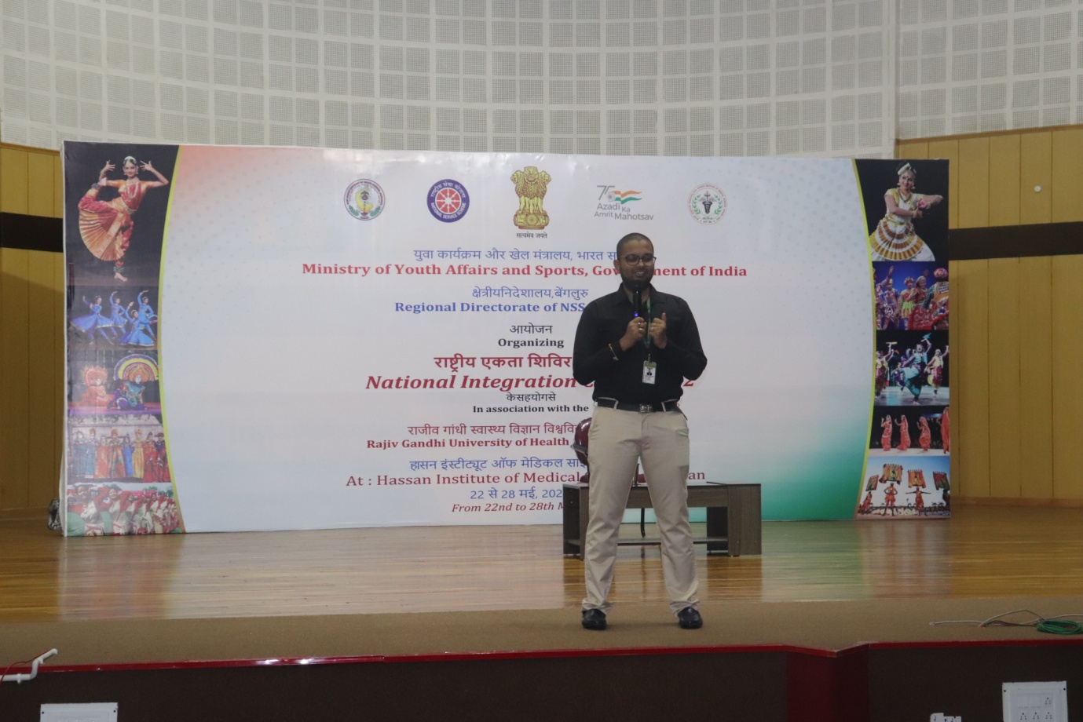
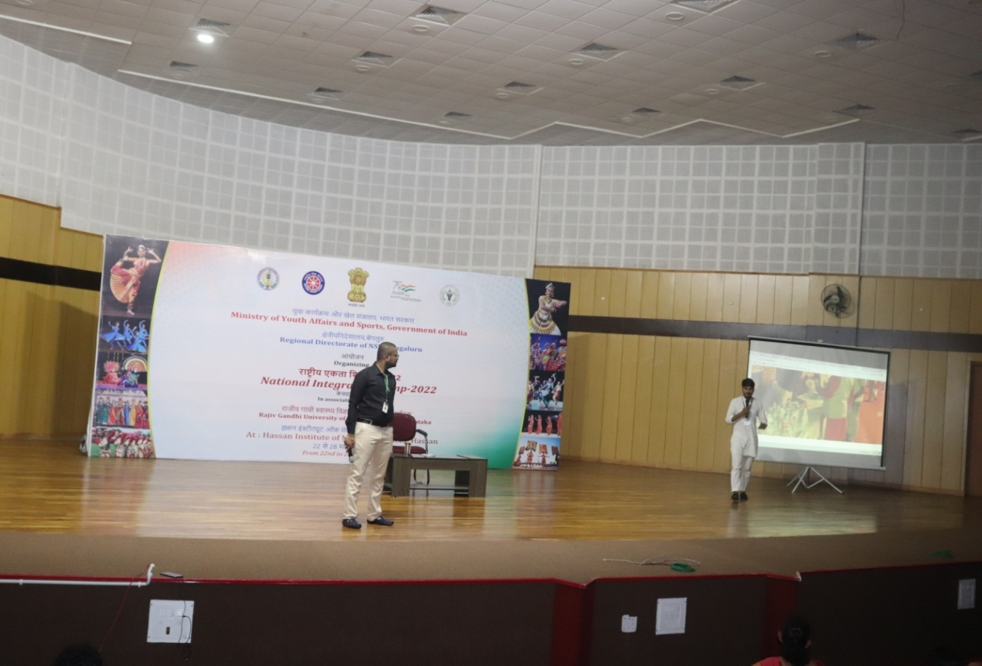
Evening onwards the cultural programs were conducted which lit the stage.
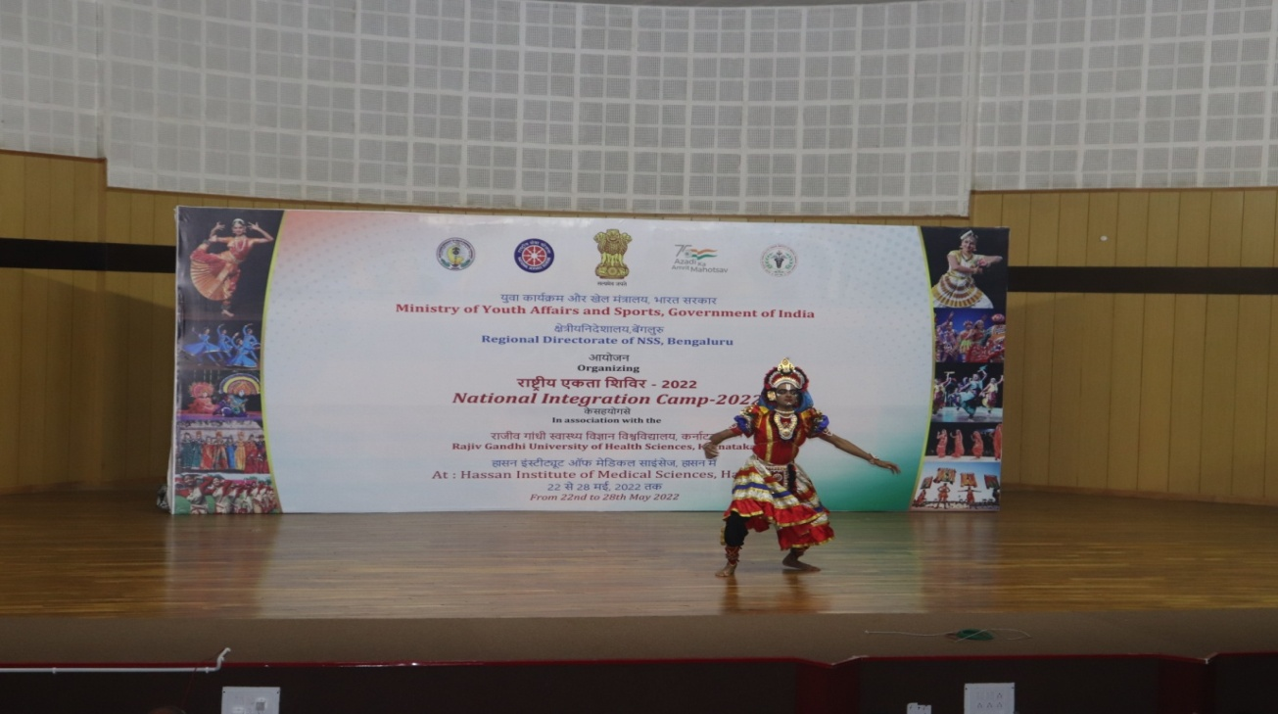
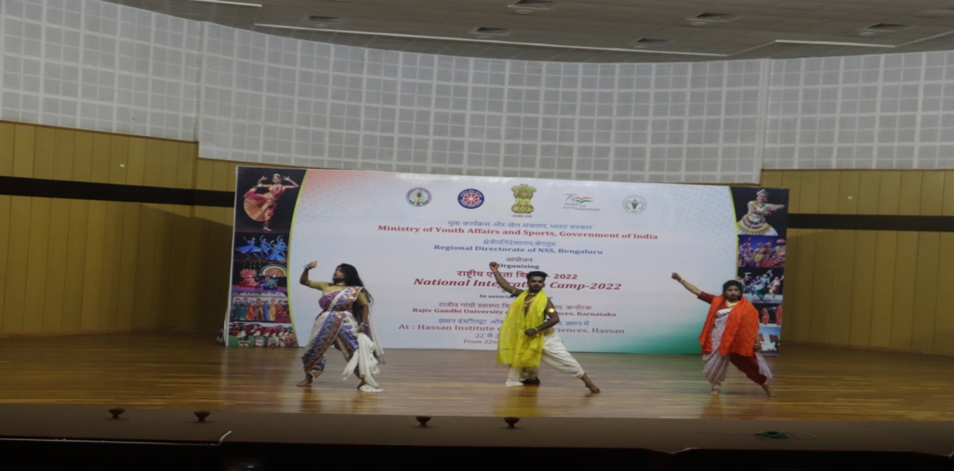
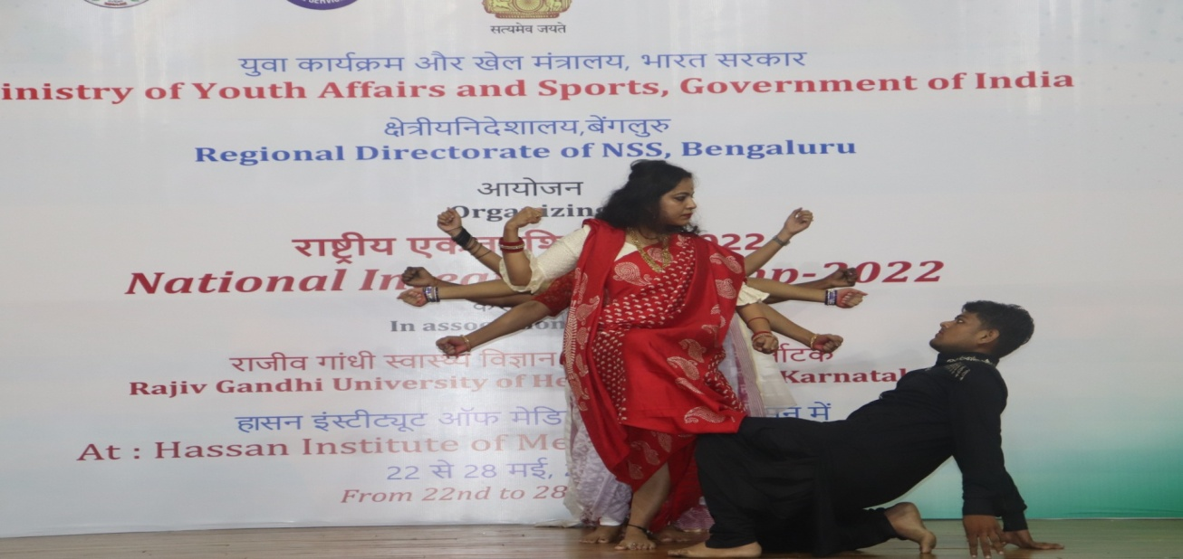
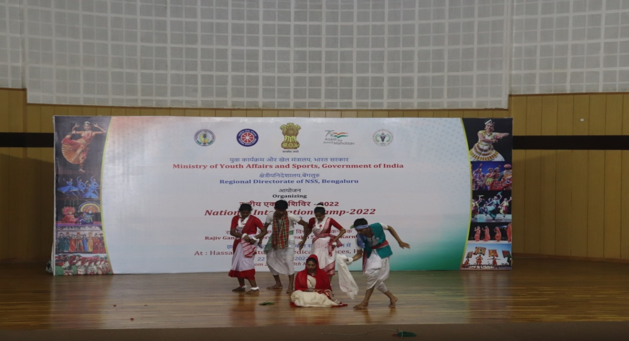
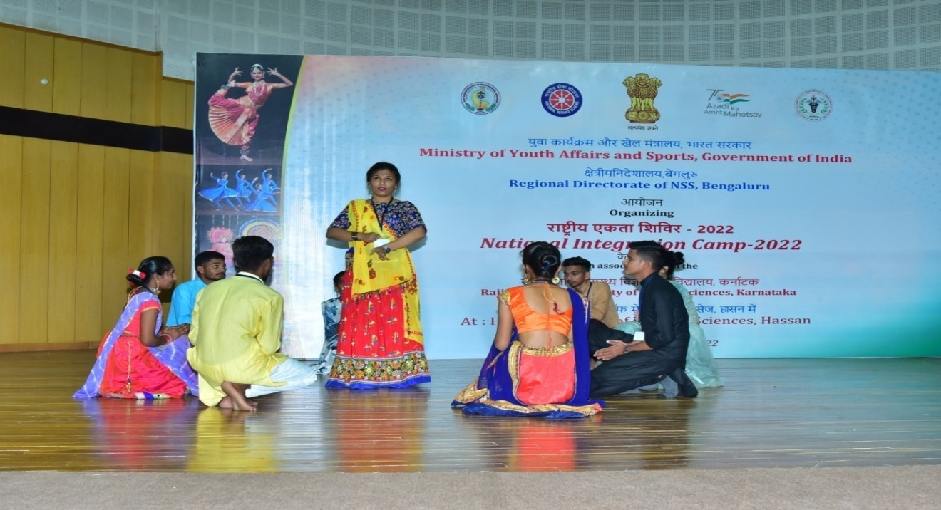
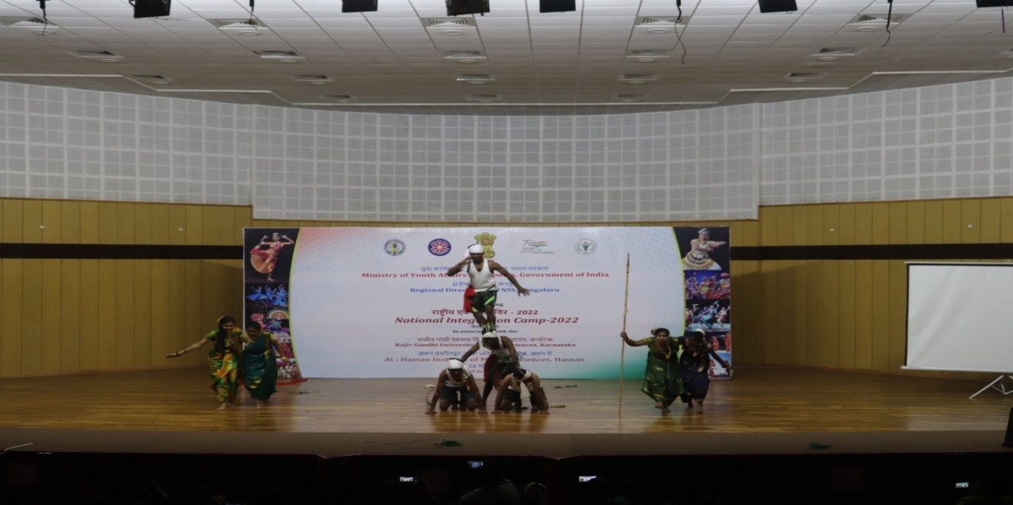
Date: 24-05-2022 Day:Tuesday
The day started with flag hoisting by Shri. Akhil Pasha, the former secretary, district literary committee, Member of Indian Red Cross Society. He shared his opinion on unity in diversity and national integration being the main motive behind this camp.
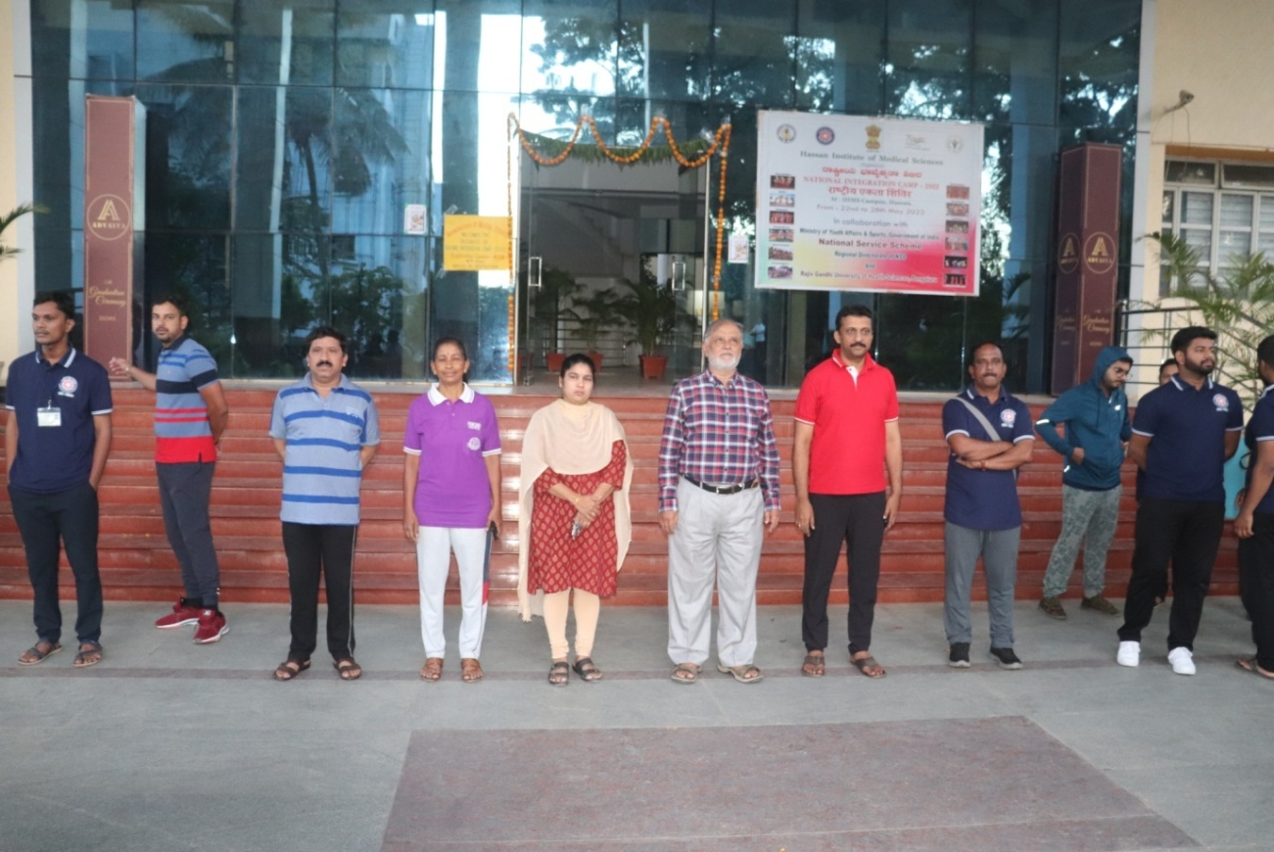
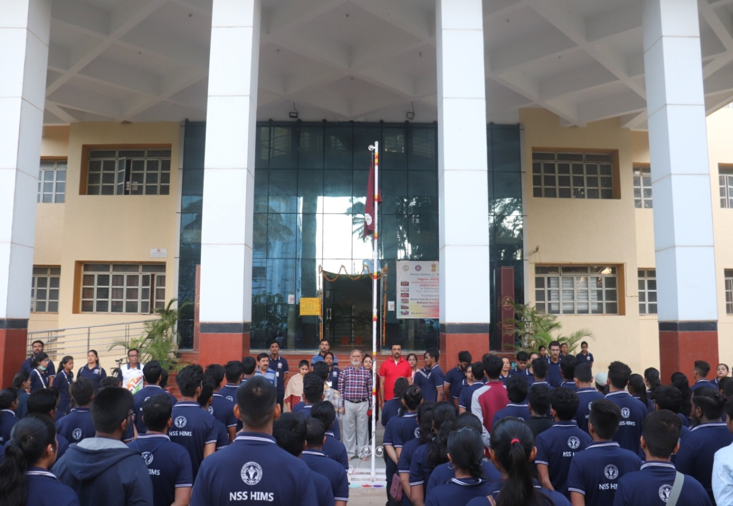
This was followed by yoga session conducted by Dr. Gurubasavaraj. 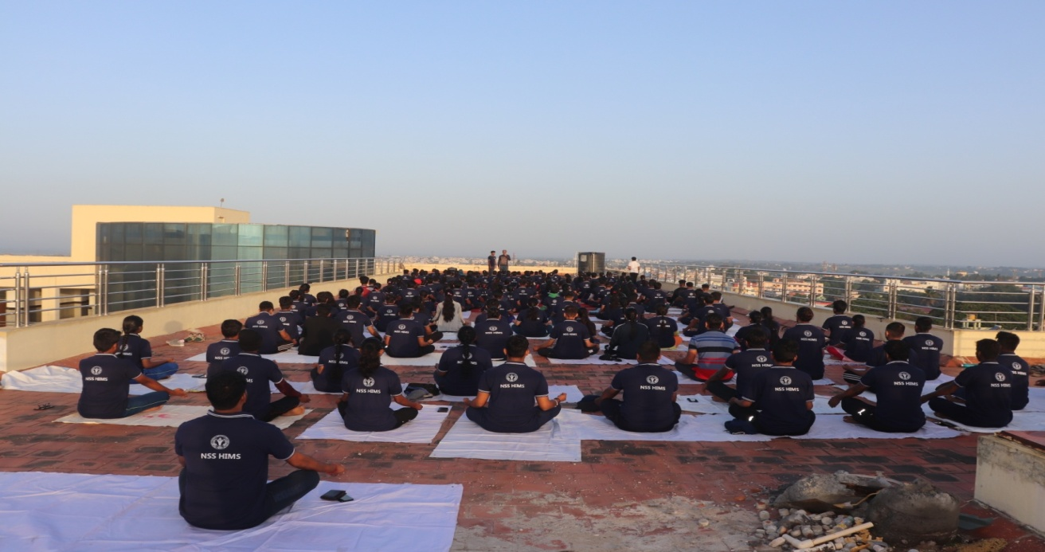
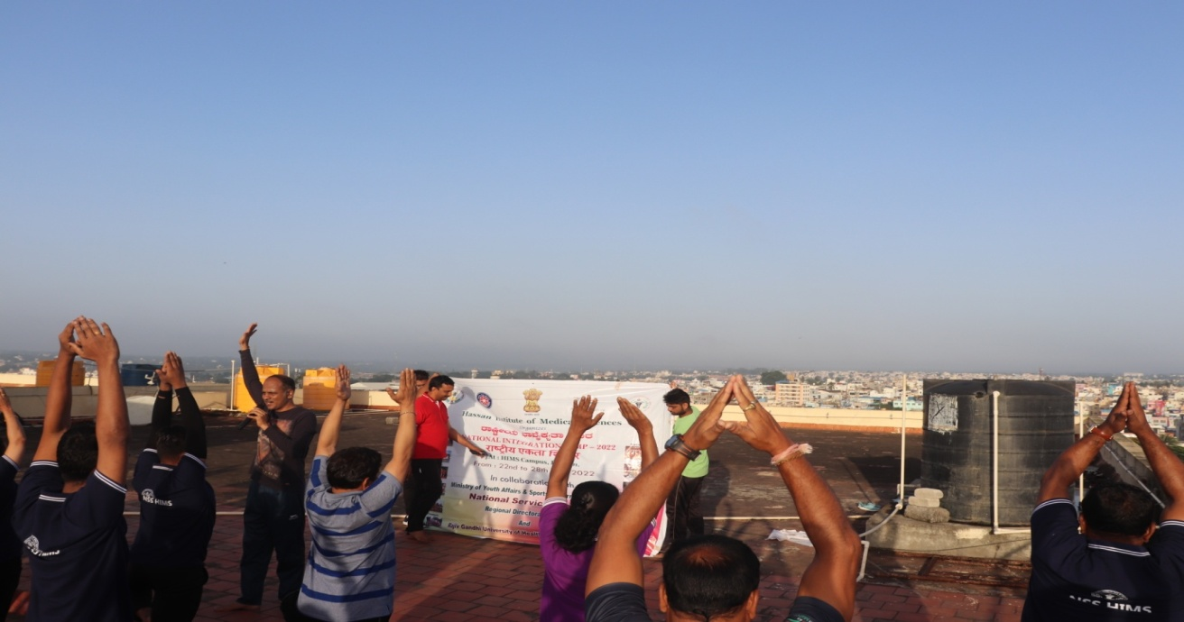
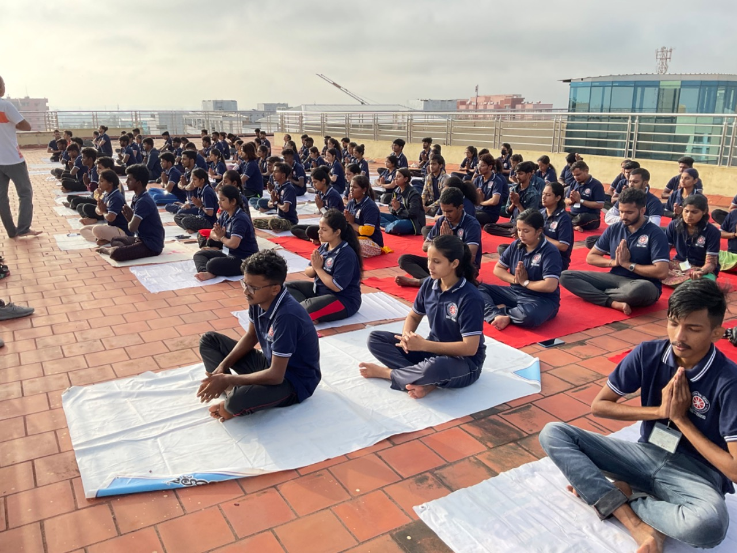
There was an amazing session on “life skill training” by Dr. Pradeep B S, Professor and HOD of department of Epidemiology, NIMHAMS Bangalore along with Smt. Veeksha Rai, life skill Training coordinator, NIMHANS Bangalore. Life skills and their importance were taught through interactive talks and activities. The Yuva Spandana team of Hassan joined the NIMHANS faculty in the life skill training.
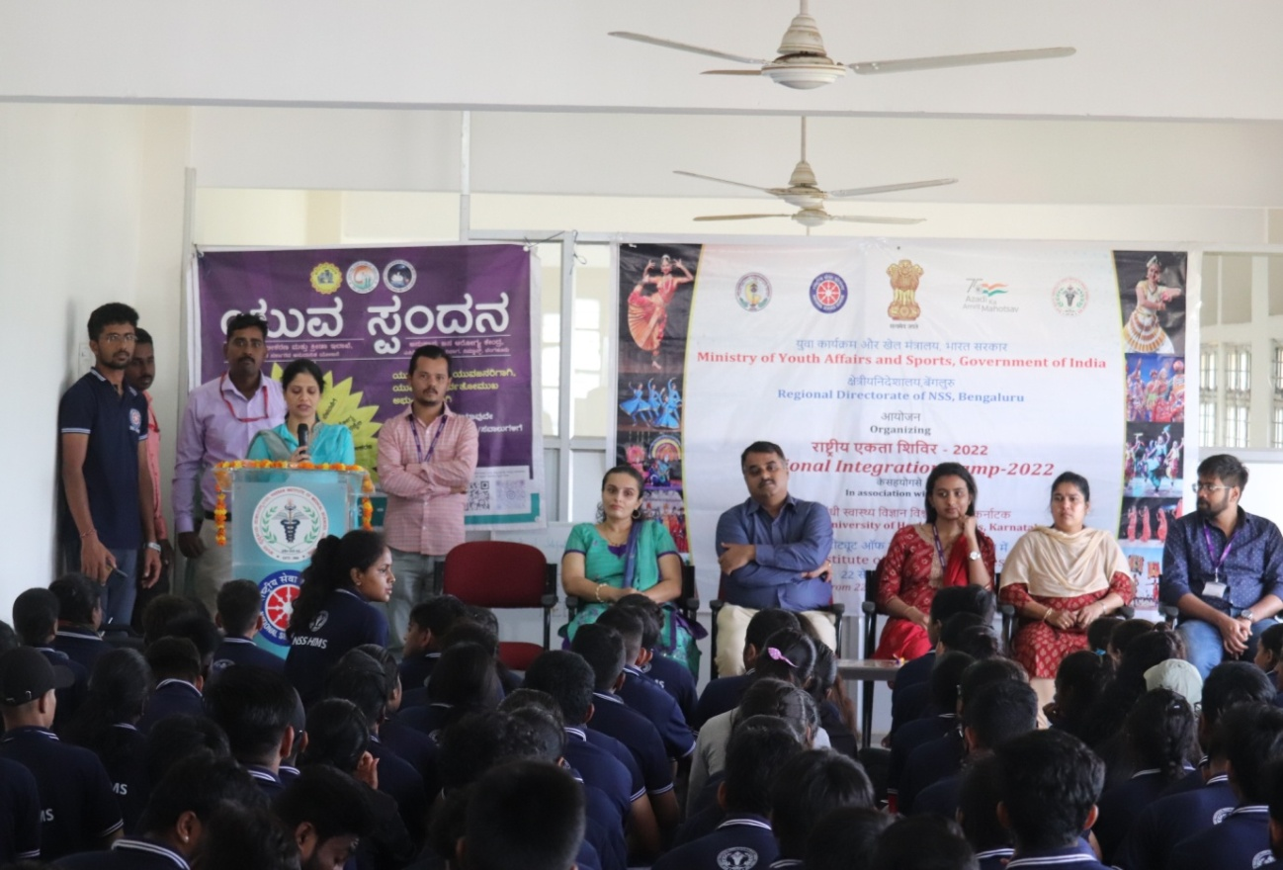
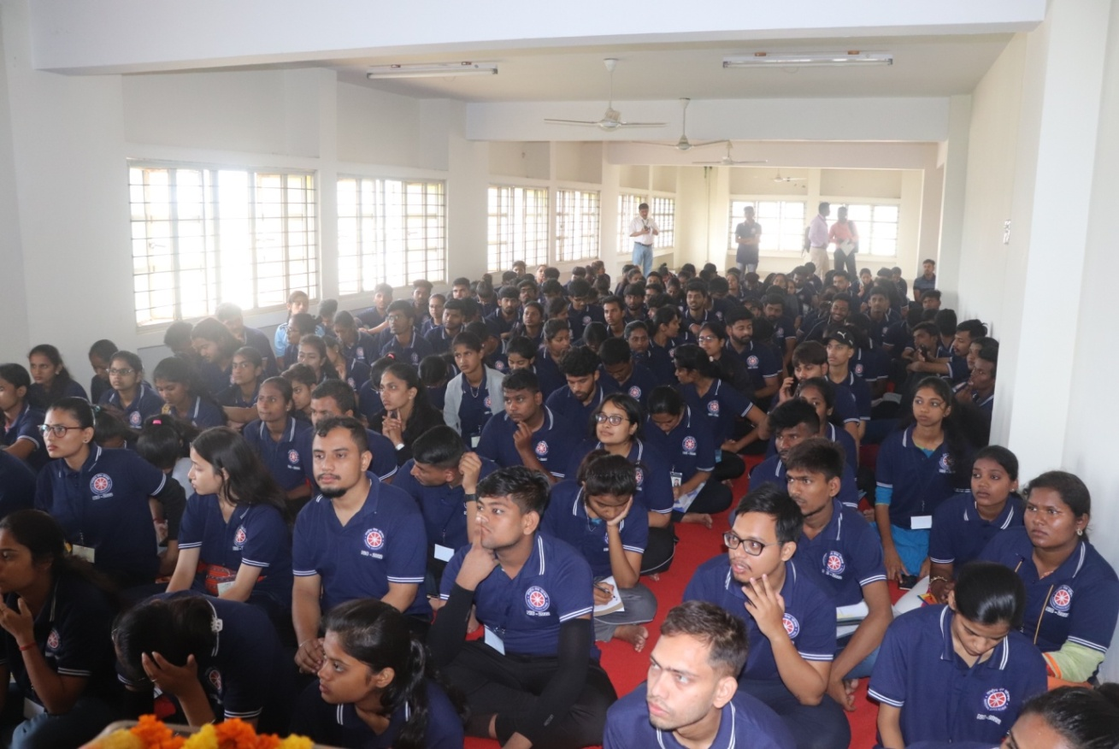
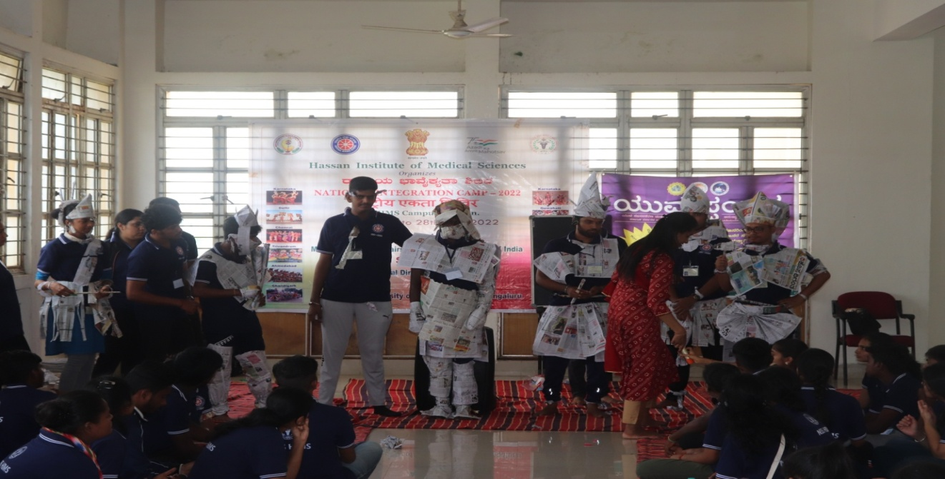
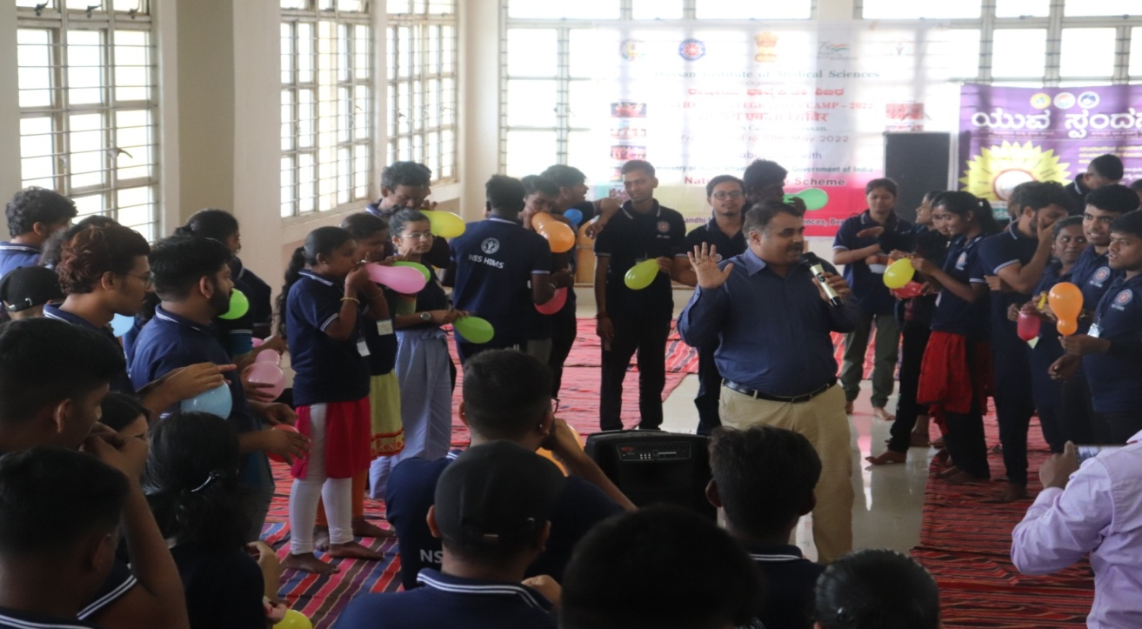
After the lunch various street plays were performed by NIC participants on the topics of digital India, National integration, India against Covid-19 Pandemic, climate change and its impact and conservation of resources and hence serving the purpose of creating awareness among general public.
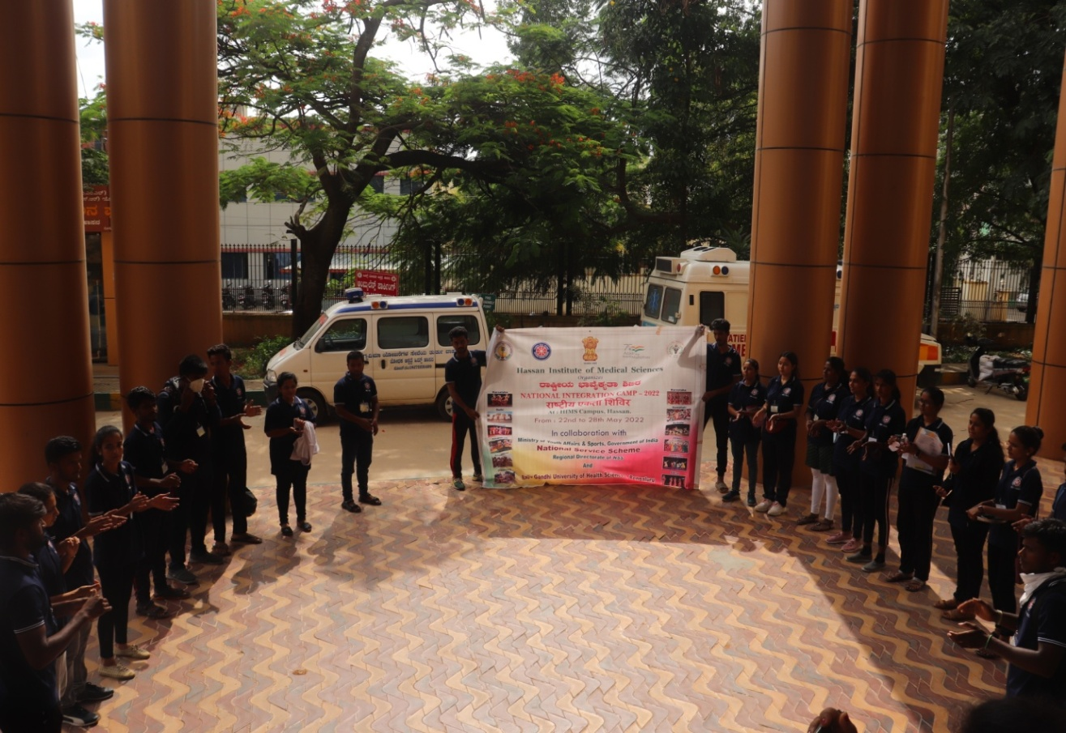
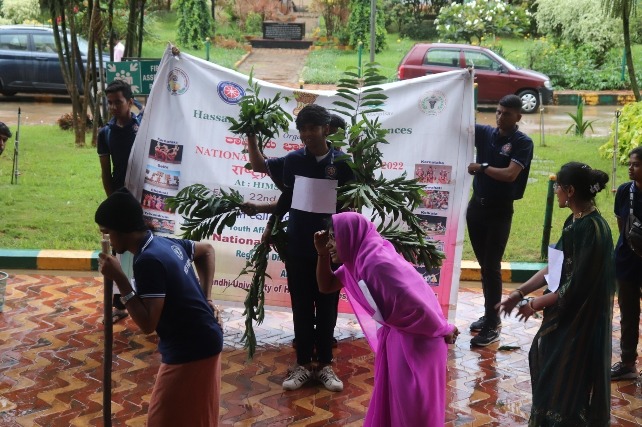
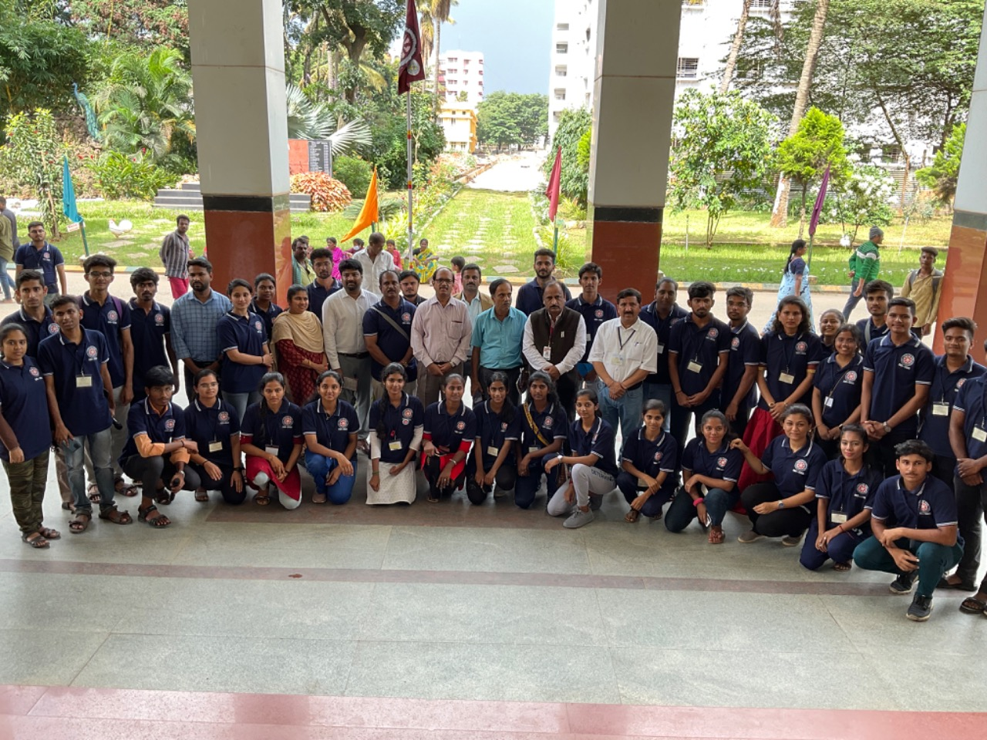
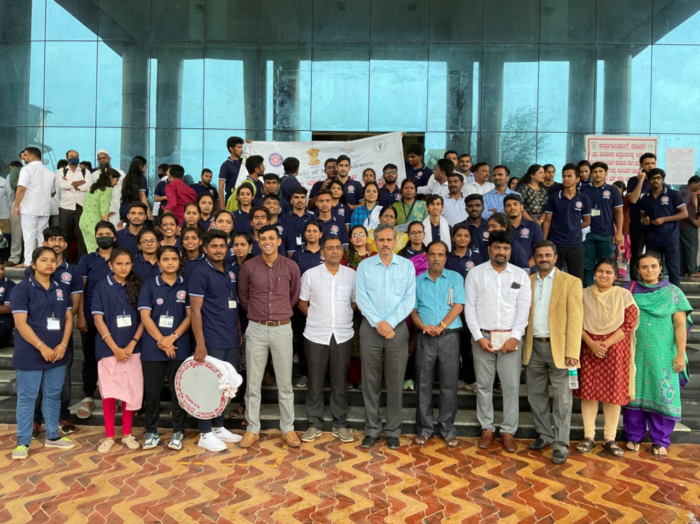
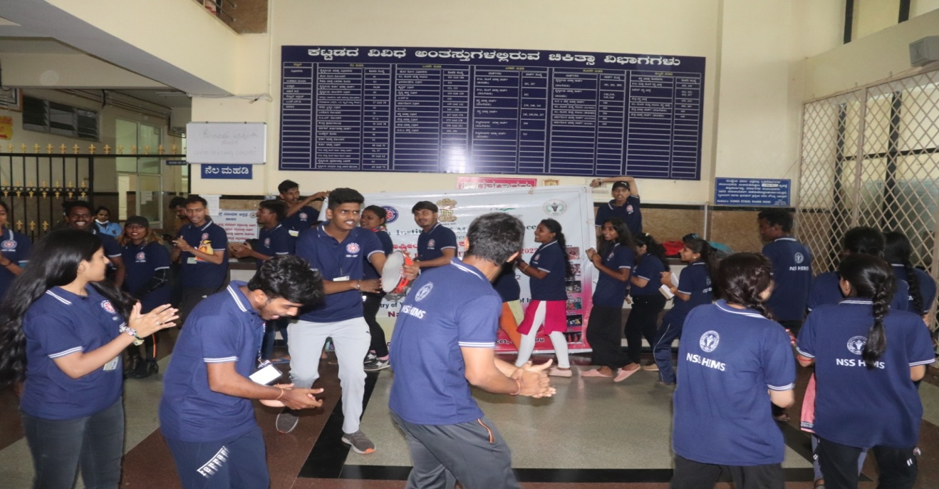
As usual evening onwards cultural programs lit the stage.
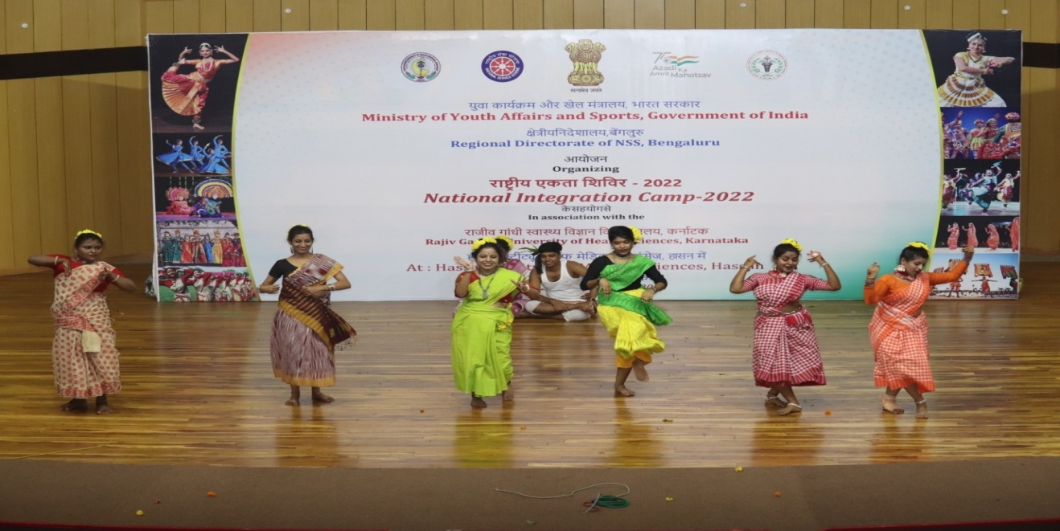
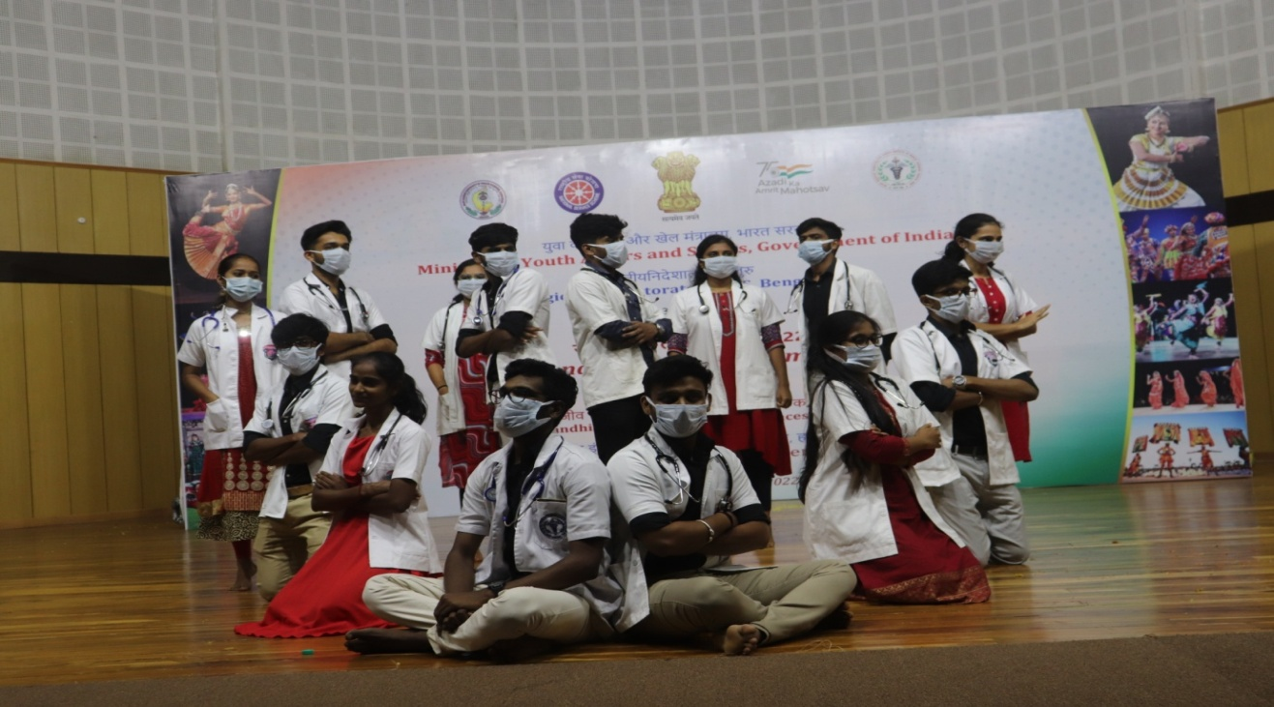
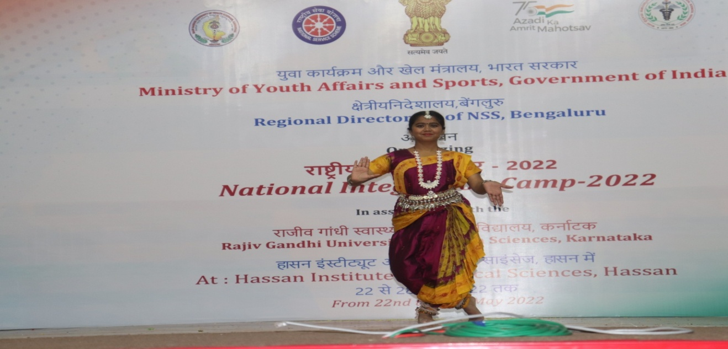
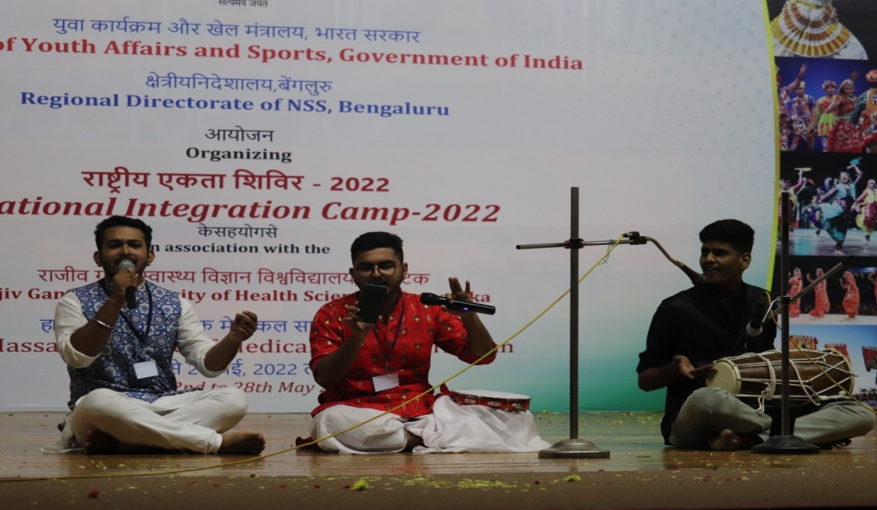
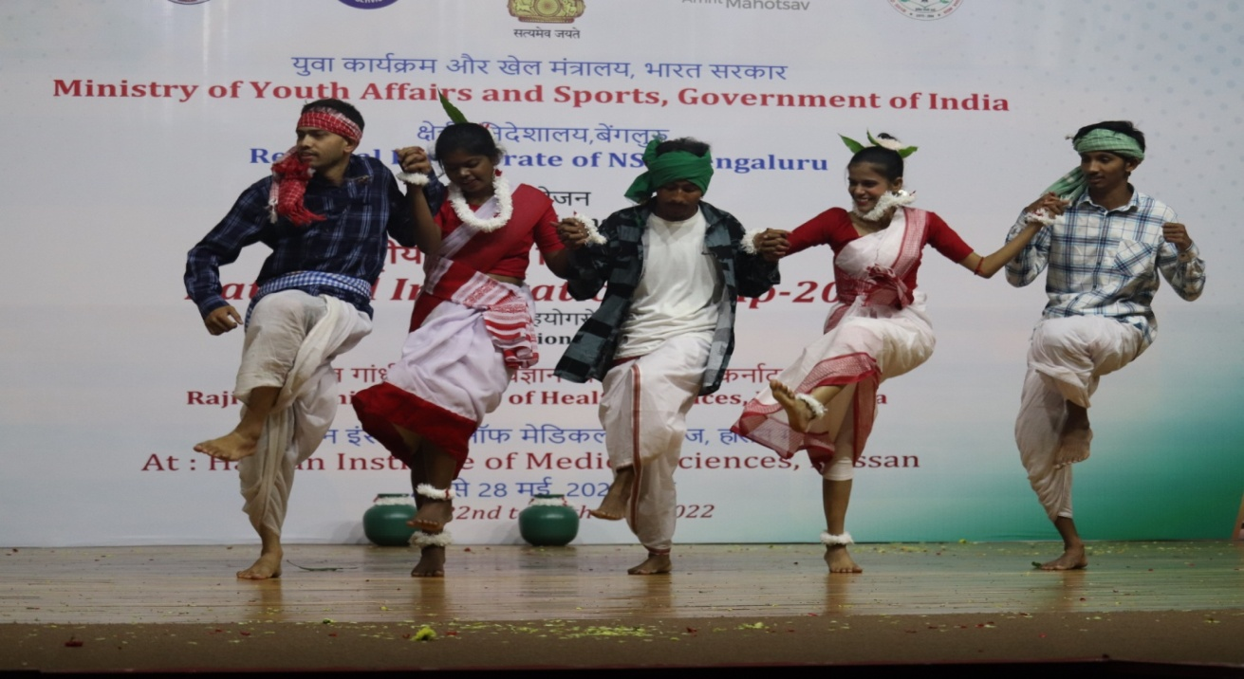
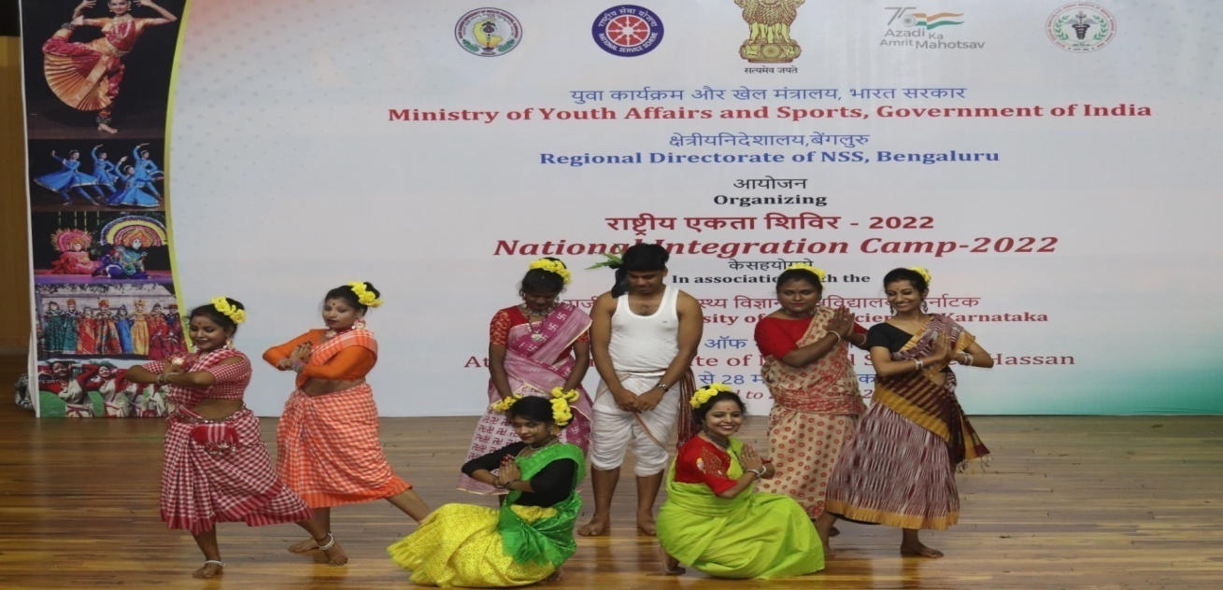
Date: 25-05-2022 Day: Wednesday
On this day the flag hoisting was done by Shri Natesh, tahsildar of Hassan taluk and he spoke about the importance of NSS and NIC camp.
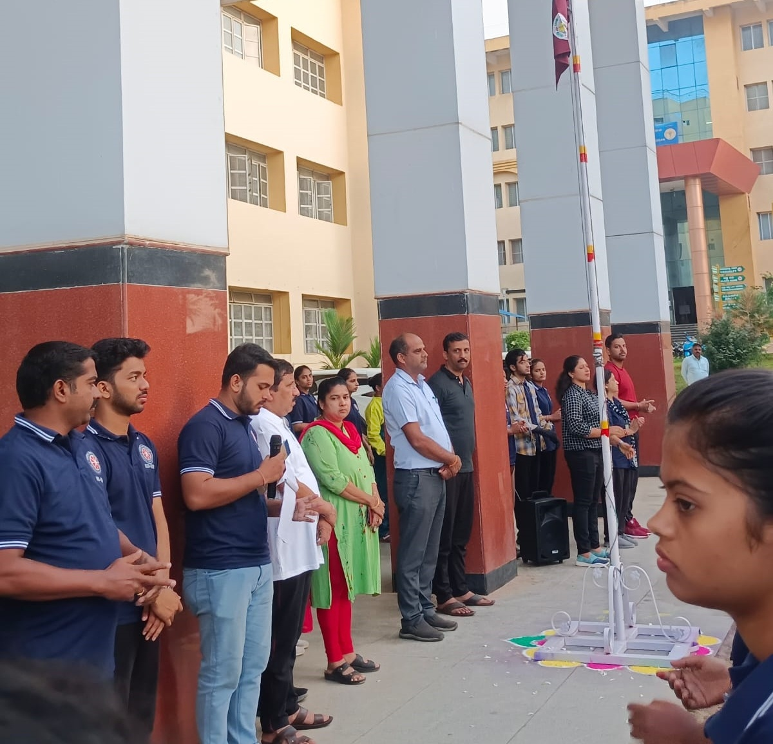
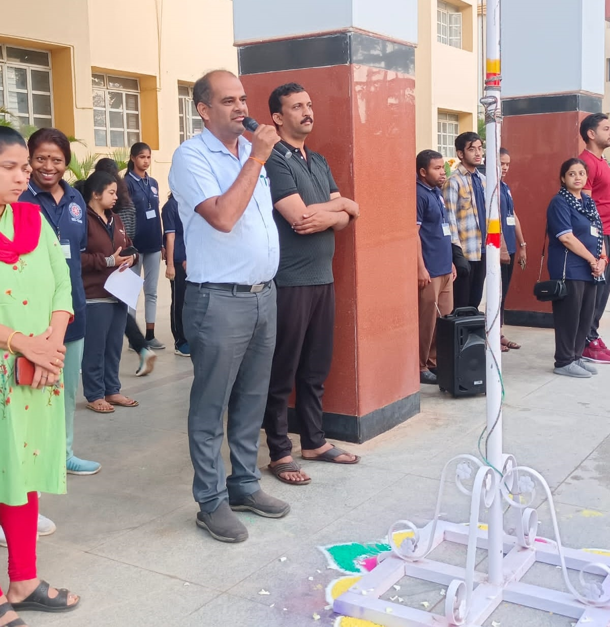
As usual yoga session was conducted by Dr. Gurubasavaraj.
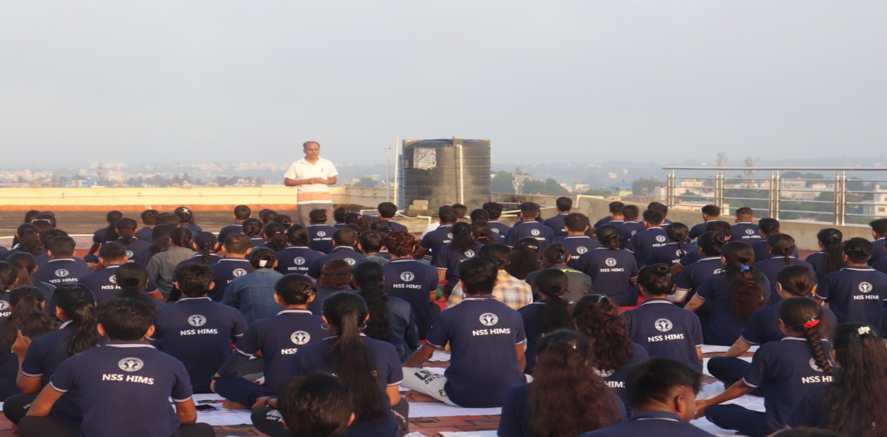
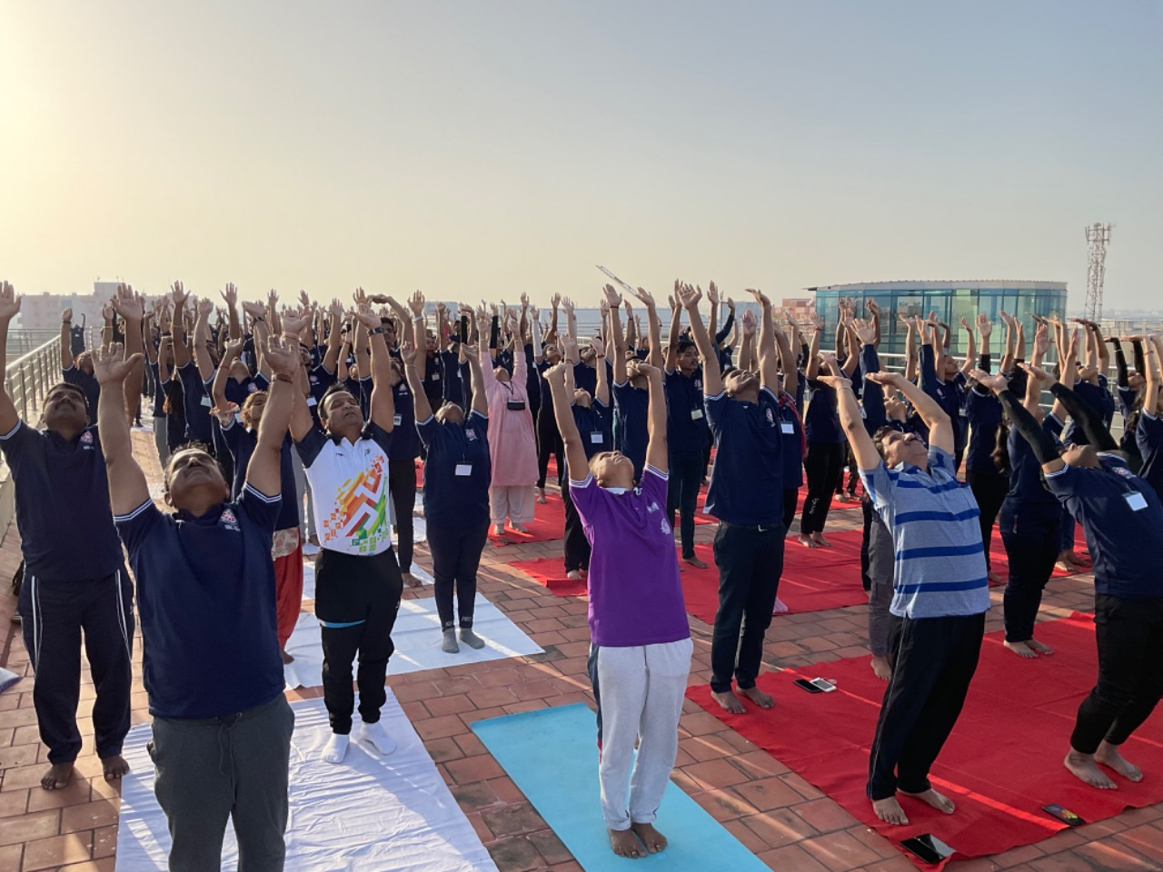
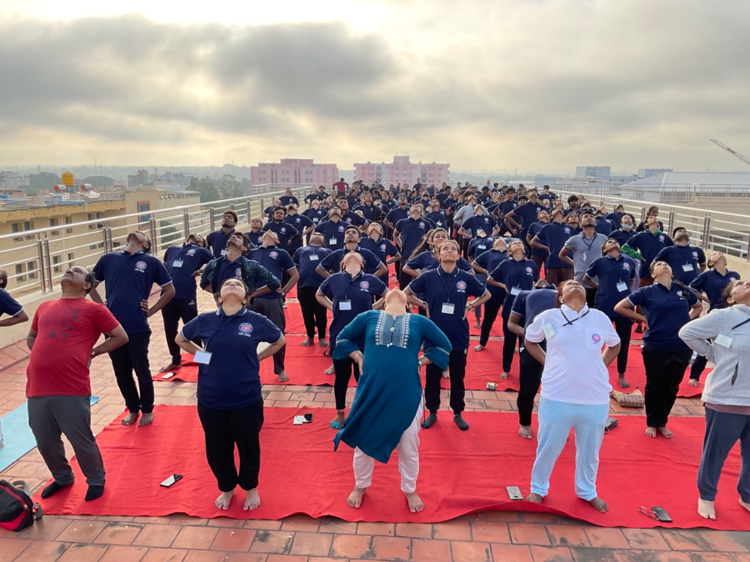
After the breakfast Shramadana was done by the NIC participants, upholding the principle-“clean nation-healthy nation”. The participants cleaned the entire campus in five groups.
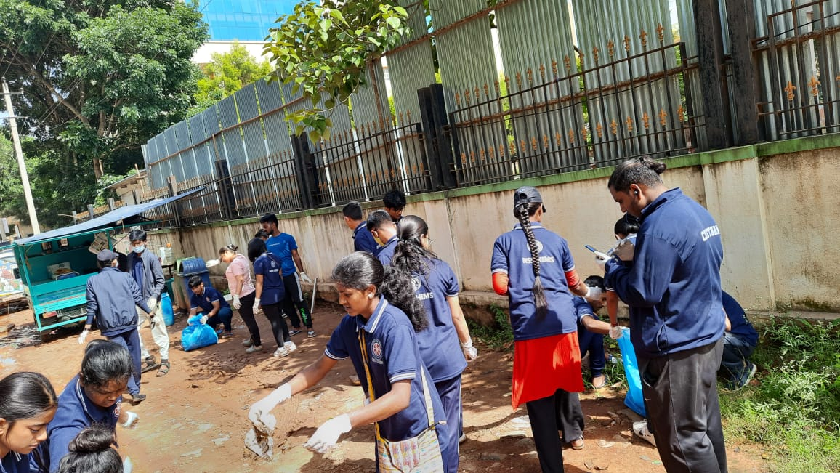
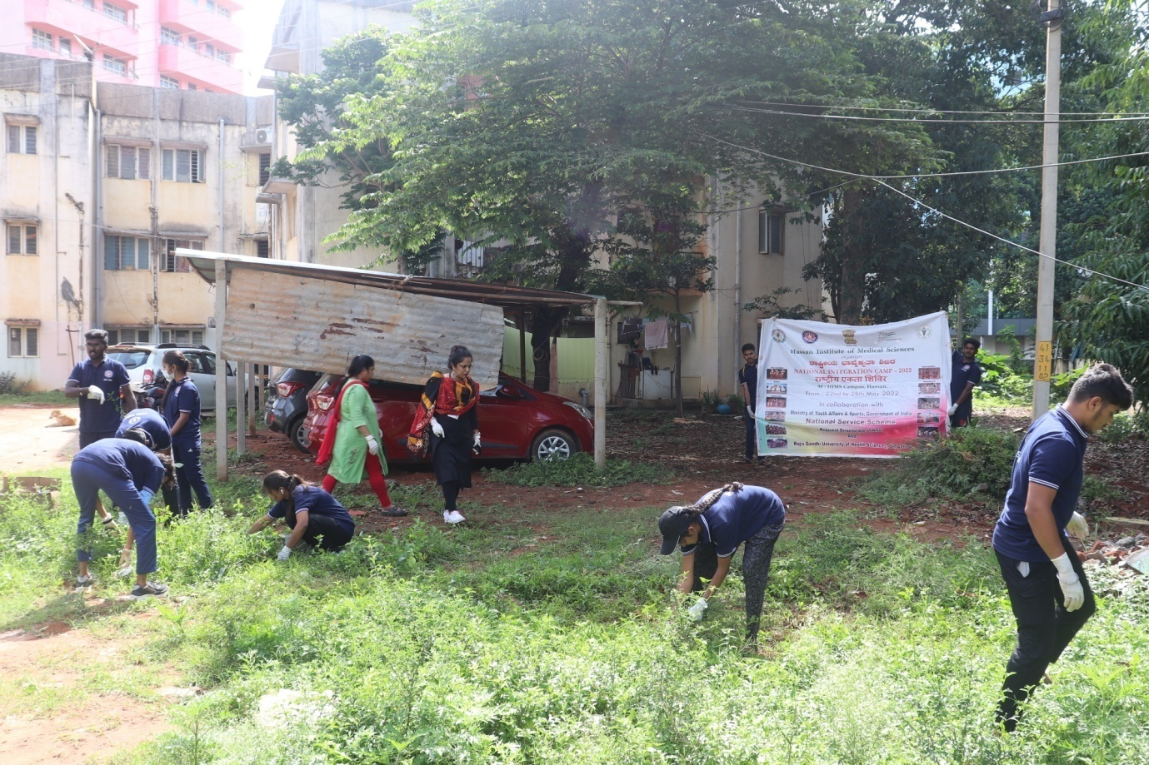
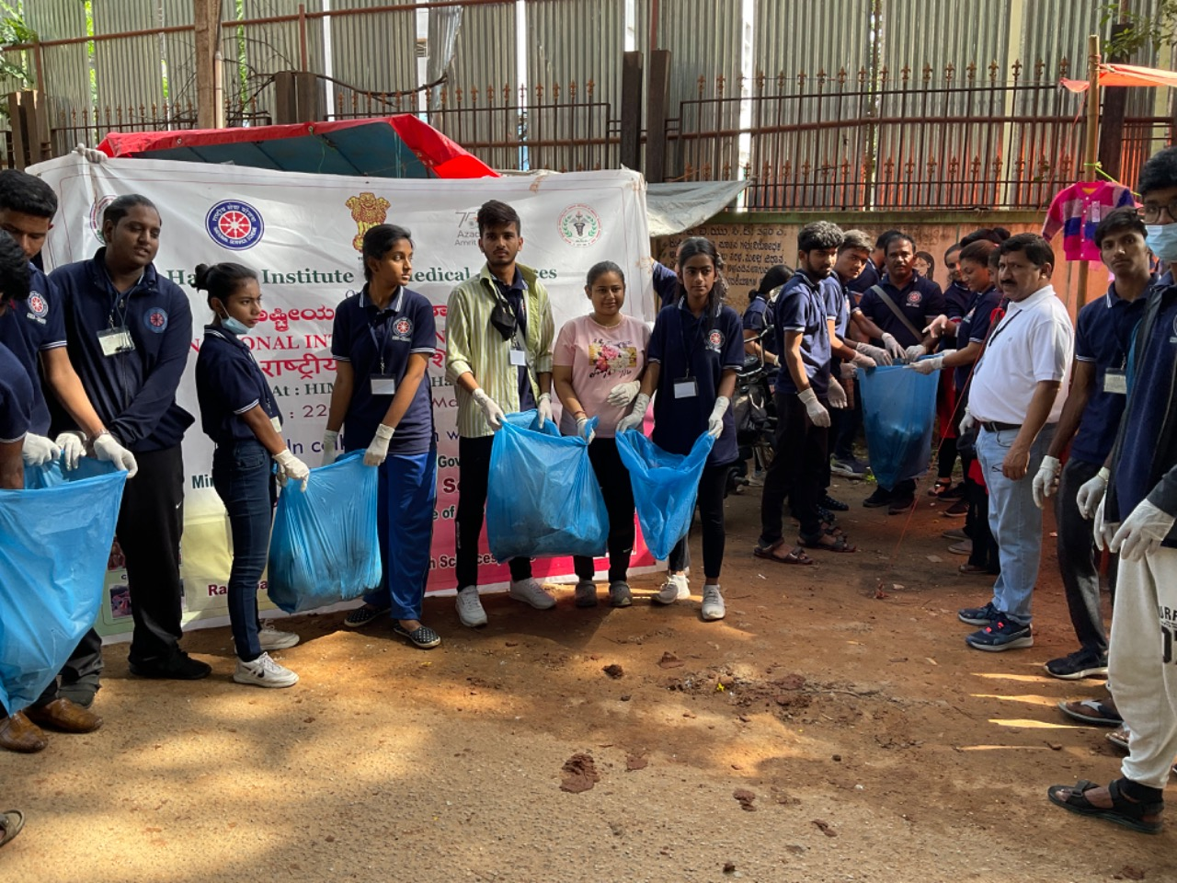
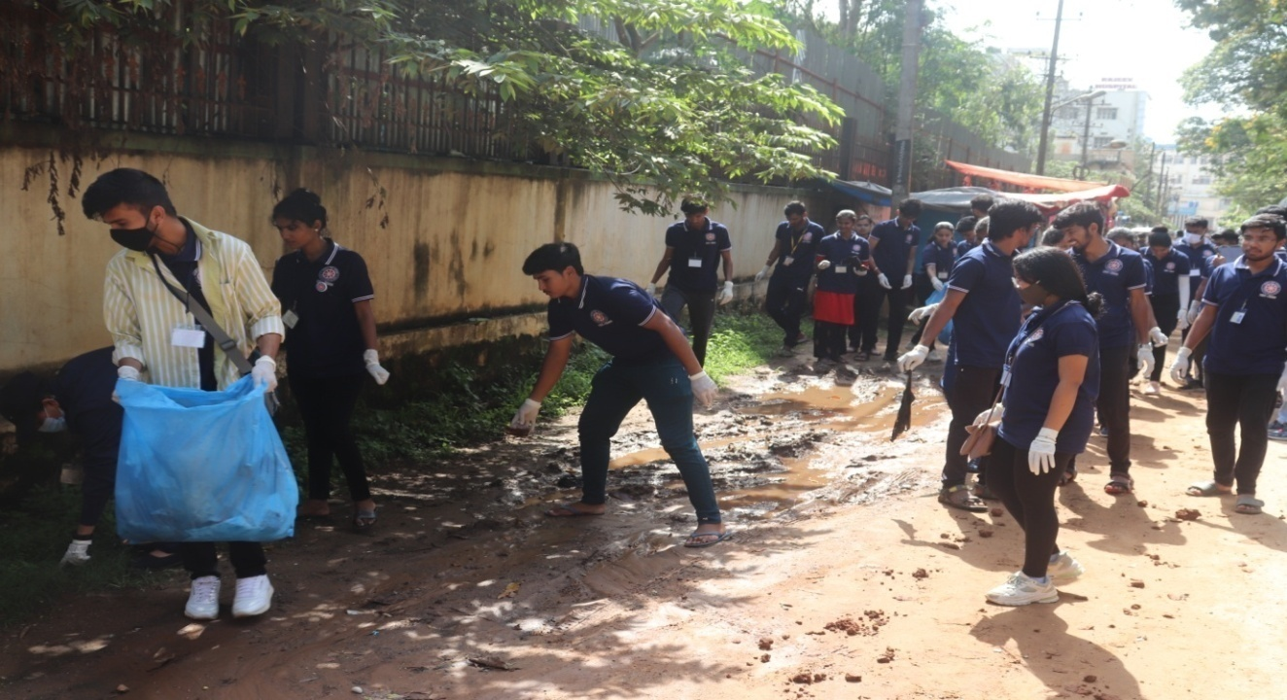
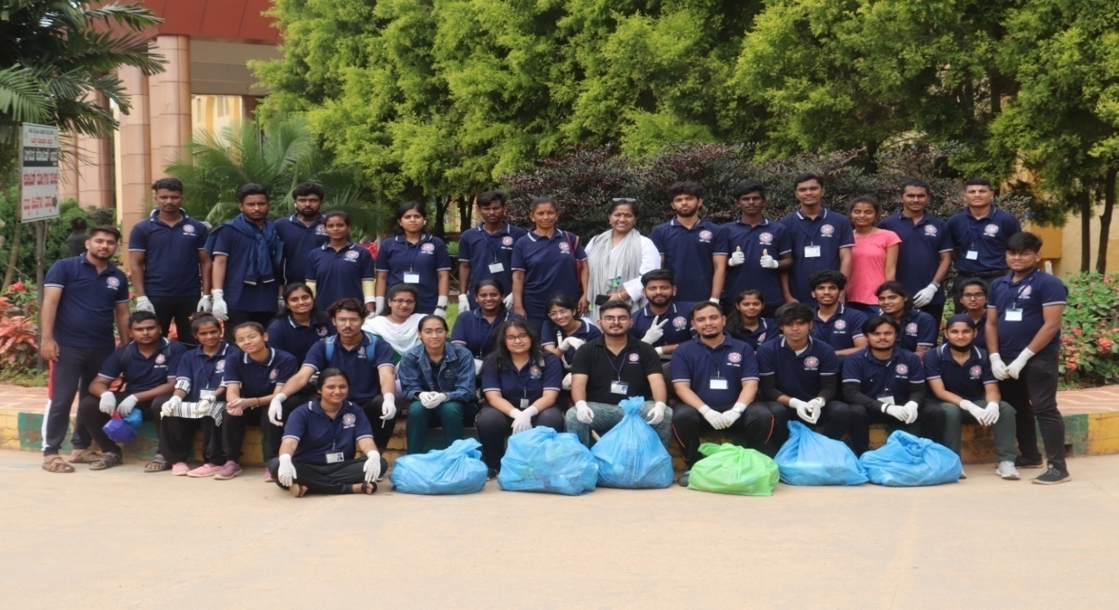
After the lunch NIC participants were taken to visit anatomy, forensic medicine, pathology, Community medicine and microbiology museums of HIMS, Hassan. Visit of the medical college's museums, was to expand knowledge base and instill a scientific fervor in young minds. 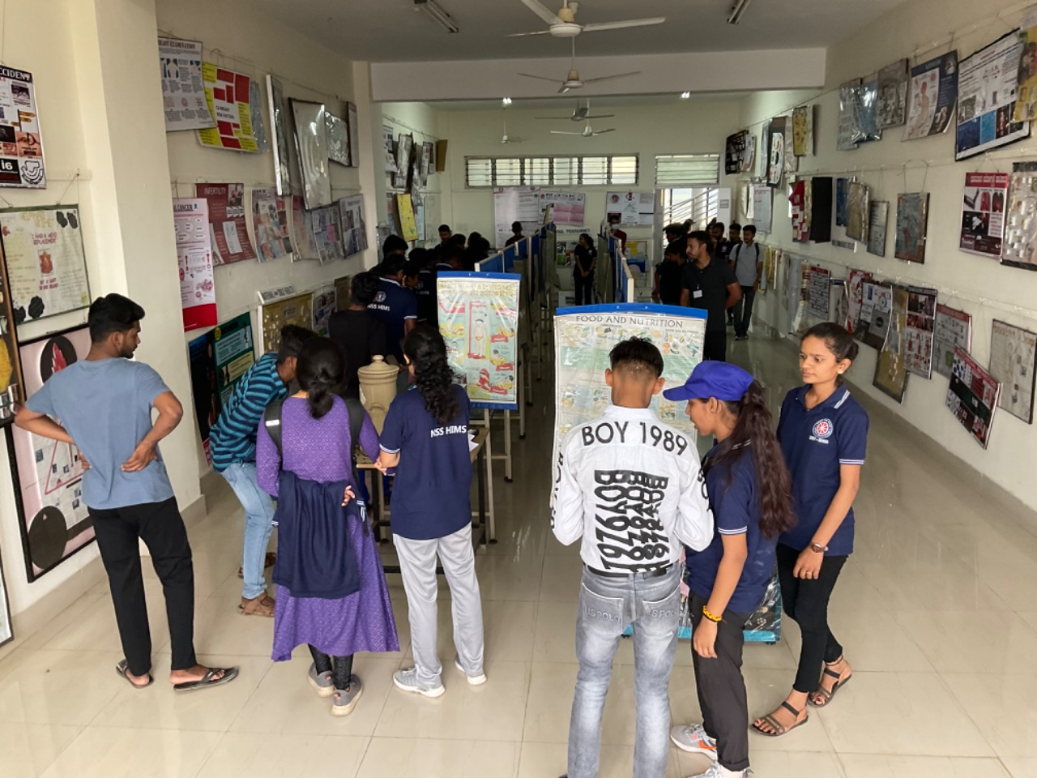
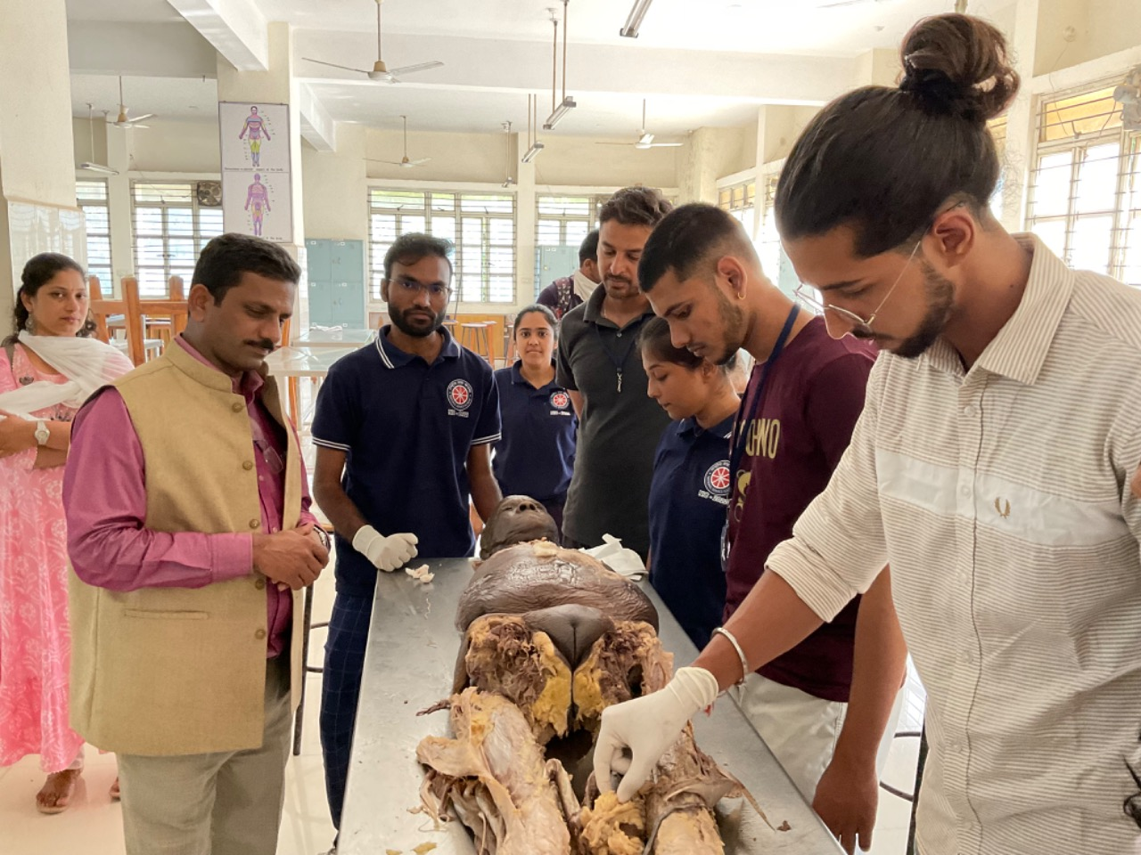
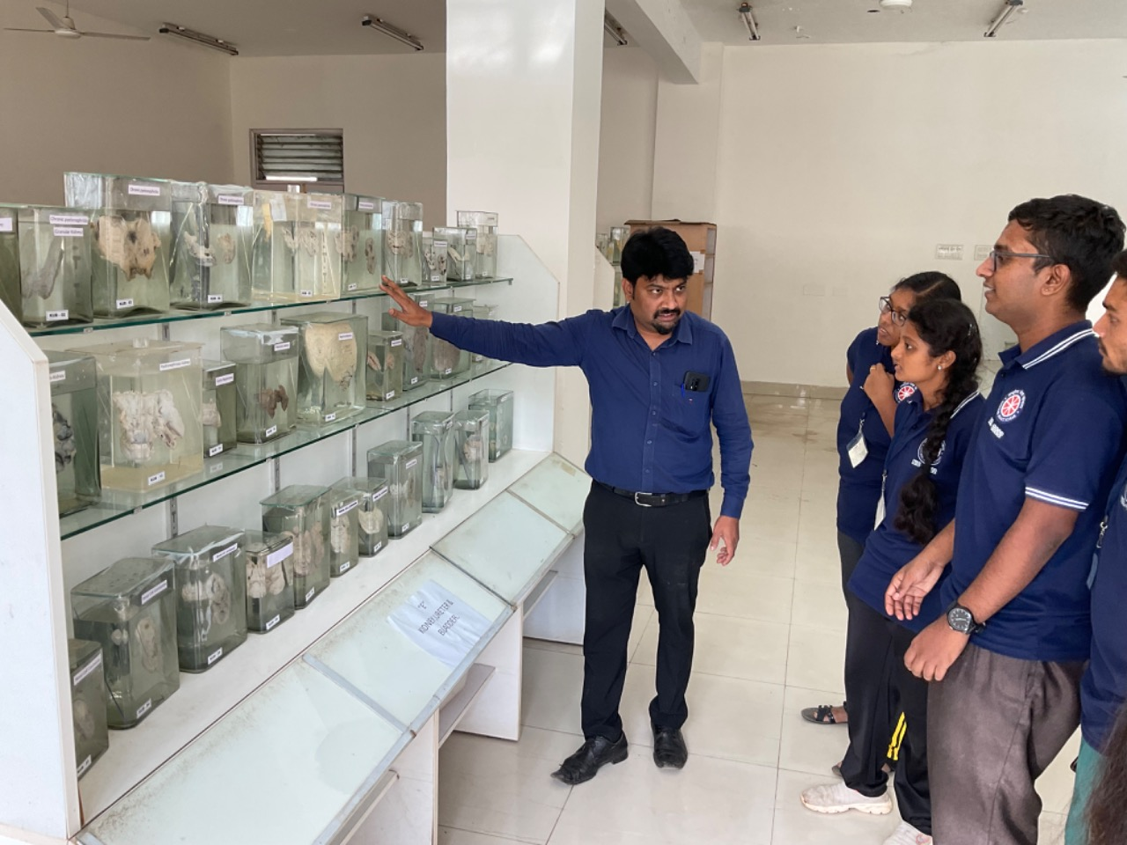
After Snacks, the cultural program resumed to exhibit the different cultures and traditions across the country.
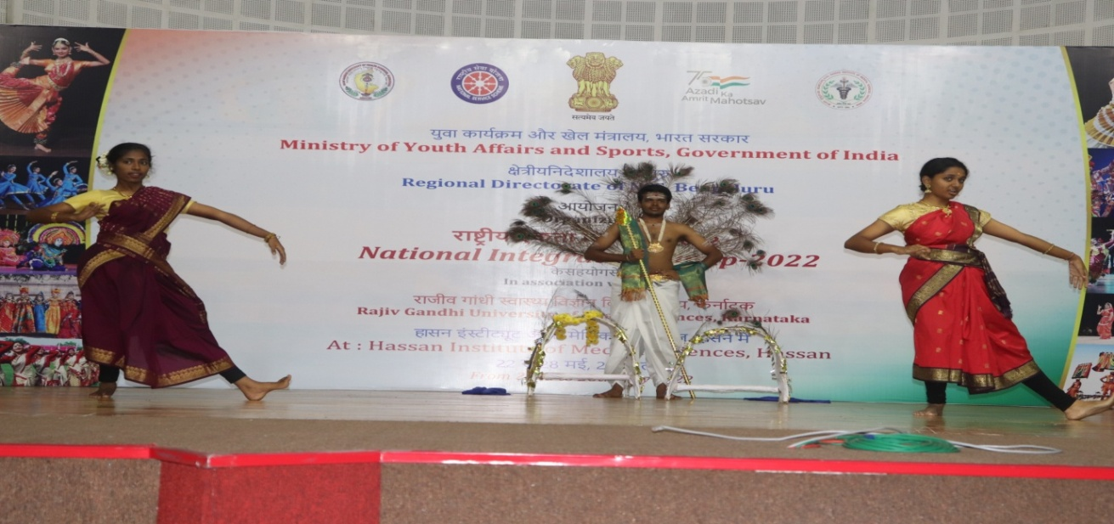
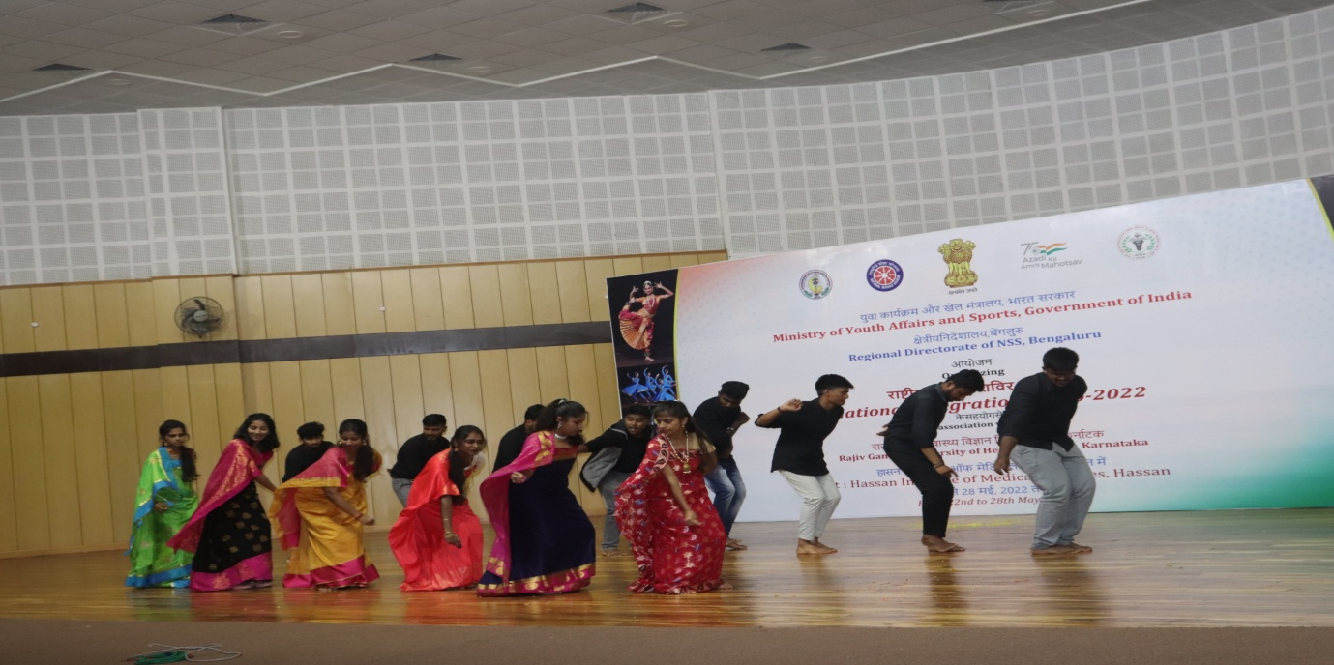
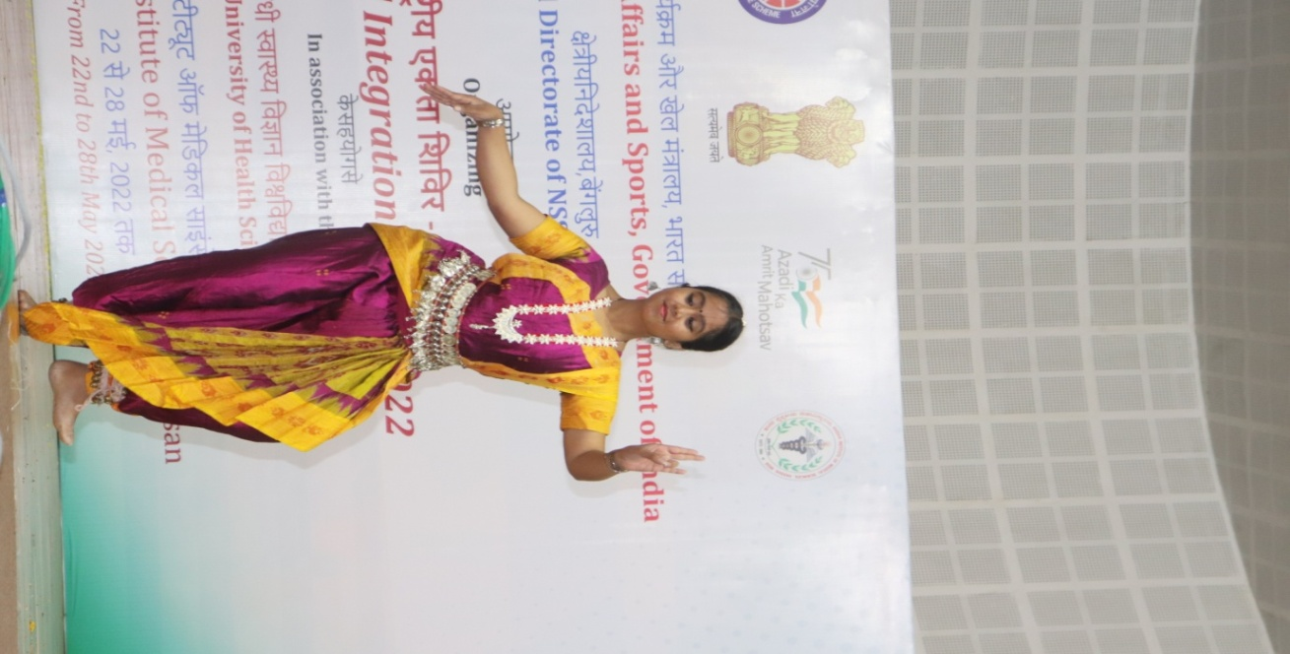
Date: 26-05-2022 Day: Thrusday
Today, Dr. Praveen G, RMO HIMS, Hassan hoisted the flag, addressing the NIC participants, he threw light on role of youth in nation building and their overall personality building.
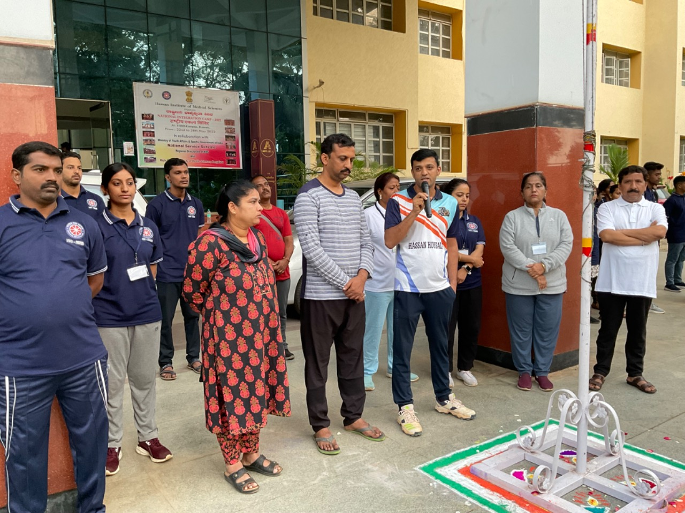
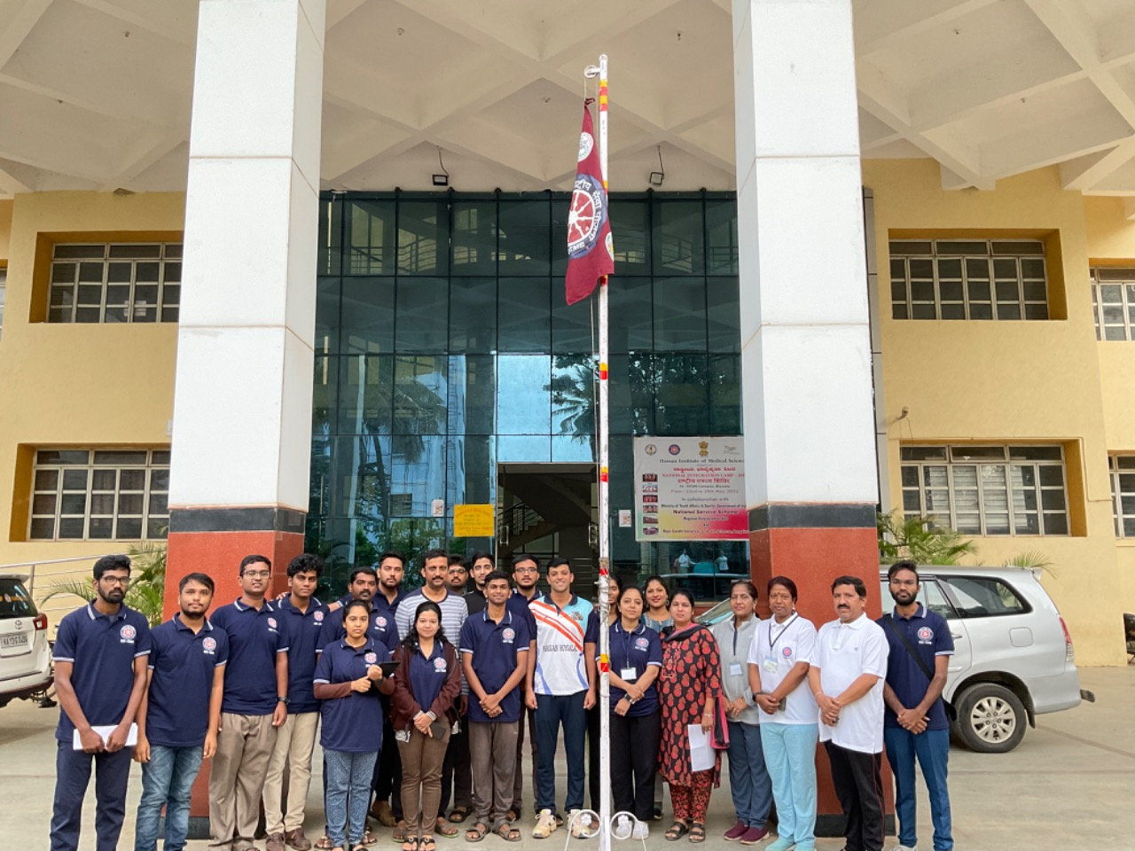
Thereafter the yoga session was conducted by Dr.Gurubasavaraju.
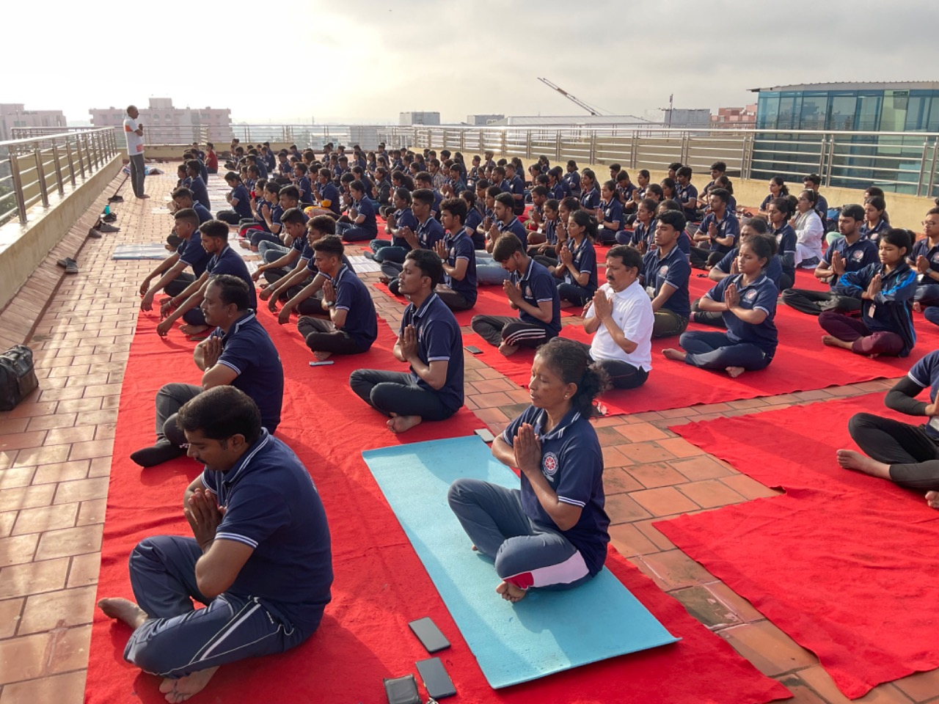
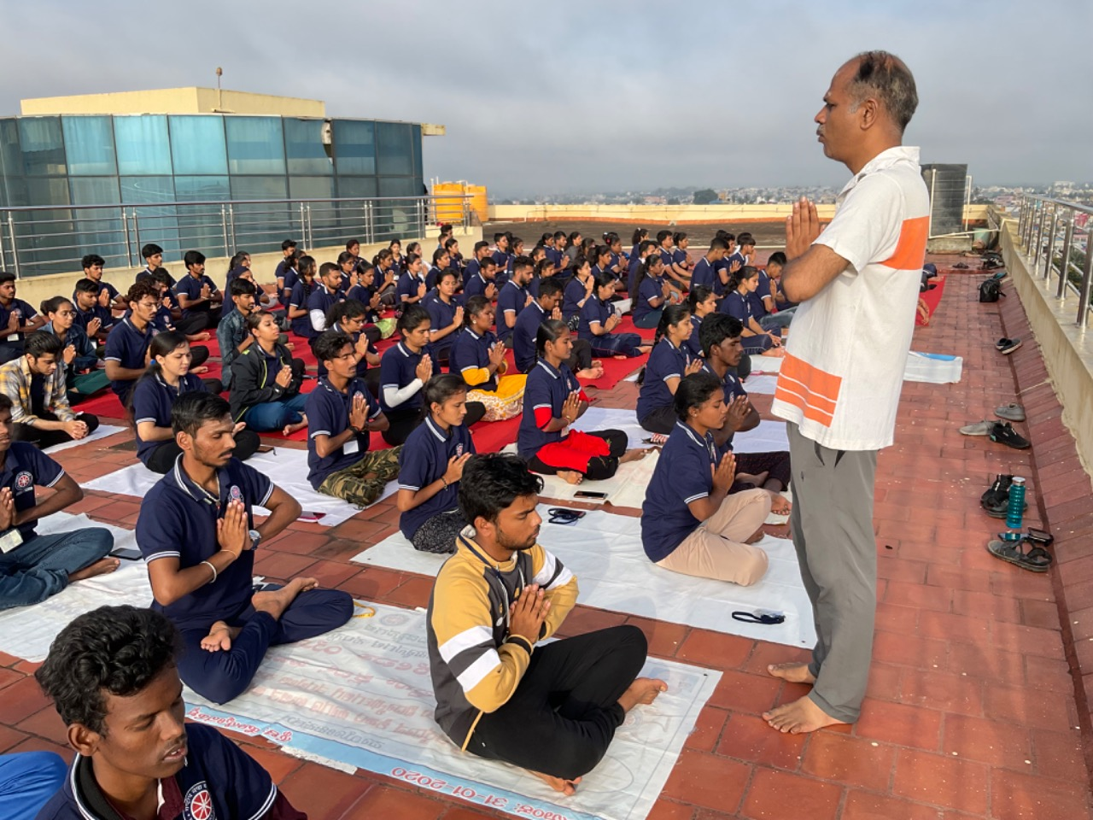
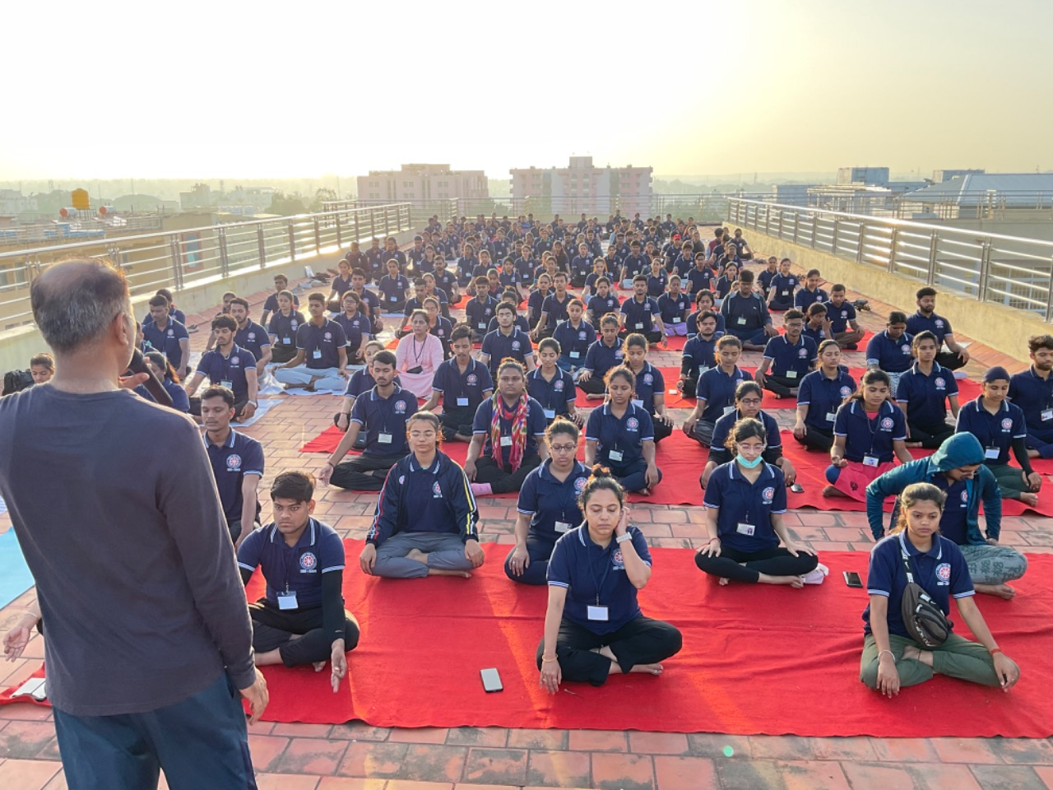
After breakfast all the participants visited Kasturba Gandhi Ashram in Arsikere. We all witnessed the beautiful Ashram. Professor G B Shivaraj, Trustee, Kasturba Memorial Trust, Arasikere, spoke about the importance of quality education and how to apply Mahatma Gandhiji’s teachings in life.
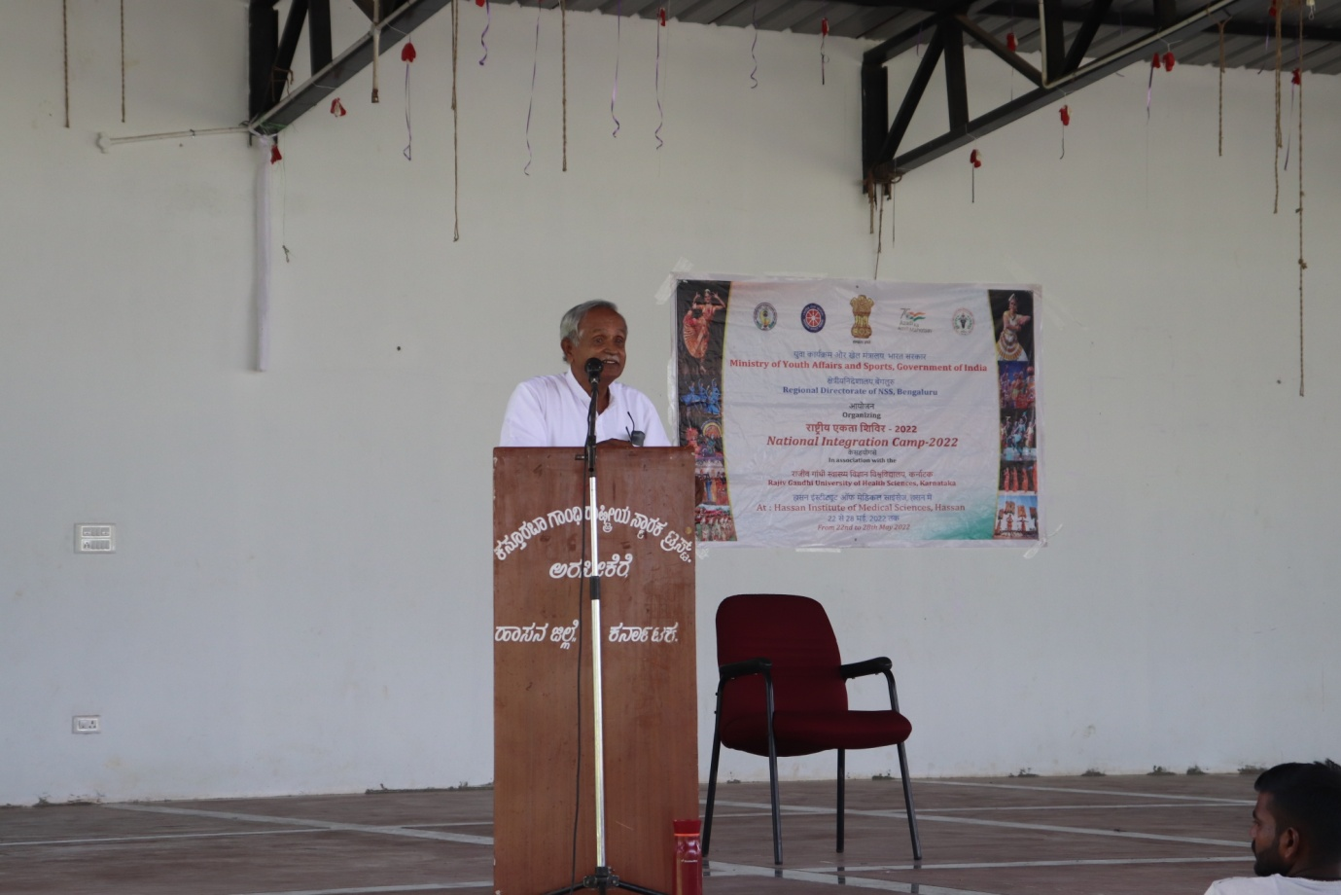
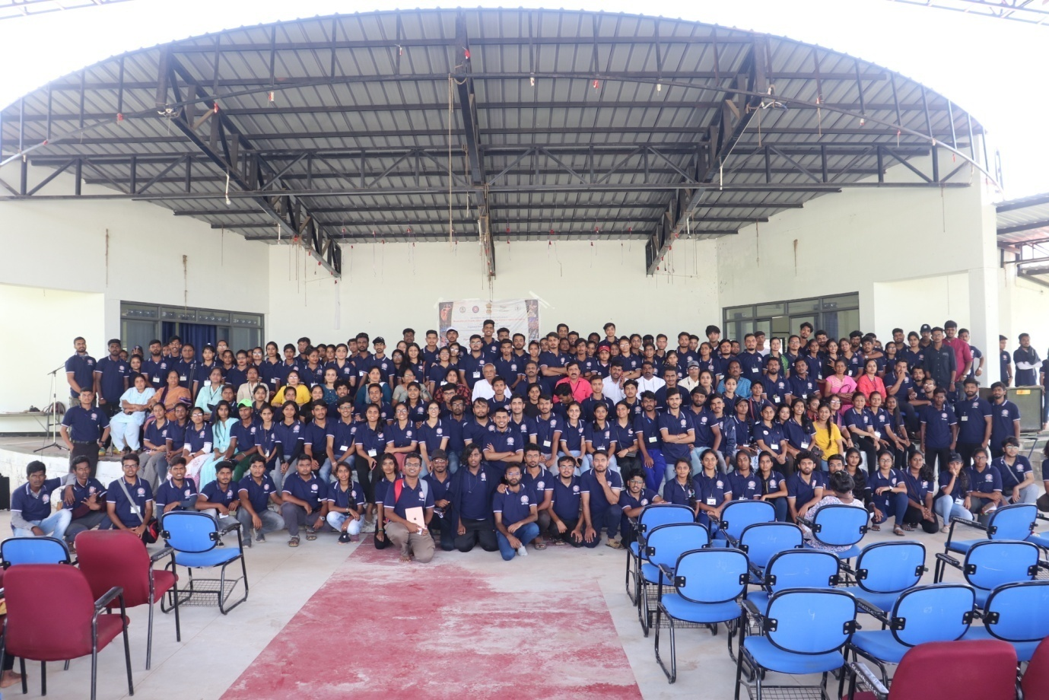
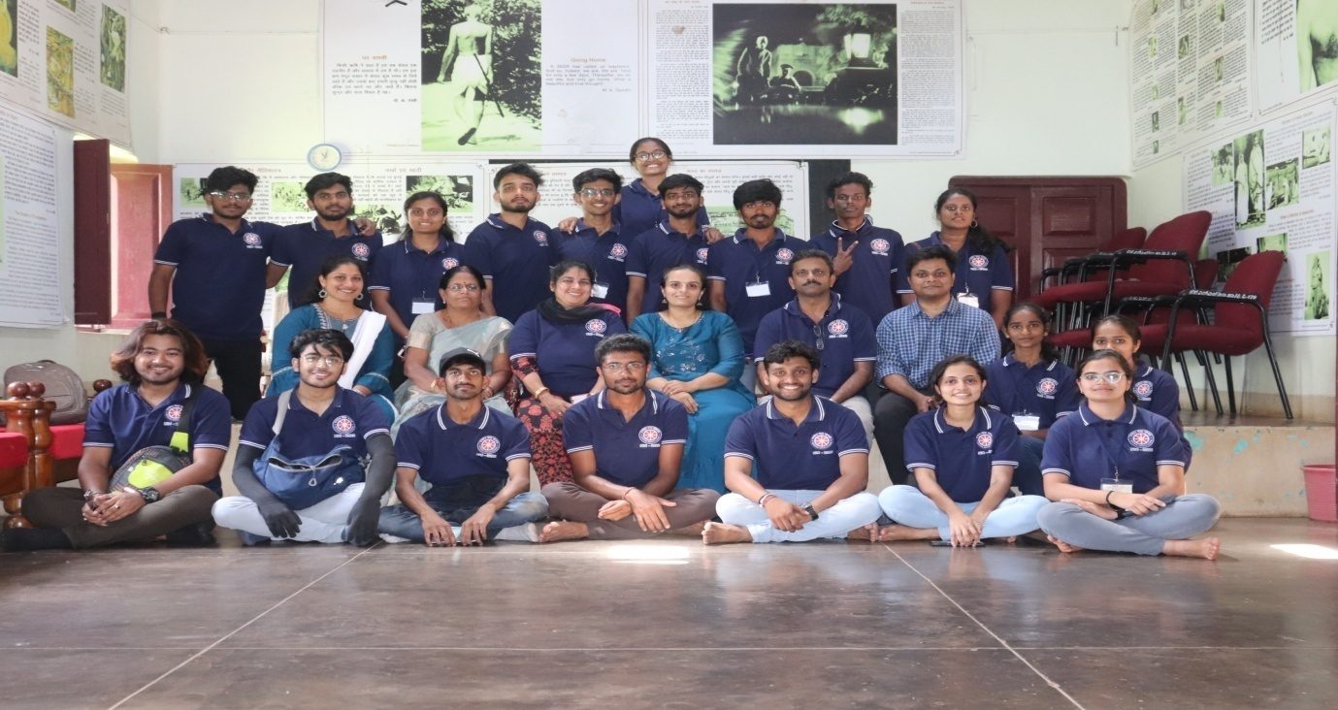
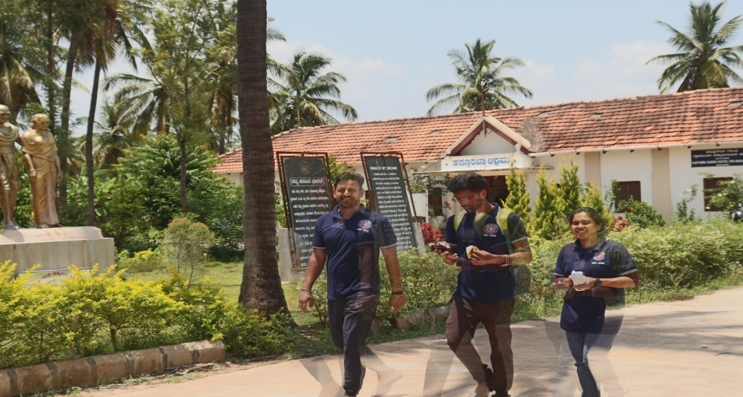
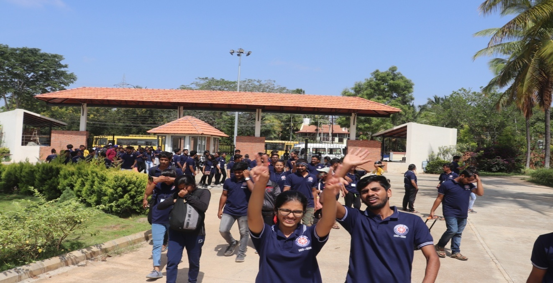
After lunch all participants visited SDM Ayurveda College, Hassan. They were introduced to Ayurveda and its various branches.
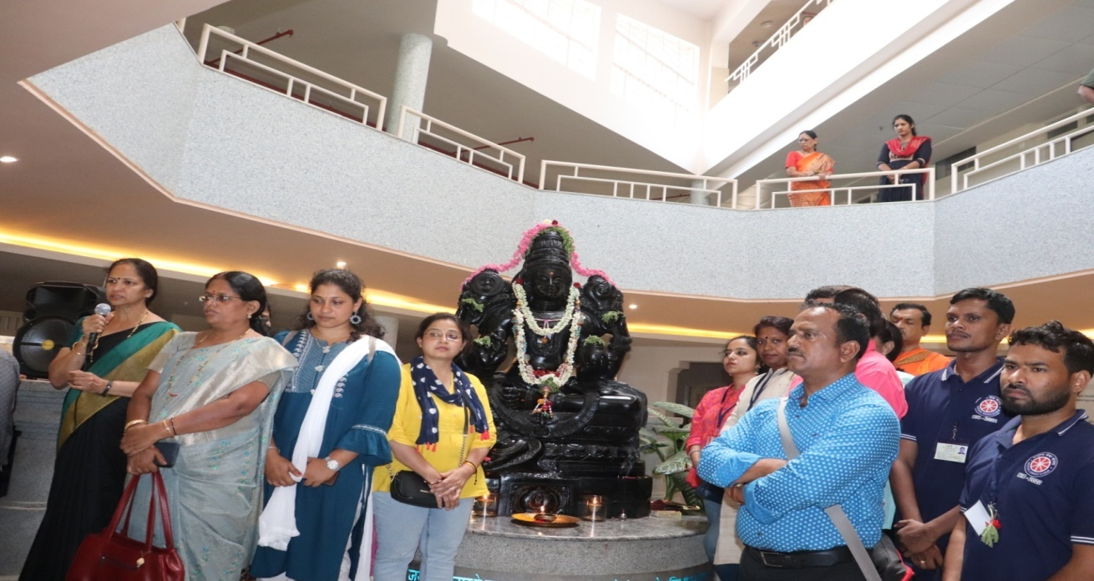
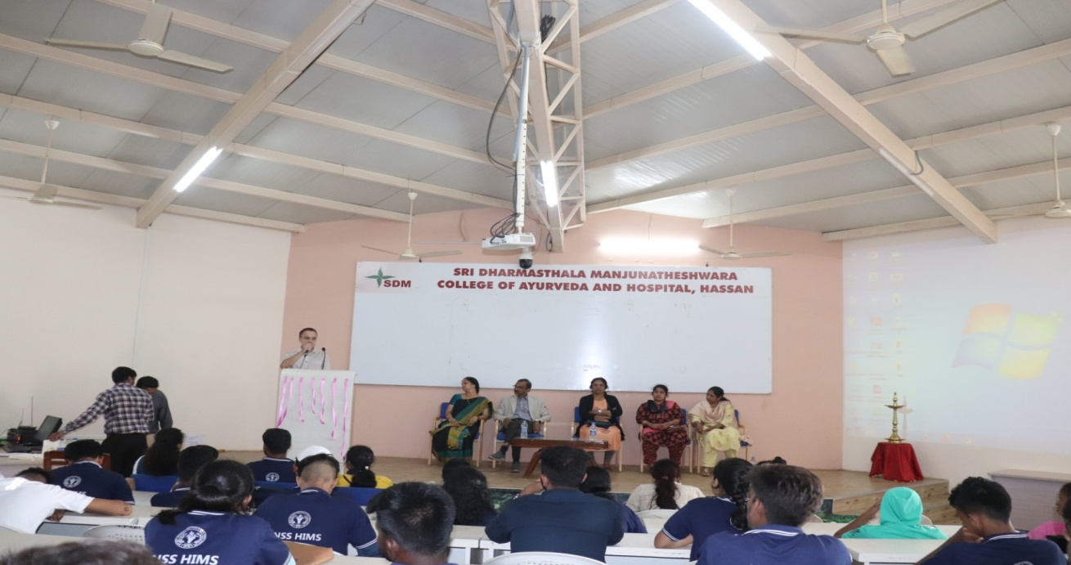
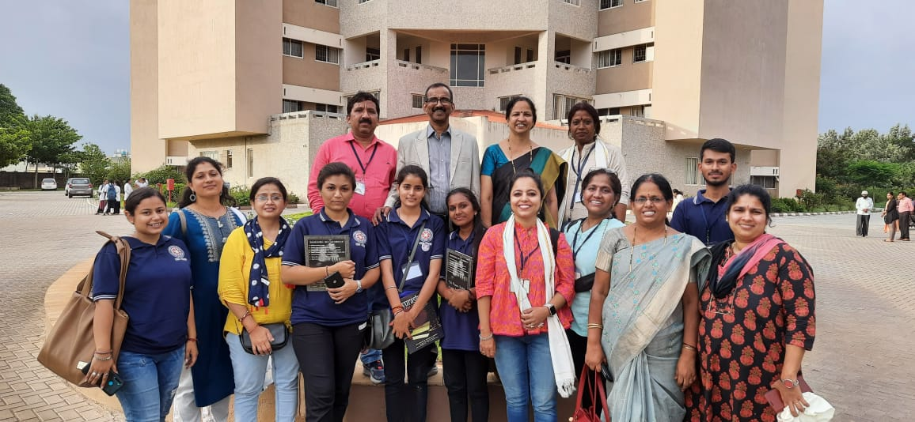
After snacks the cultural program continued to spread the colors of integration at the national integration camp.
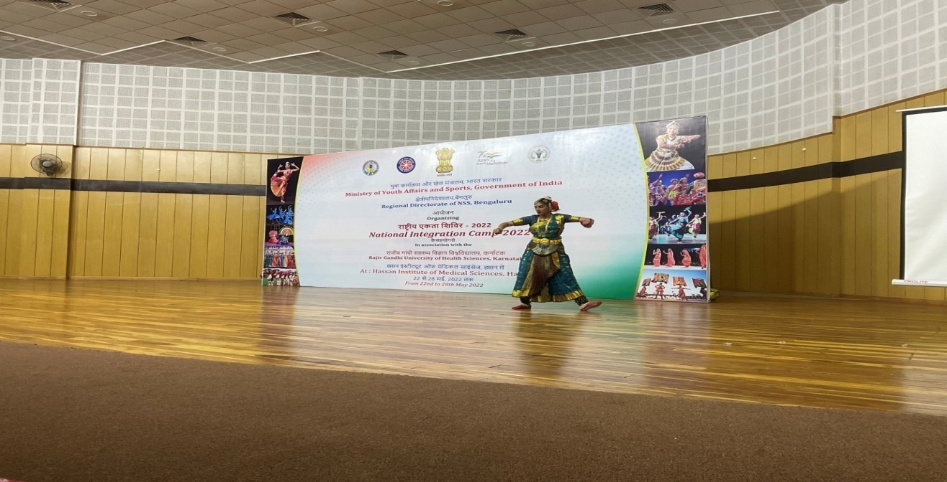
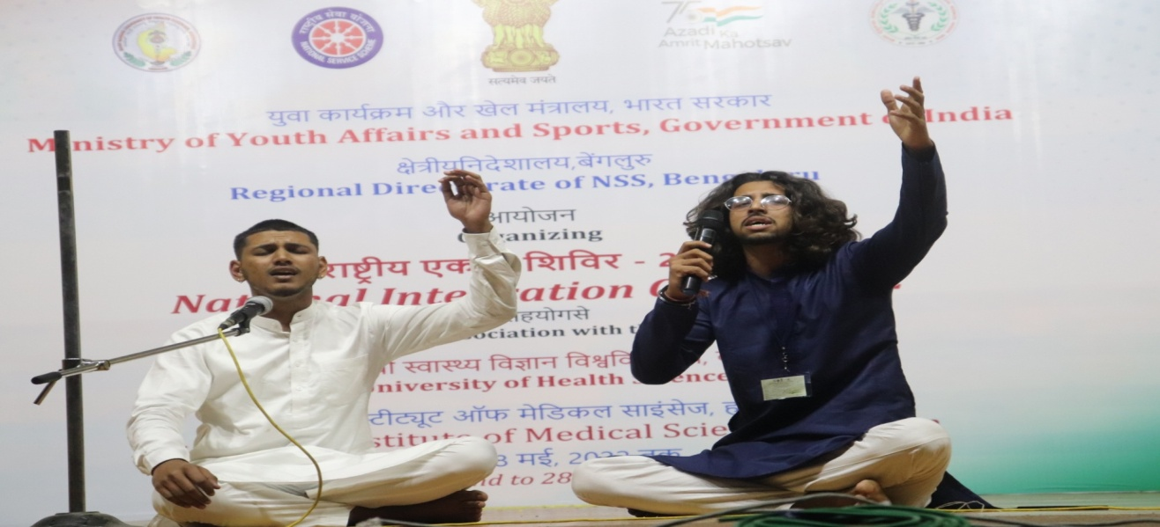
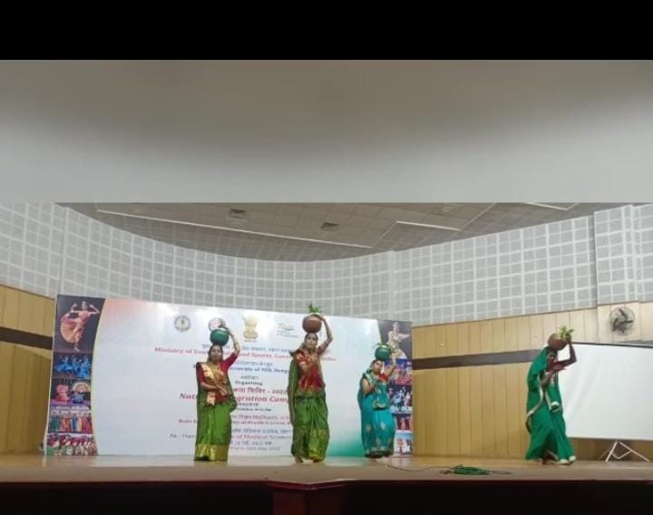
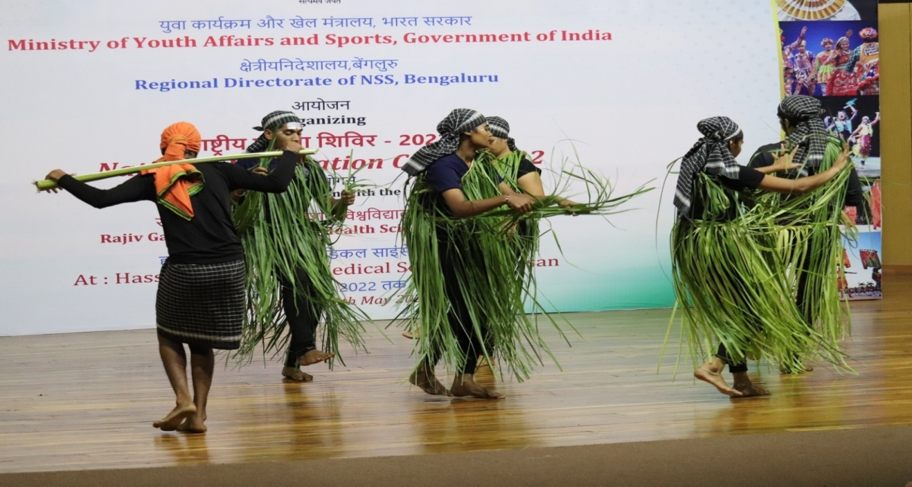
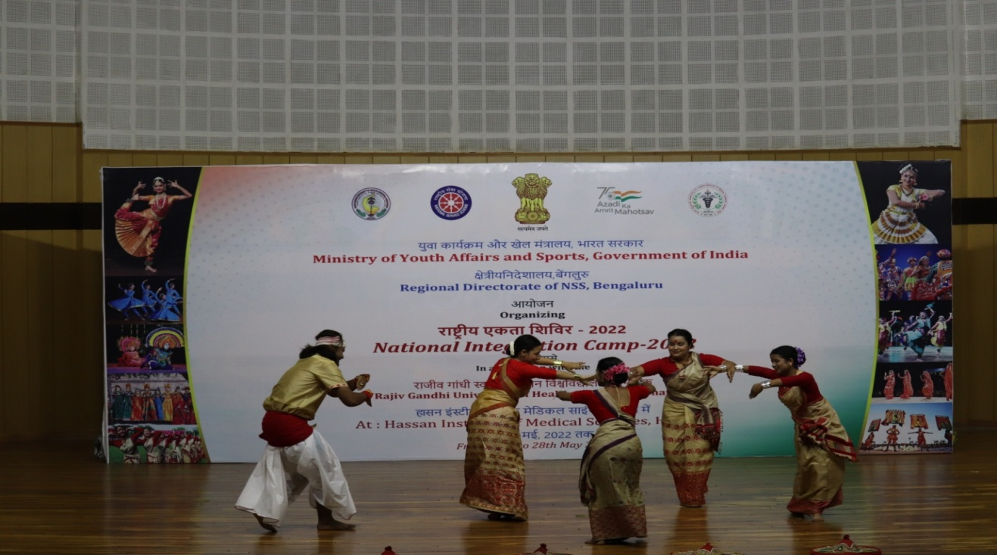
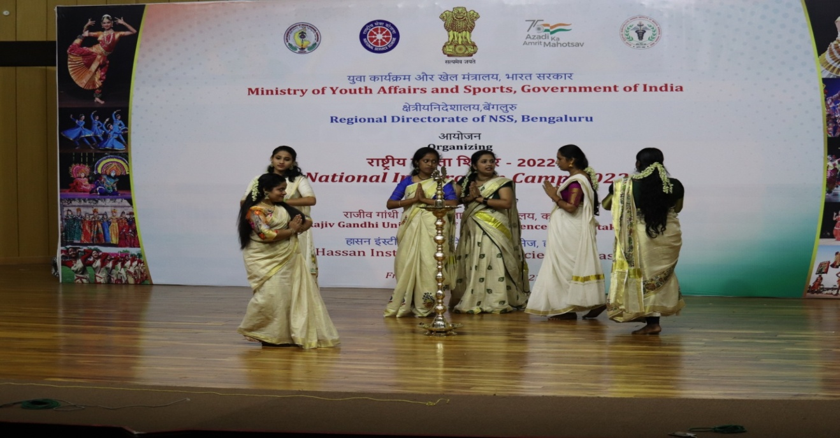
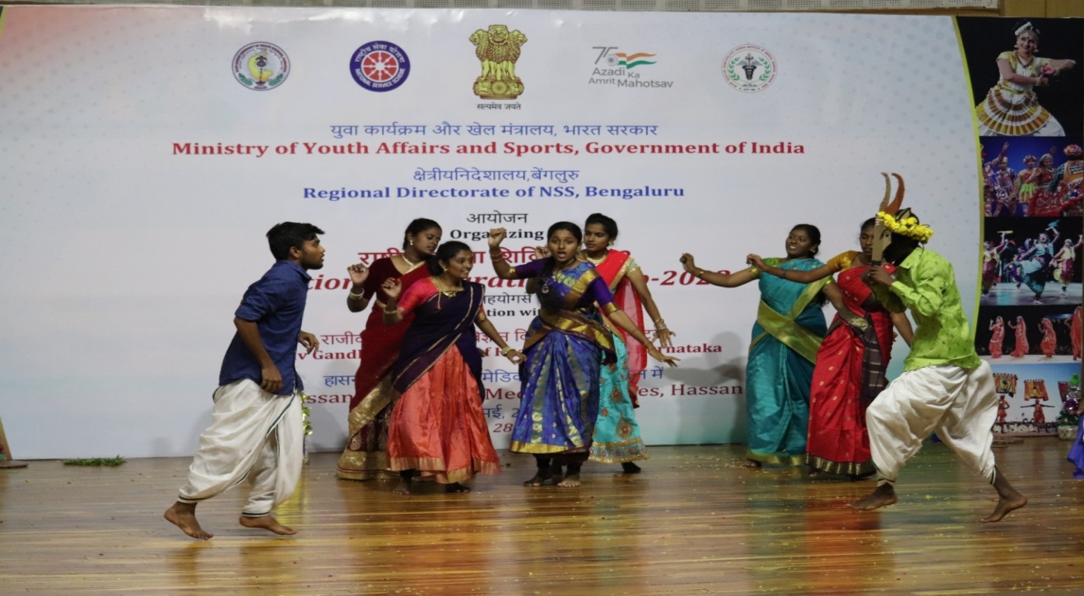
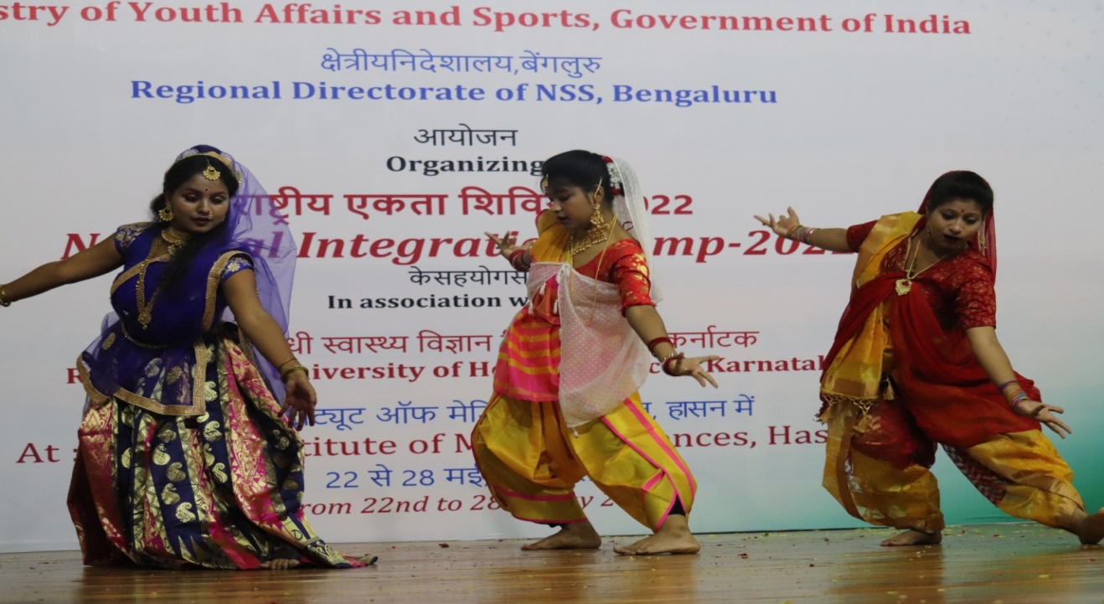
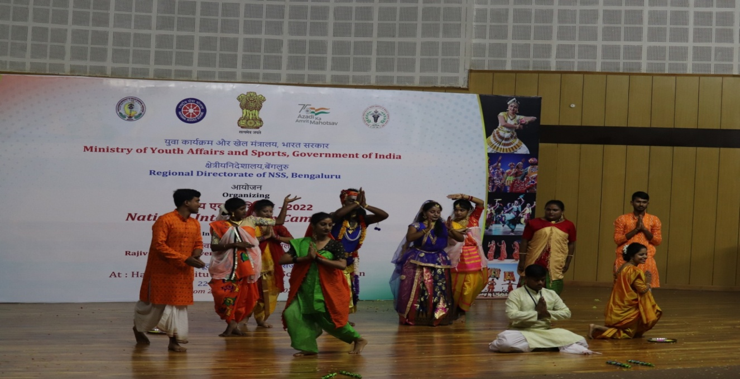
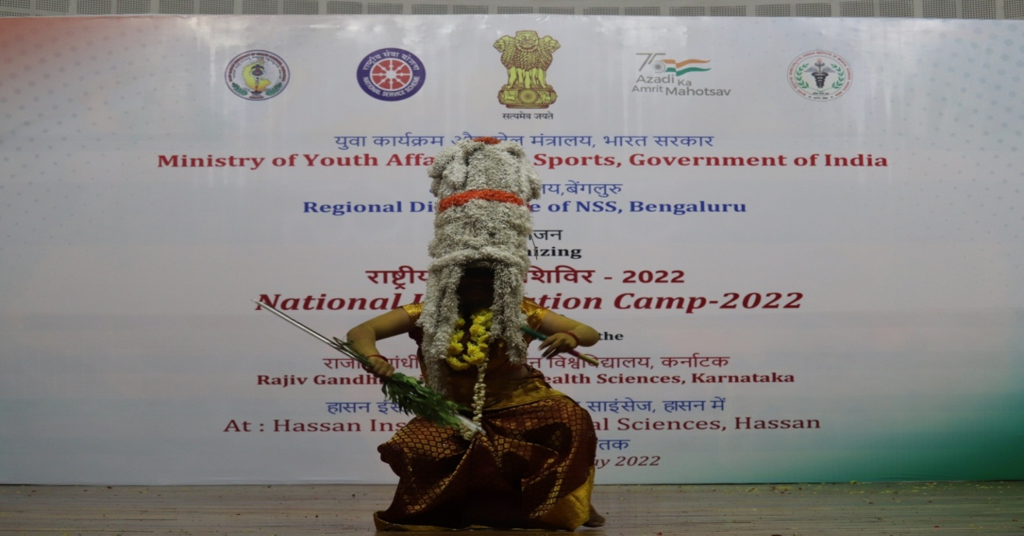
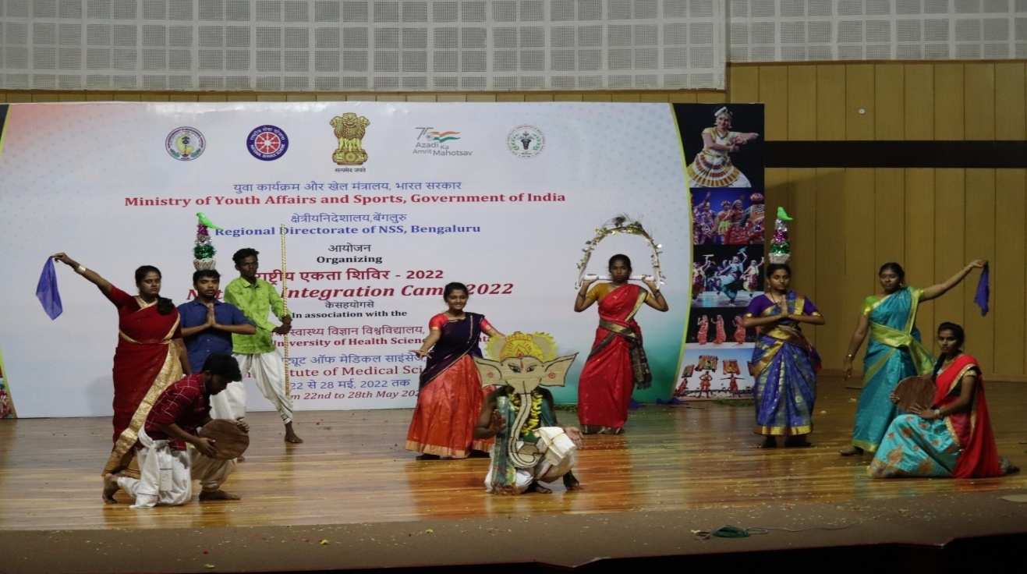
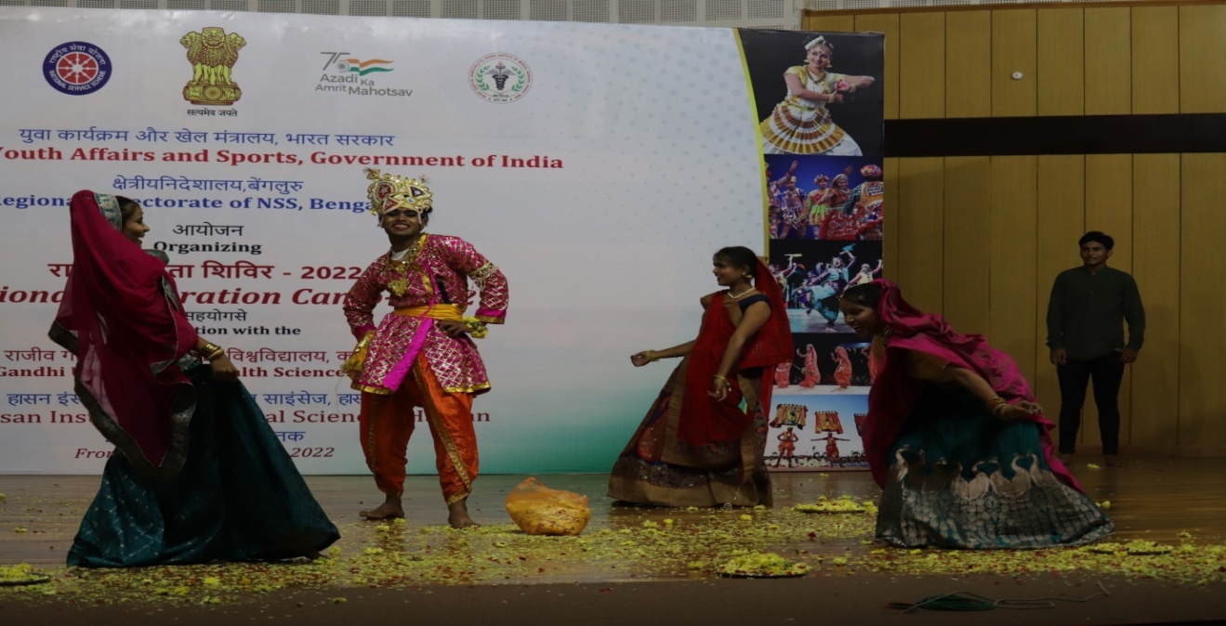
Date: 27-05-2022 Day: Friday
This morning the flag hoisting was done by Dr. Tejaswini Gowda, KAS, Assistant registrar, Cooperative Society, Hassan and she spoke a few words on the importance of patriotism among the youth.
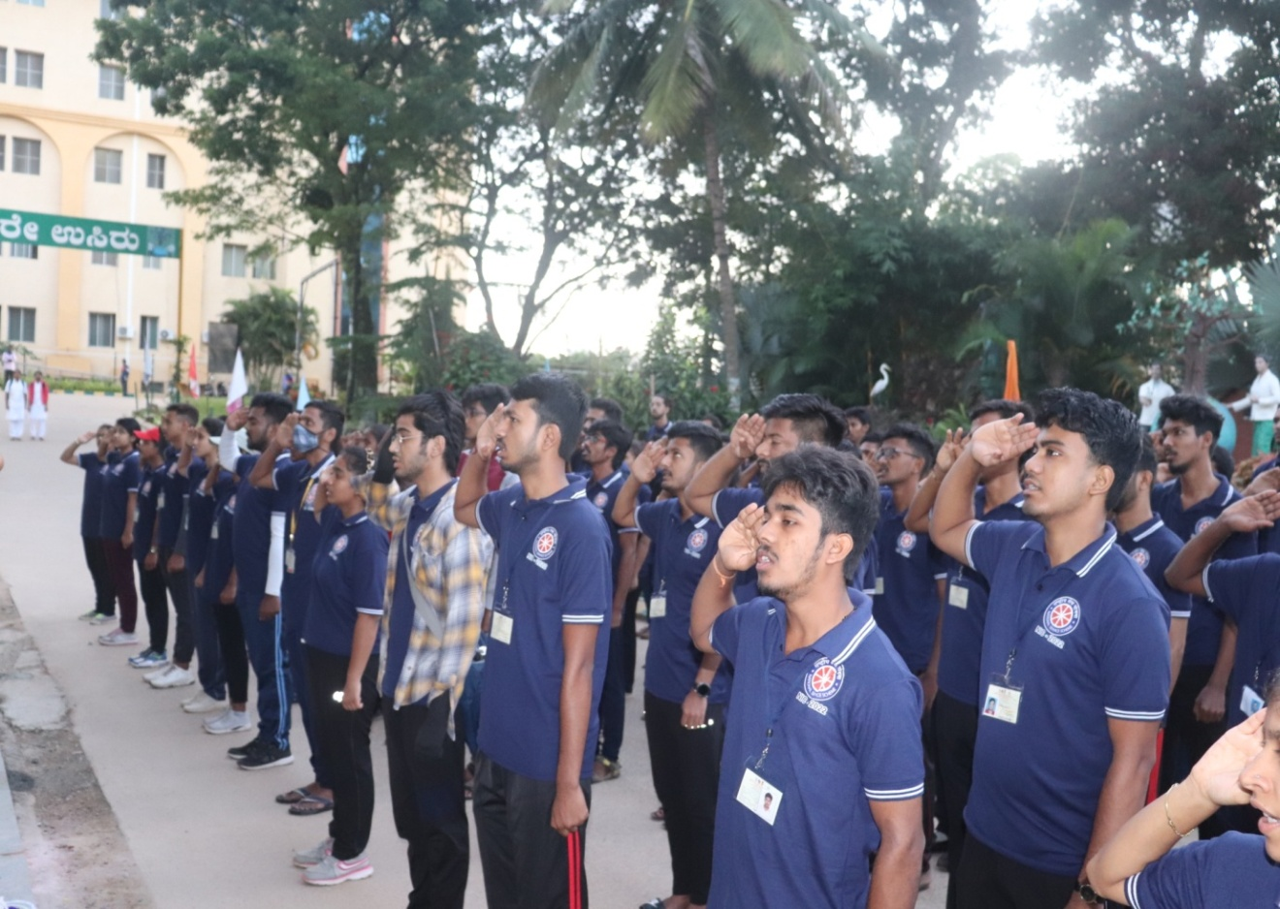
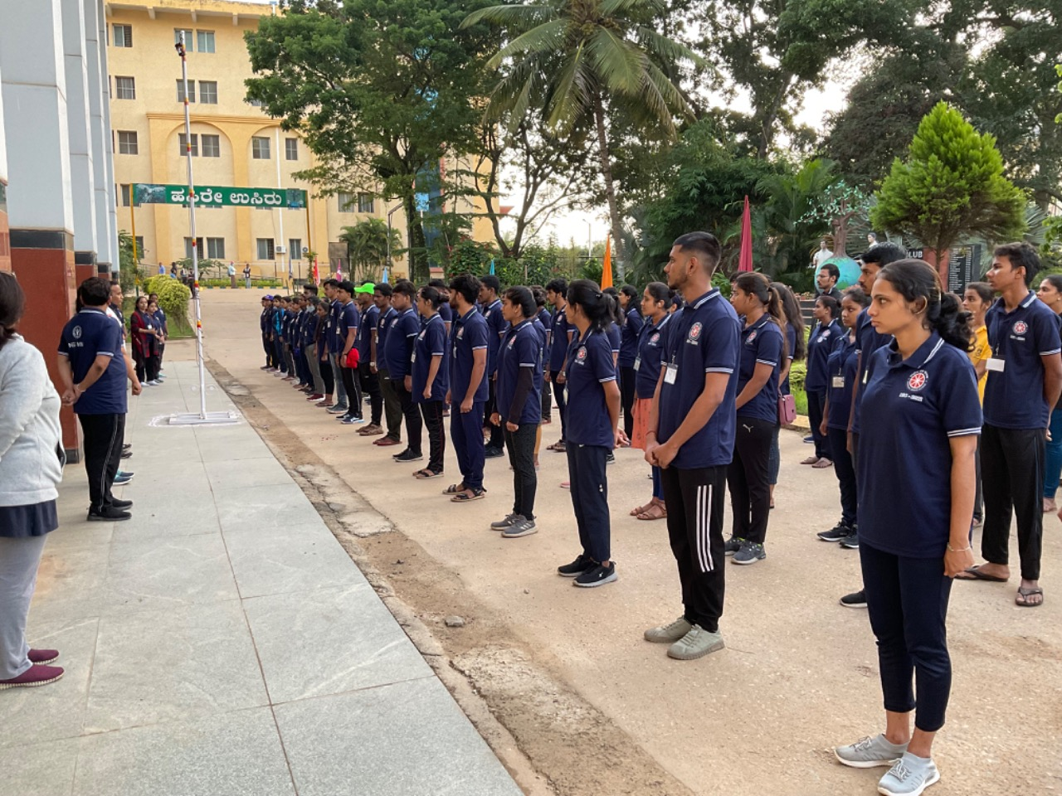
Soon after the flag hoisting, all the participants were taken to visit Shravanabelagola. All the efforts of climbing the hill top felt fruitful when we witnessed the gigantic glorious 57 feet tall statue of lord Bahubali.
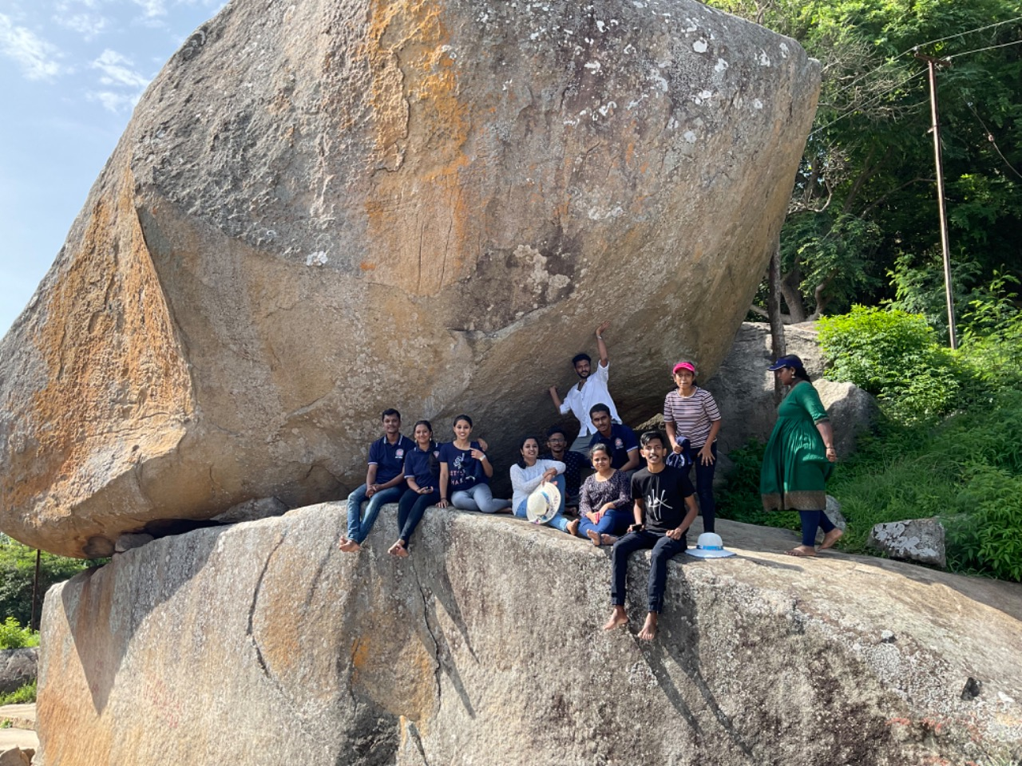
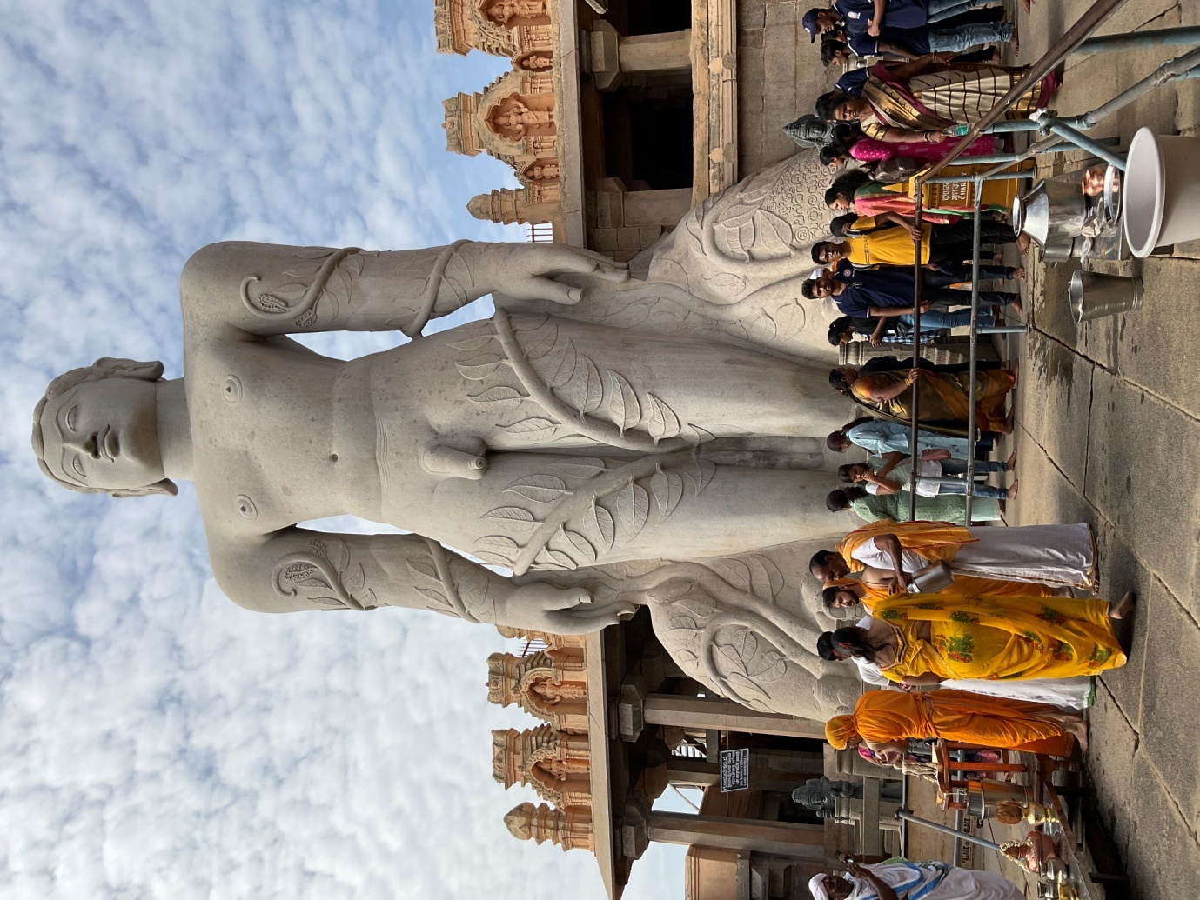
After that, we visited Mavanur. We enjoyed the mesmerizing beauty of the nature and nature friendly windmills.
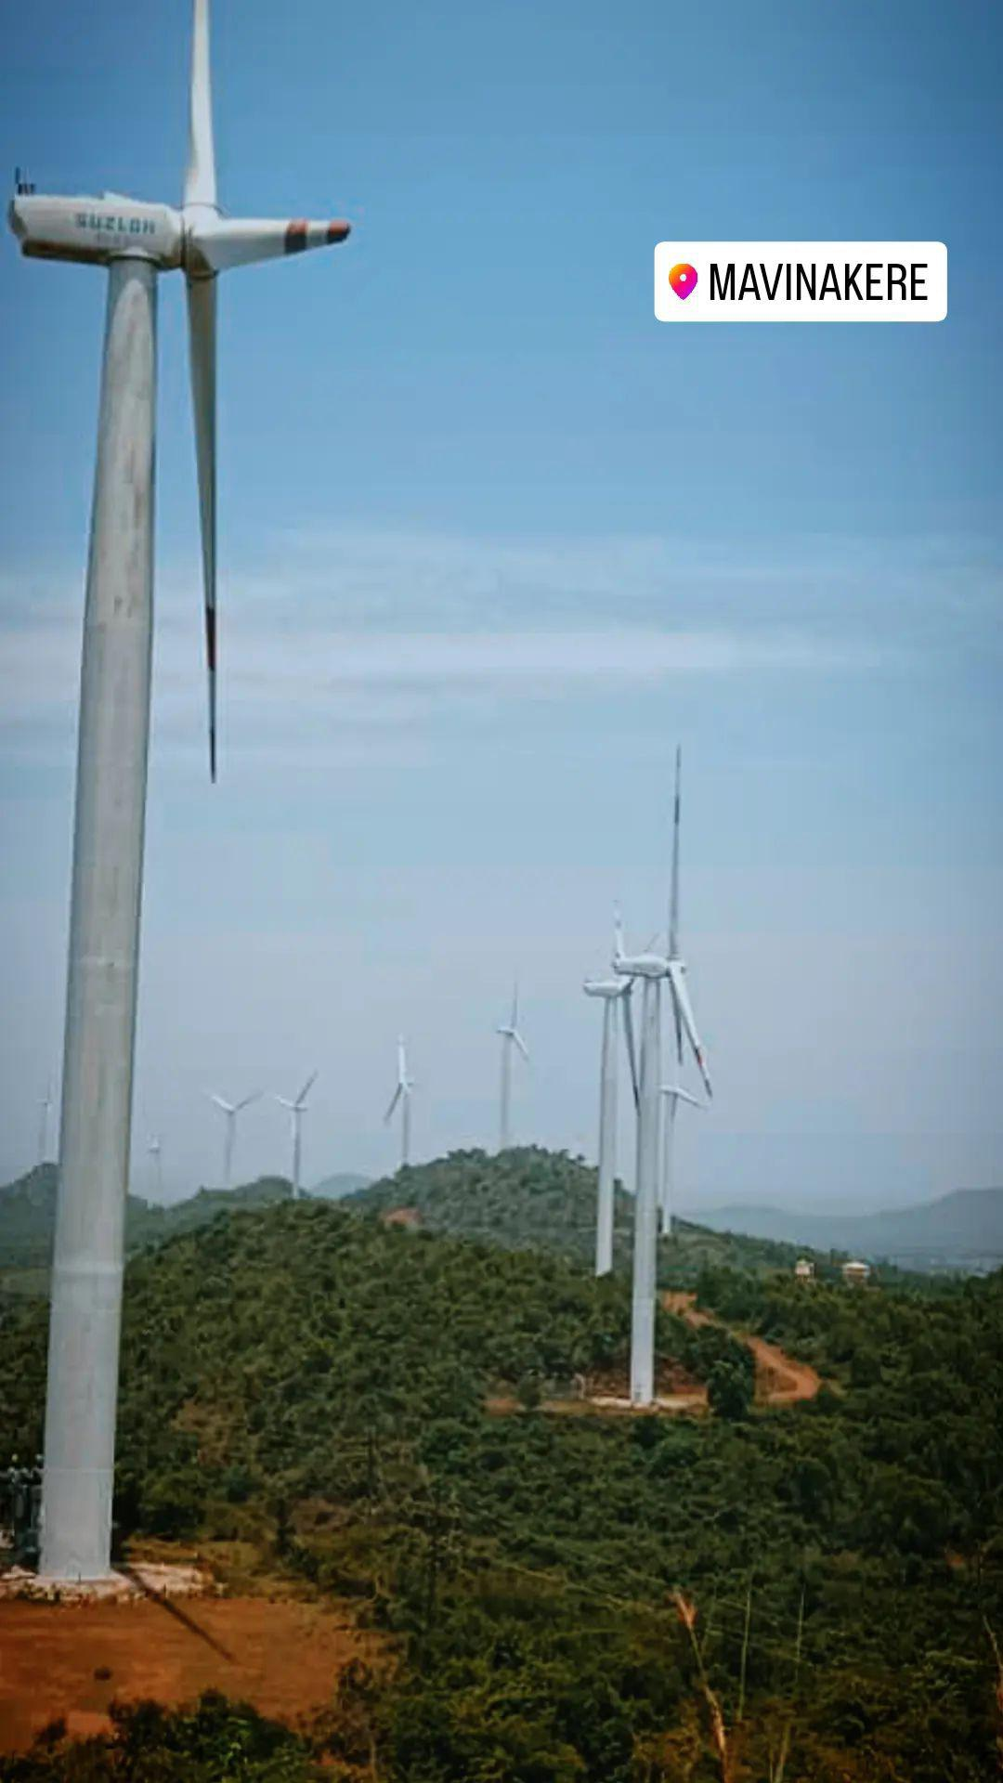
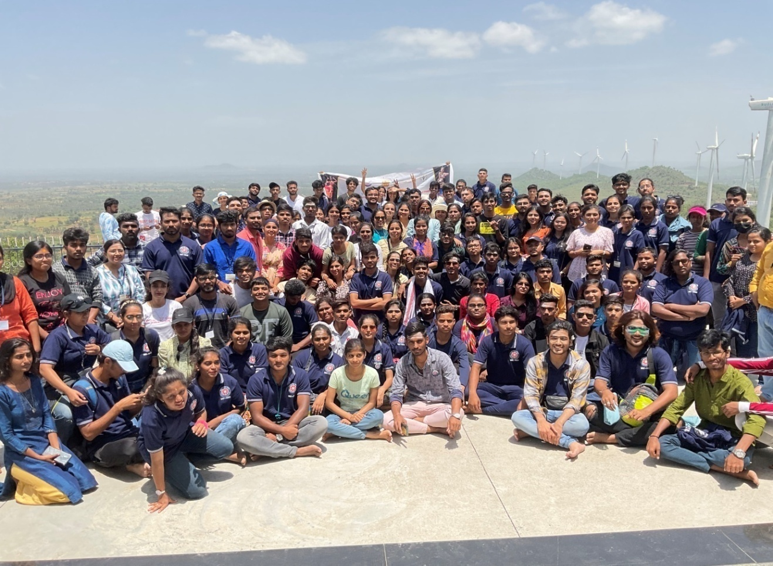
After lunch in the college campus, participants visited the world famous Belur temple. They witnessed the architectural and cultural marvel of the Hoysala dynasty.
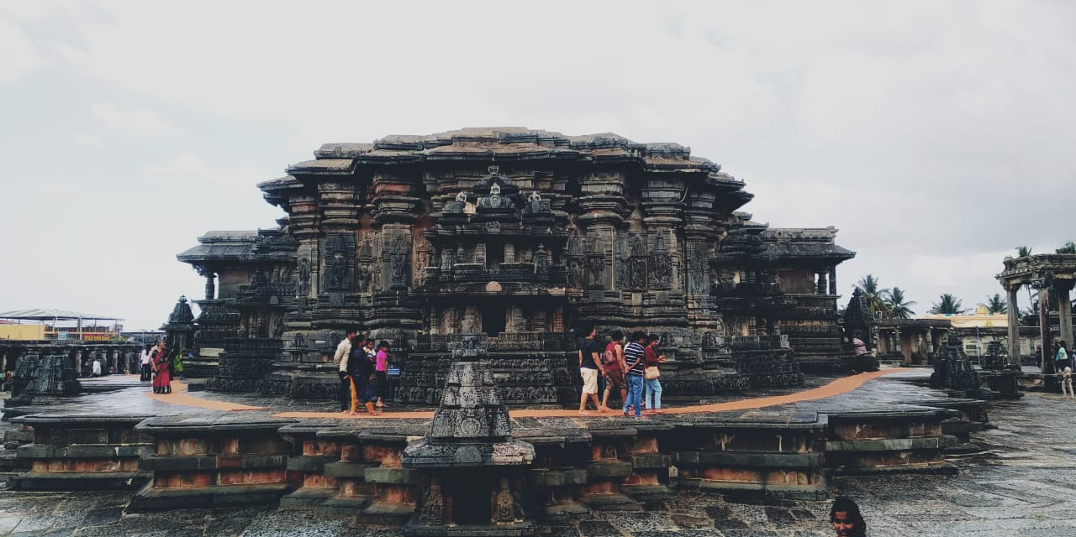
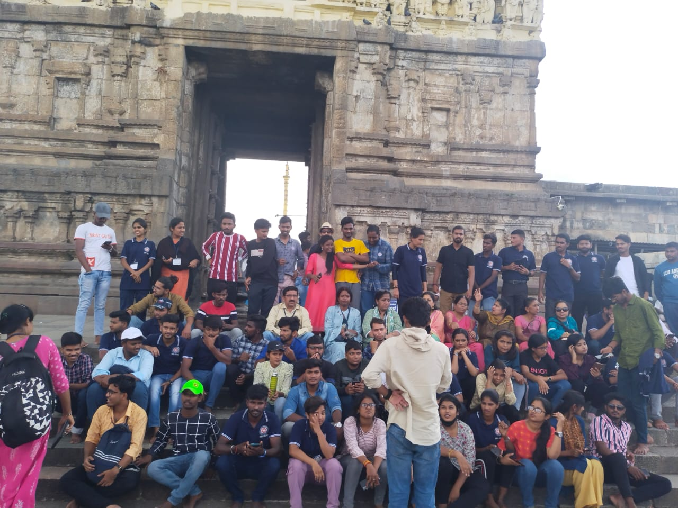
In the evening the students of HIMS Hassan, Nursing College and SDM Ayurveda College, performed in the cultural fiesta.
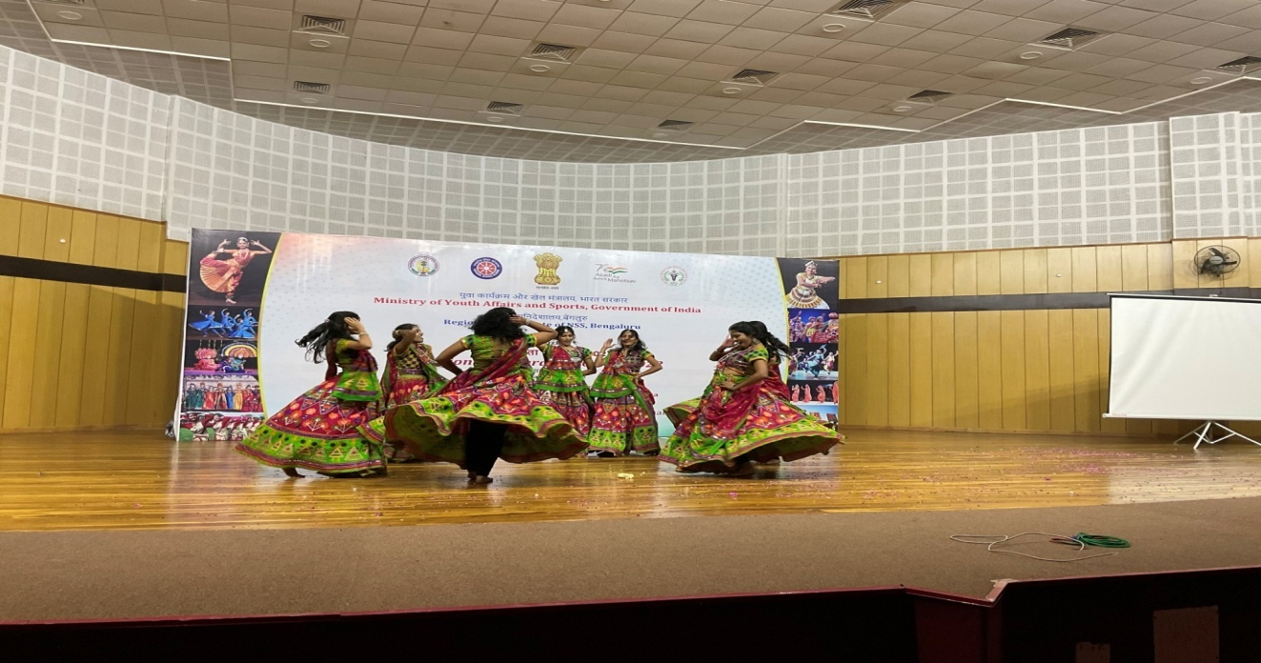
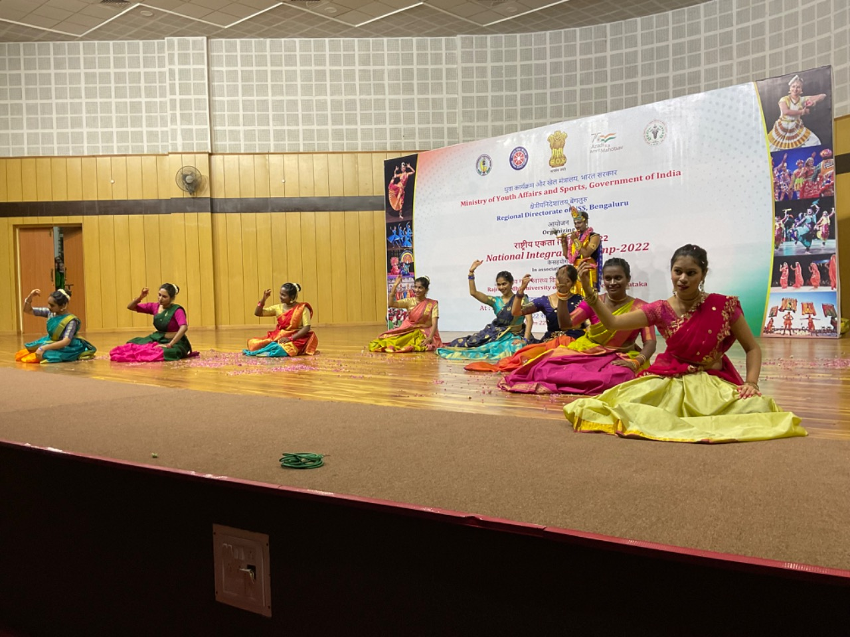
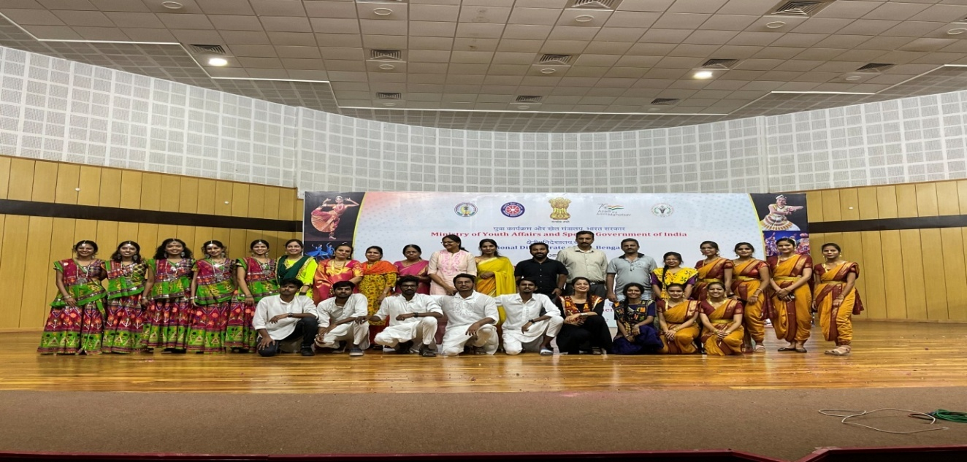
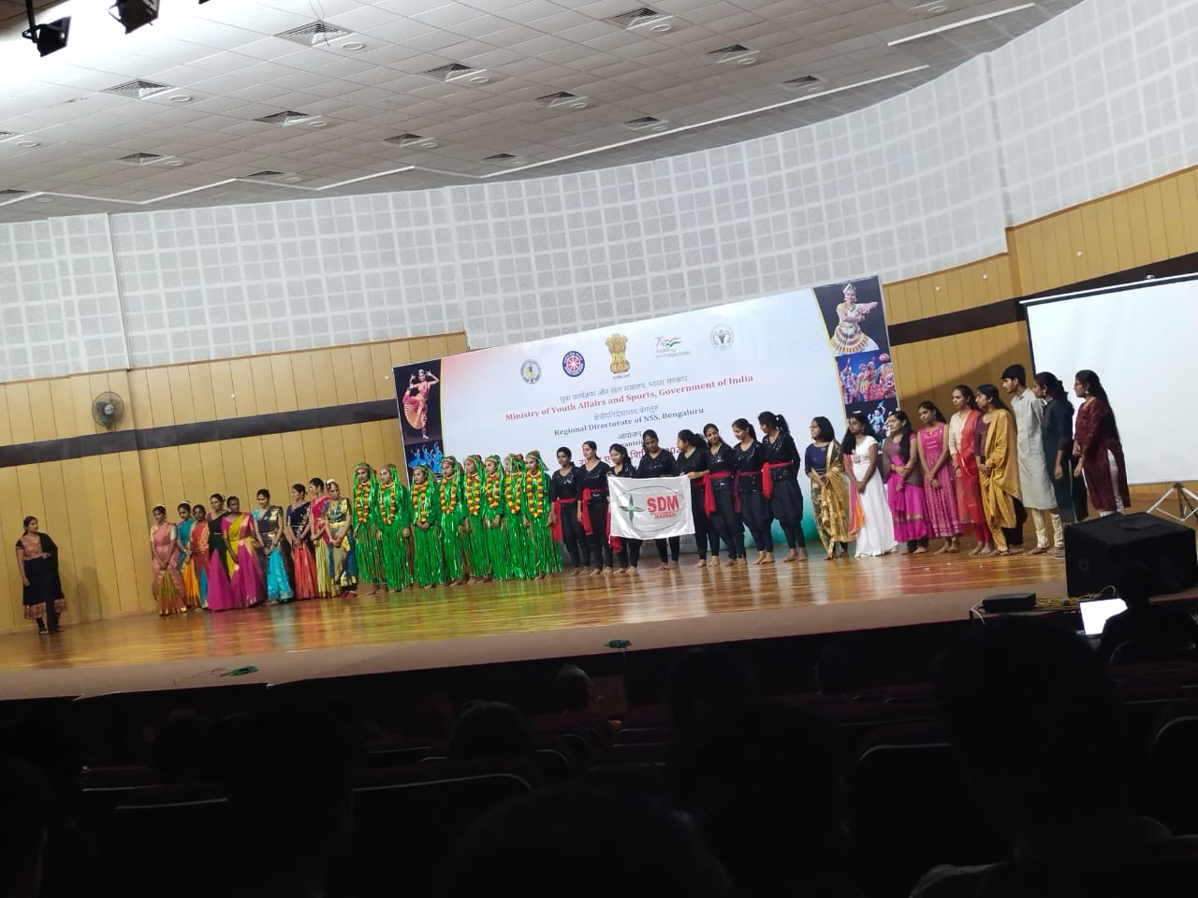
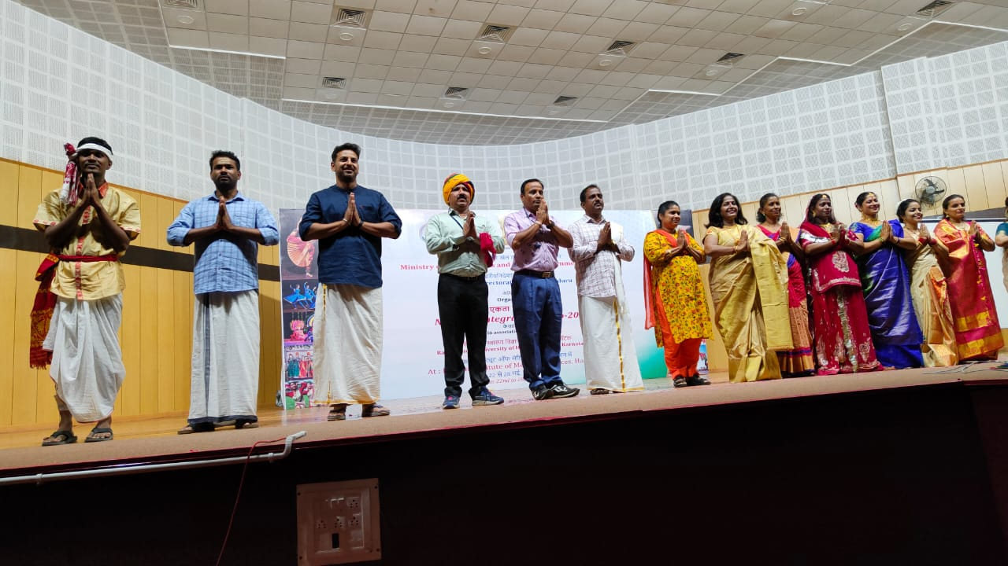
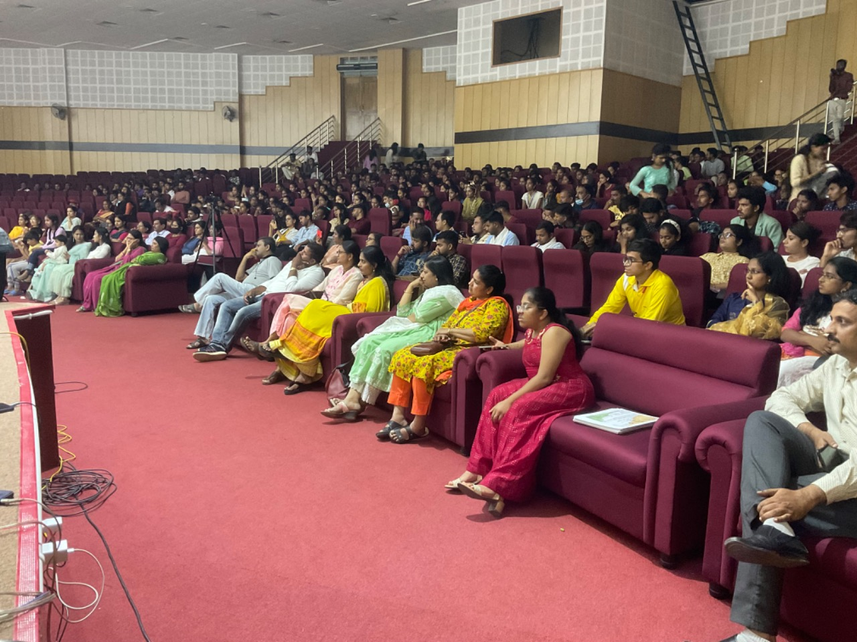
Date: 28-05-2022 Day: Saturday
On the last day of the camp, the valedictory program was conducted in the auditorium. The programme was presided by Dr. Suresh R M HOD department of General medicine. The occasion was graced by the presence of the dignitaries-Shri K V Khadri Narasimhaiah, Regional director, NSS Bengaluru, Shri Akhil Pasha, Dr. Krishnamurthy V R, M S, HIMS Hassan, Smt Nichitha Kumari, Camp Officer,NIC-2022 and Dr. Lohith B, NSS programme officer, SDM, College, Hassan.
The contingent leaders of all the 11 states, NIC participants and media personnel were also present. Smt.Nichitha Kumari presented the detailed report of the activities and programs of the NIC camp-2022. Following which the contingent leaders and participants of different states shared their opinions about their experience in the camp. Shri K V Khadri Narasimhaiah, addressed the gathering. Dr. Krishnamurthy V R, appreciated all the participants and the organizers for making the camp a great success. Dr. Suresh R M in his presidential talk told that this camp has truly united the students, NIC is bound to build strong leadership in students and bring resolution in their lives. The camp came to an end with National Anthem and a group photo.
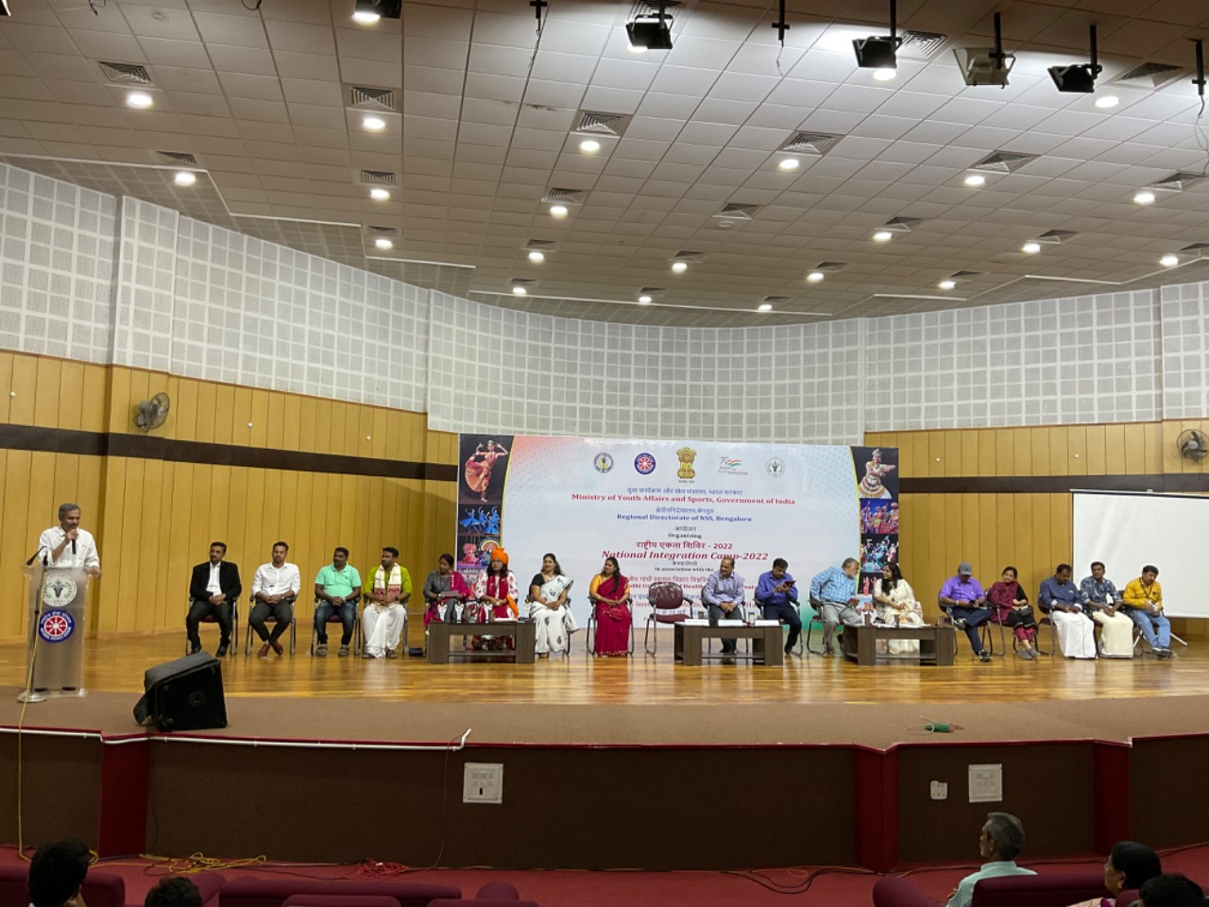
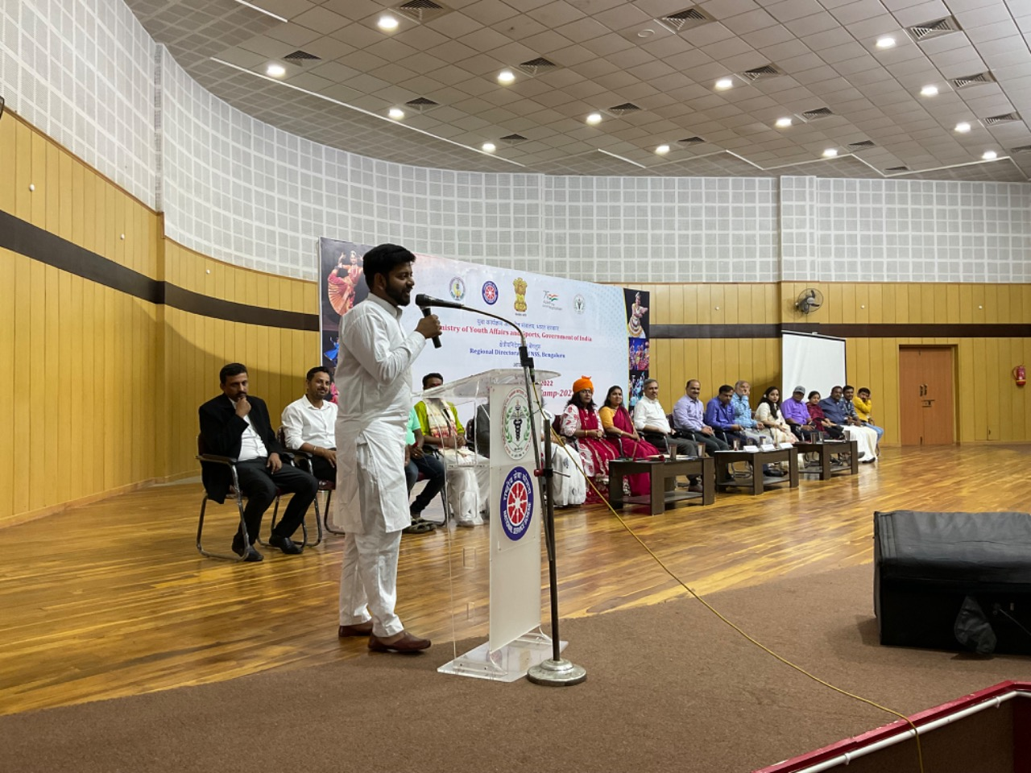
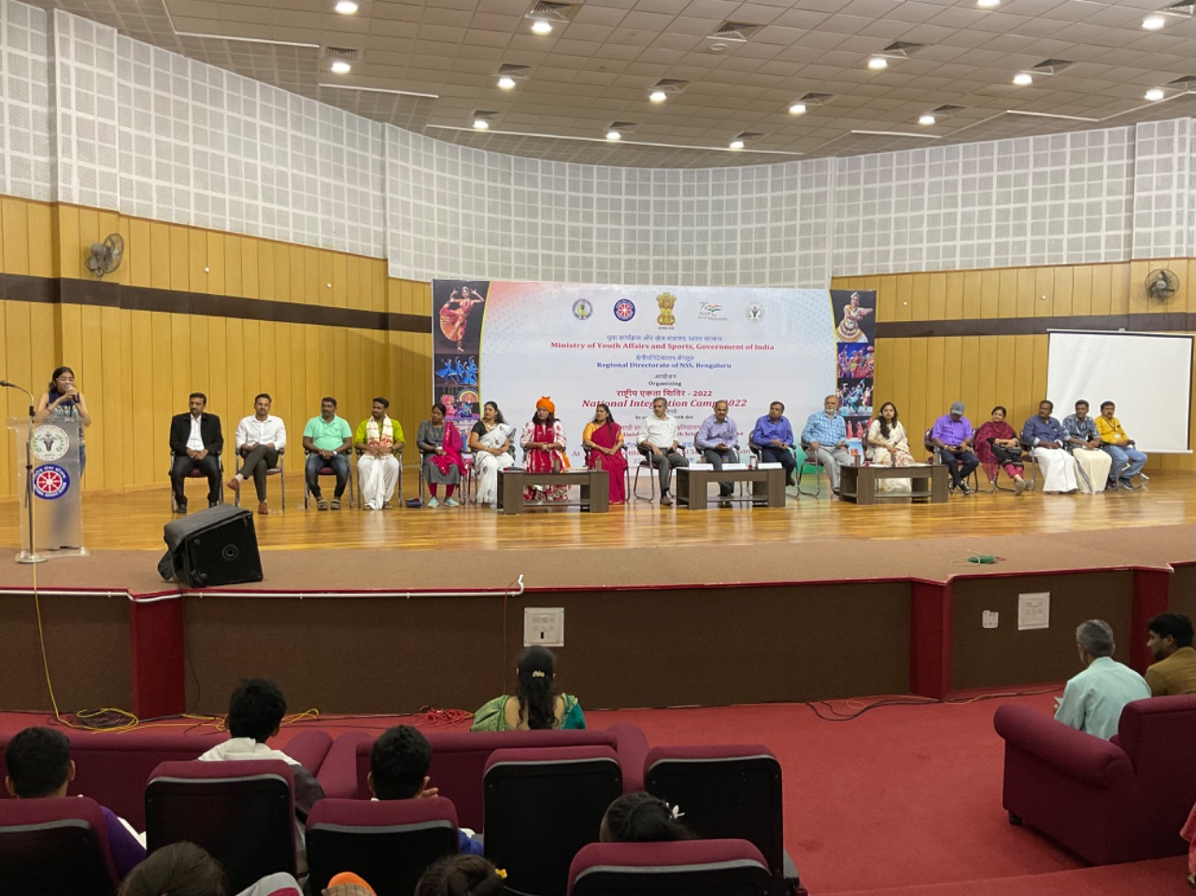
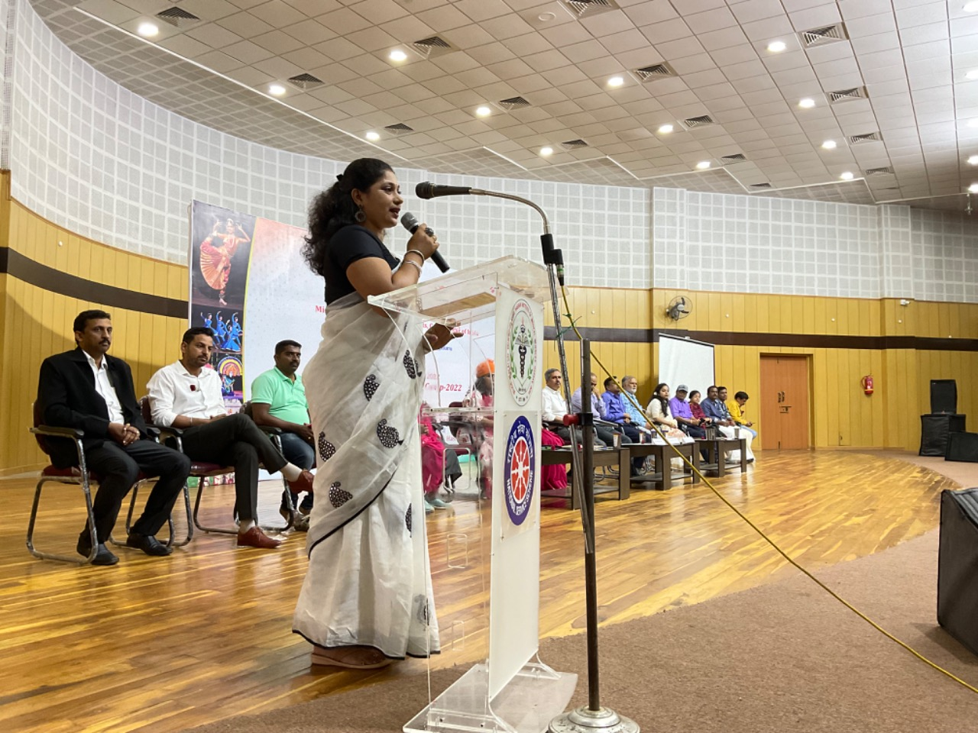
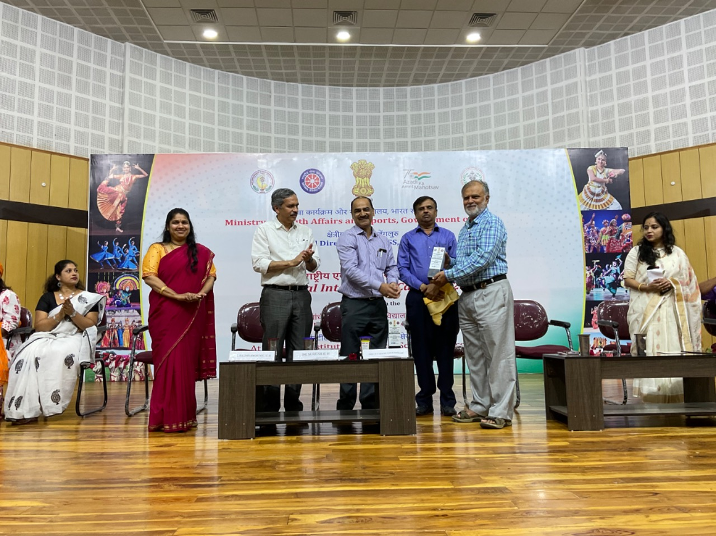
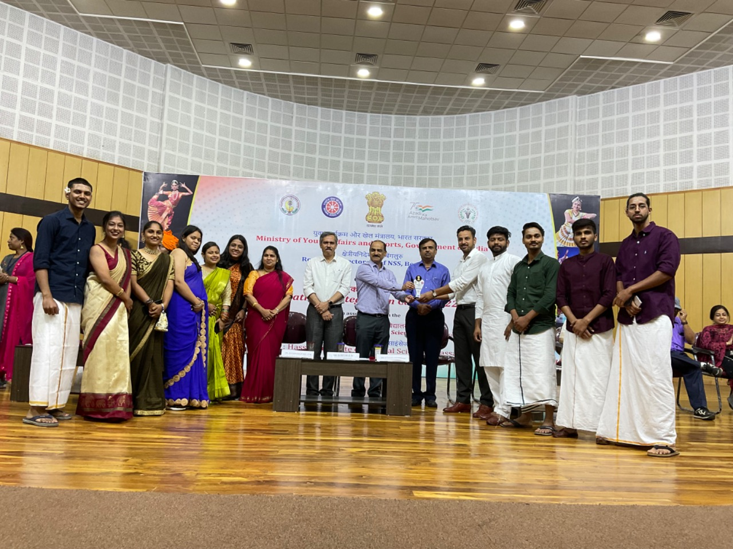
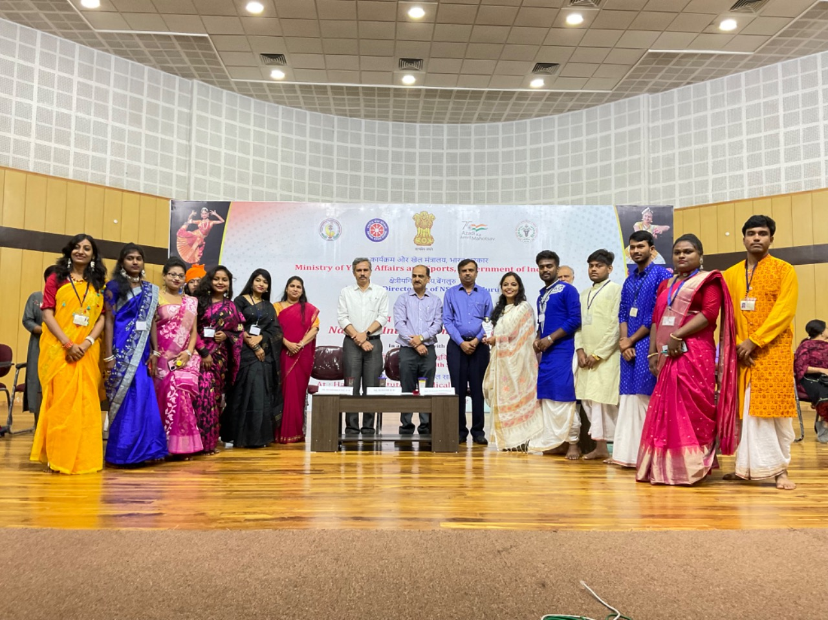
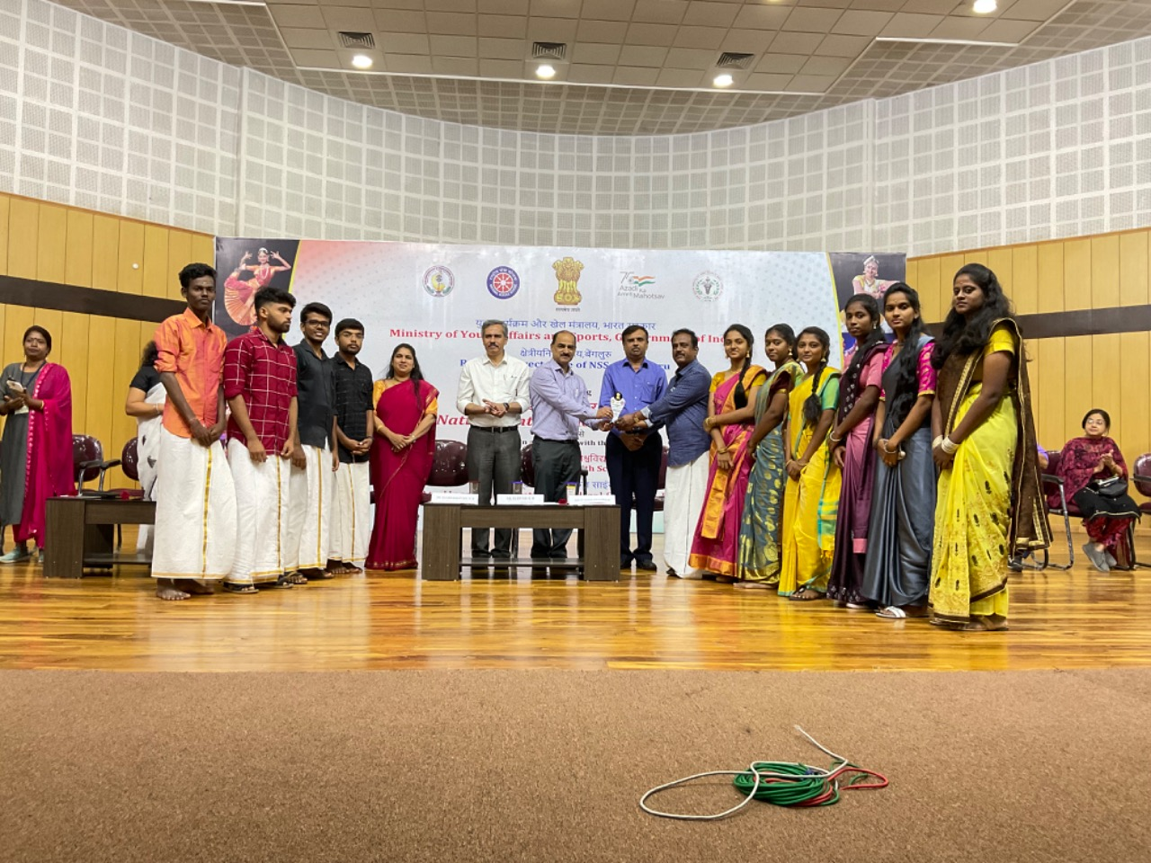
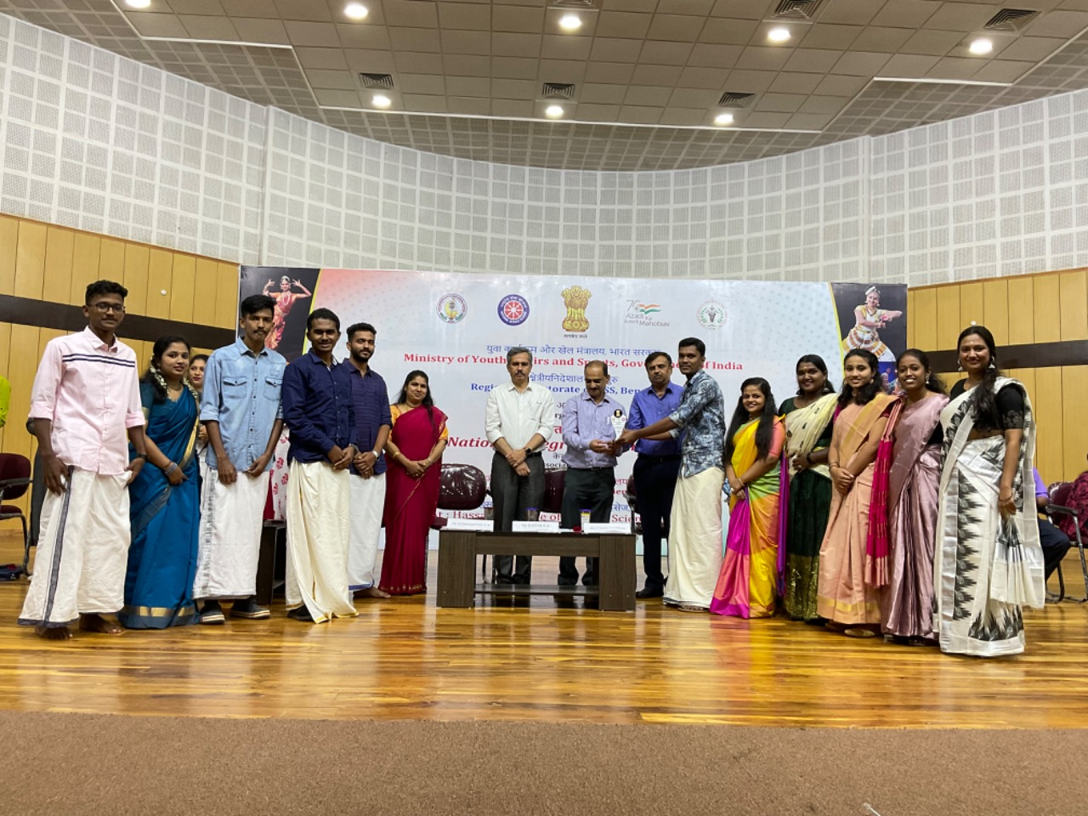
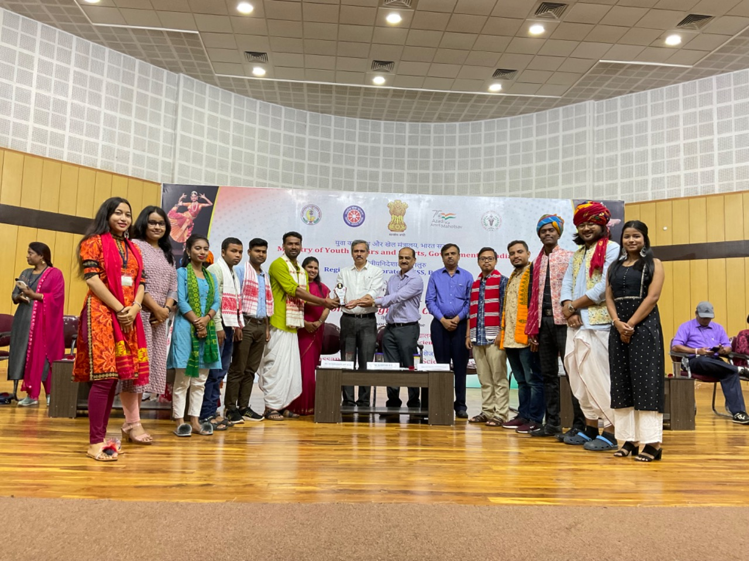
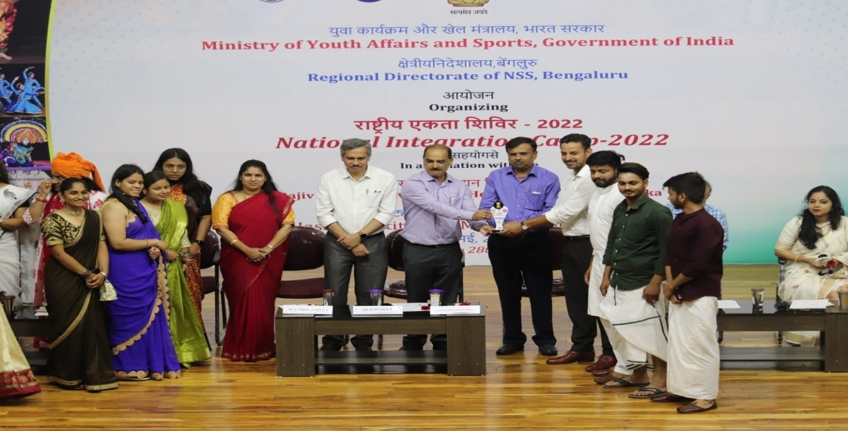
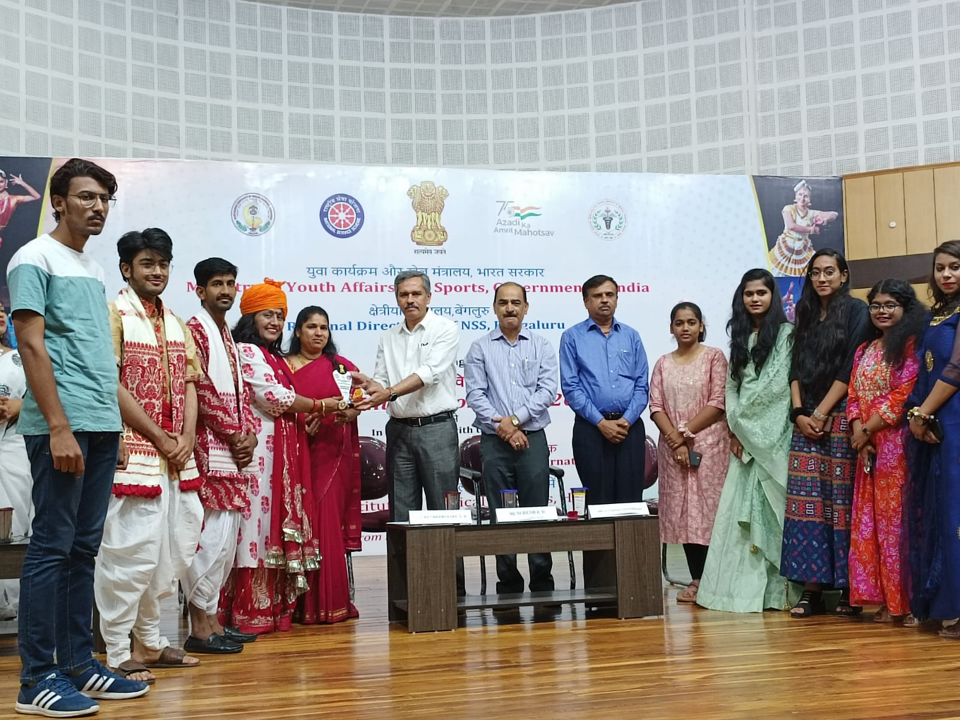
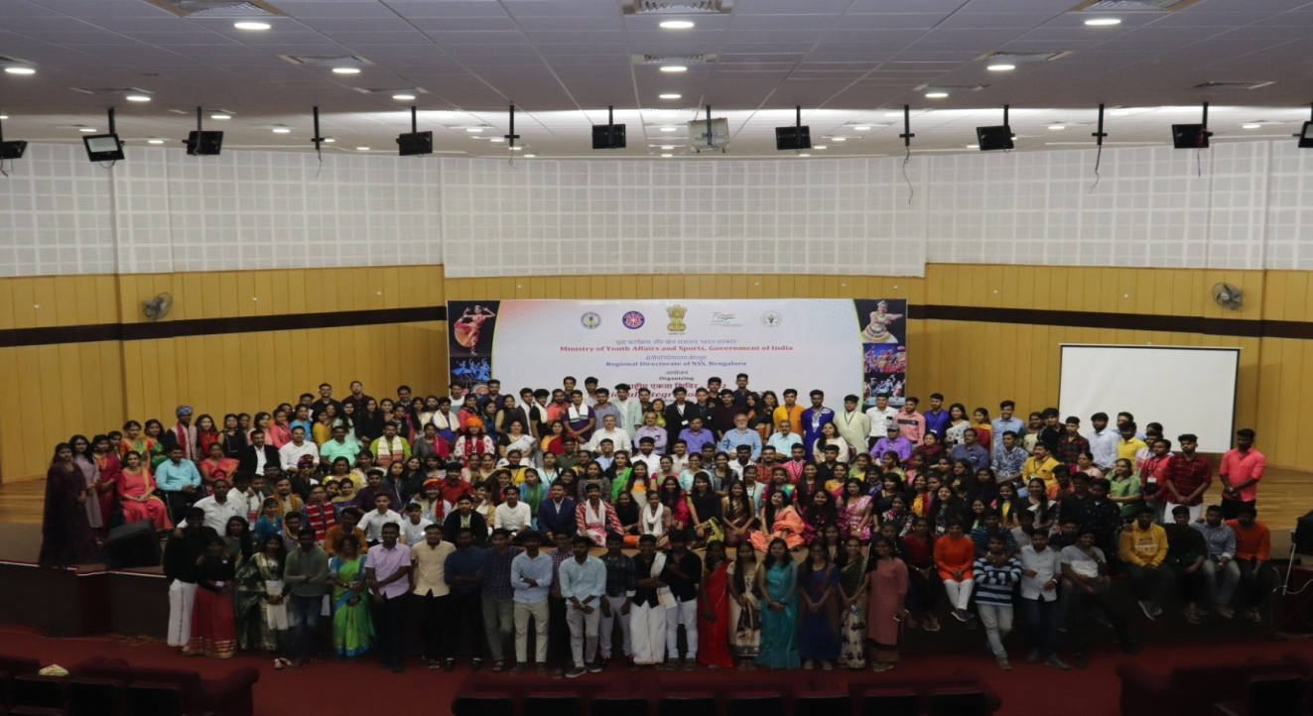
National Integration Camps (NICs) are organized at different places of India by National Service Scheme to promote the feeling of national integration and greater understanding among different cultures by the youth of the country being a largest youth platform. National Integration Camp-2022 was held at Hassan Institute of Medical Science, Hassan, Karnataka. As a matter of fact it was for the first time that a medical college organized an NIC in the country. Among 200 NSS Volunteers, 100 were from 11 different states and rest 100 from 15 universities across Karnataka.
NICs foster harmony and tolerance for different cultures and regional differences, so that there would be stronger bonding among youth. These camps lasting for 7 days leave lifelong impressions on the participants’ memories.
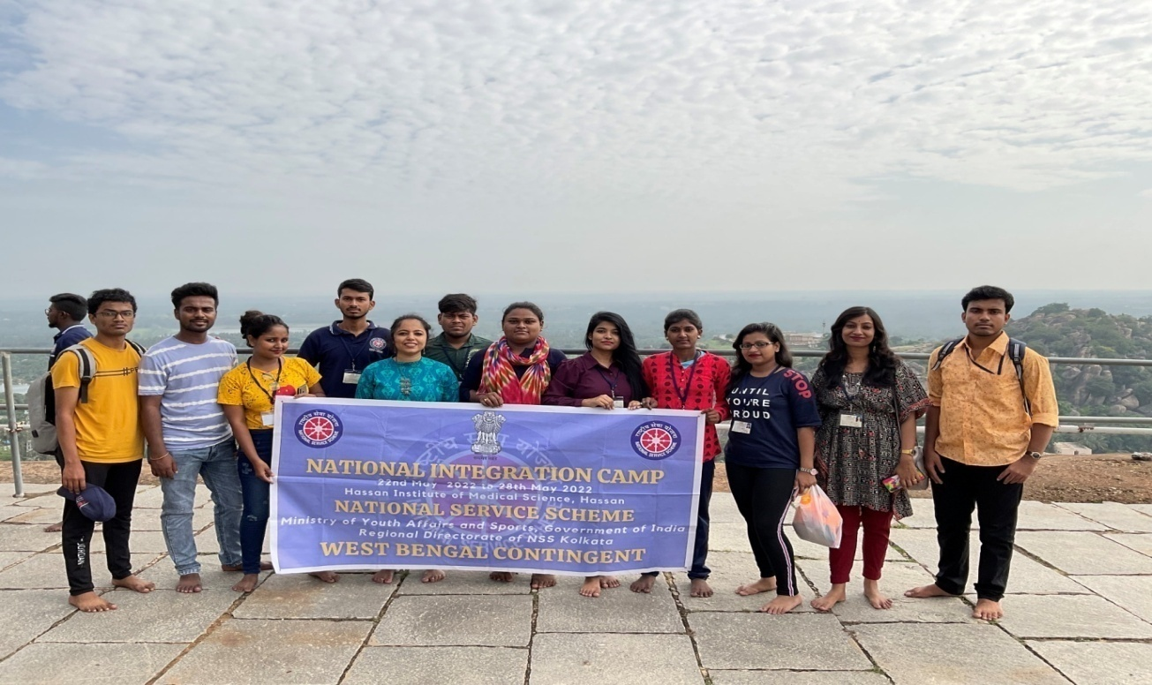
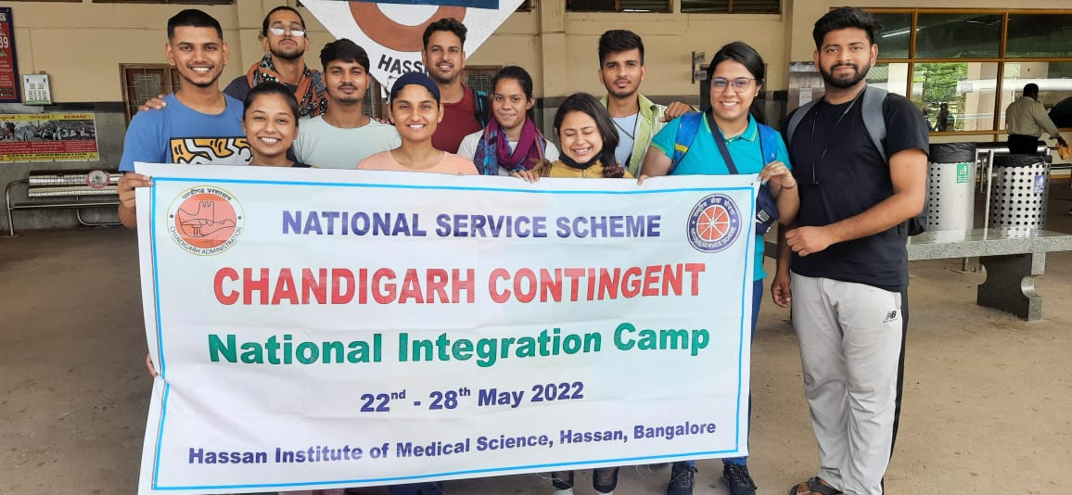
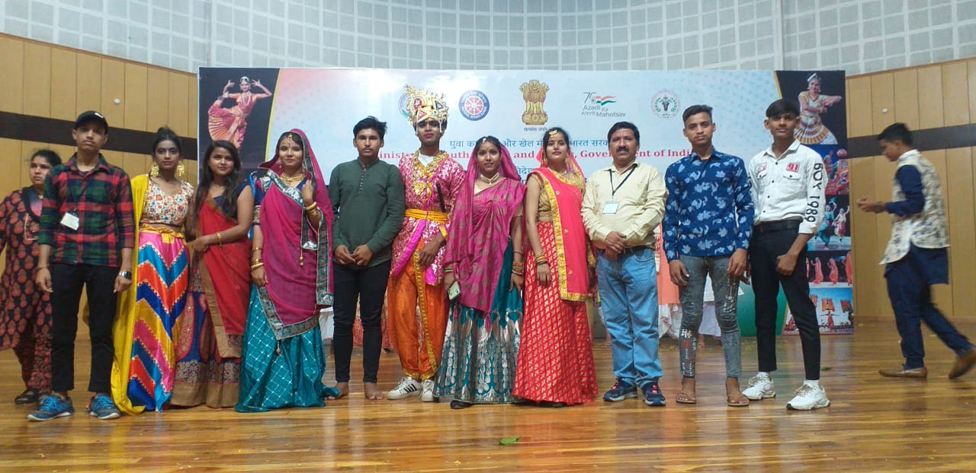
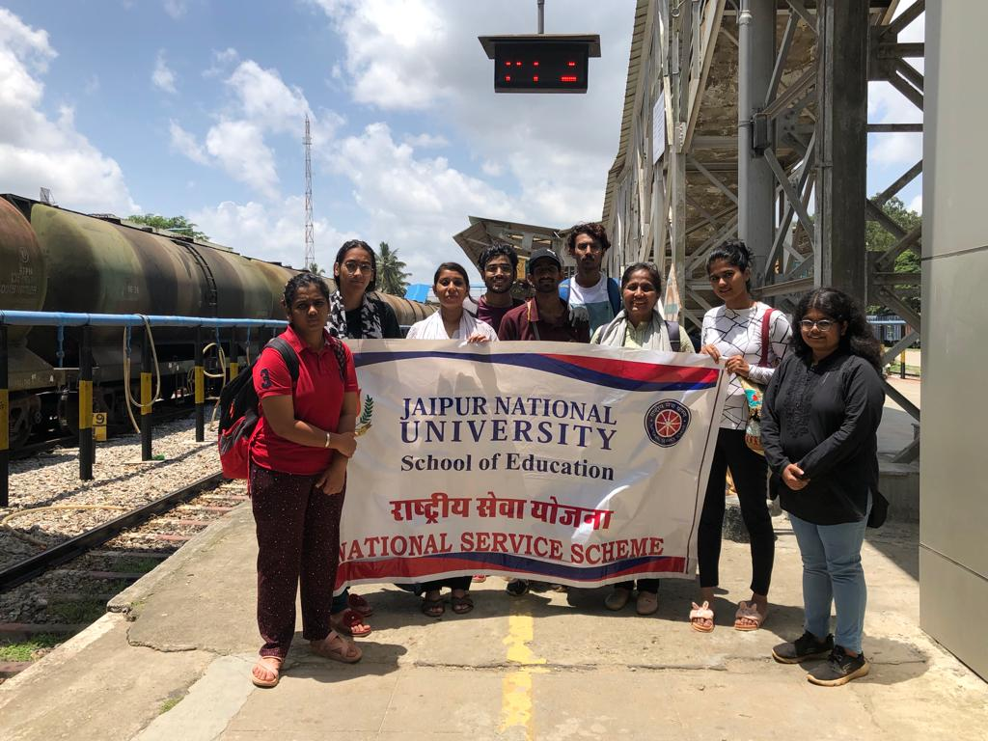
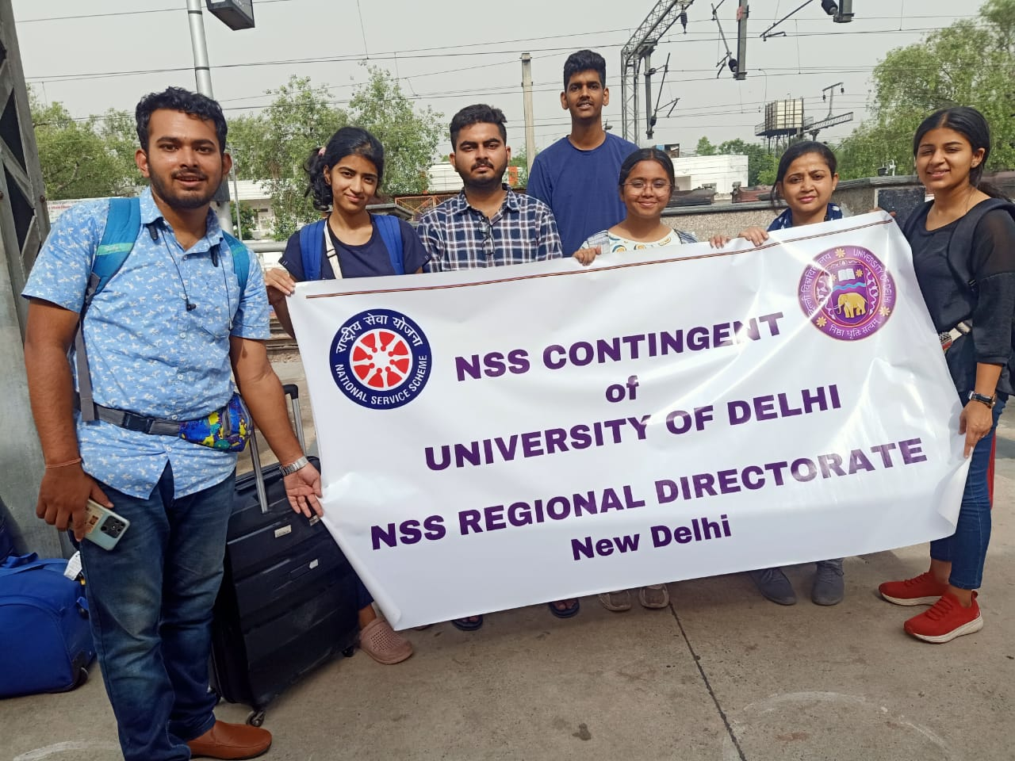
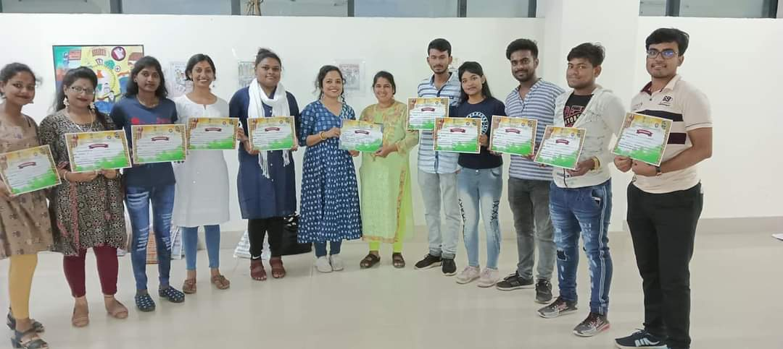
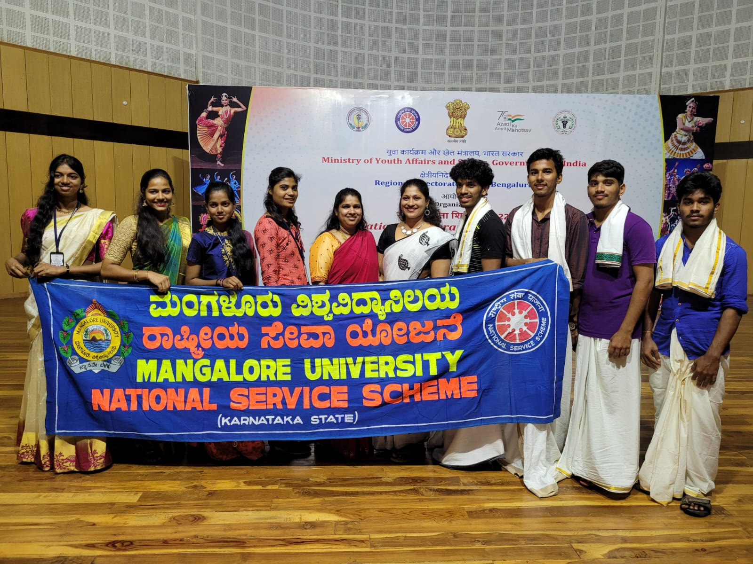
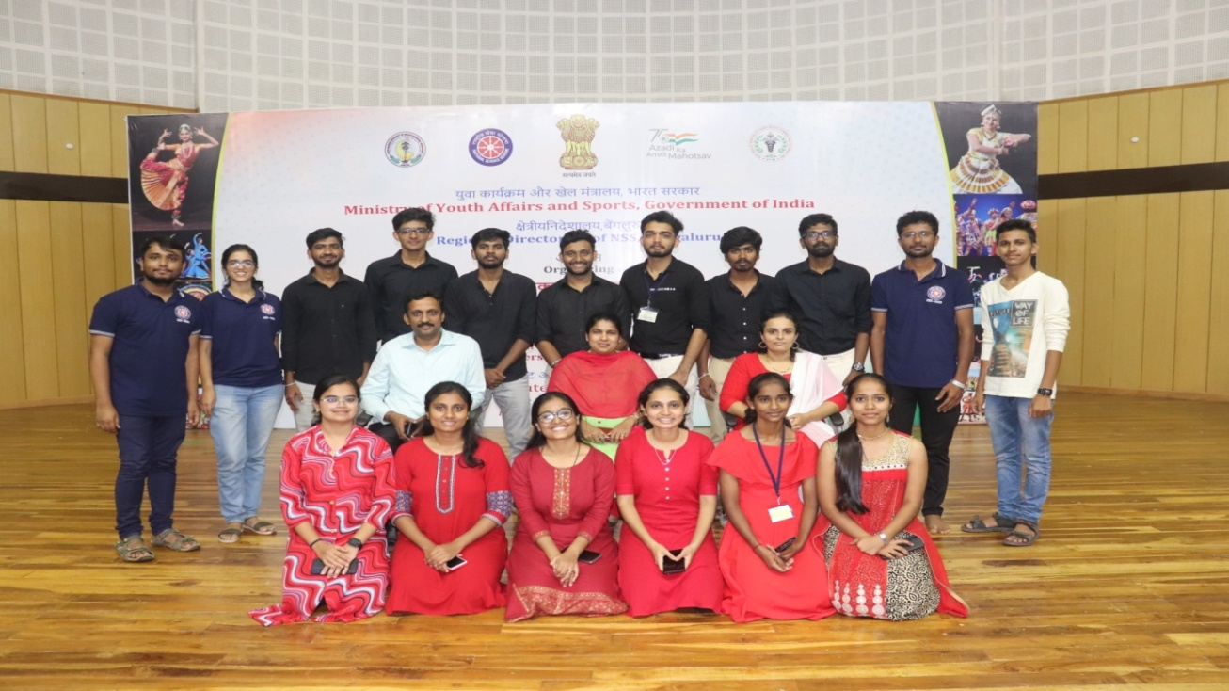
NEWS CLIPPINGS AND SOCIAL MEDIA IMPRESSIONS/REACH DURING PRE AND POST PROGRAMME.
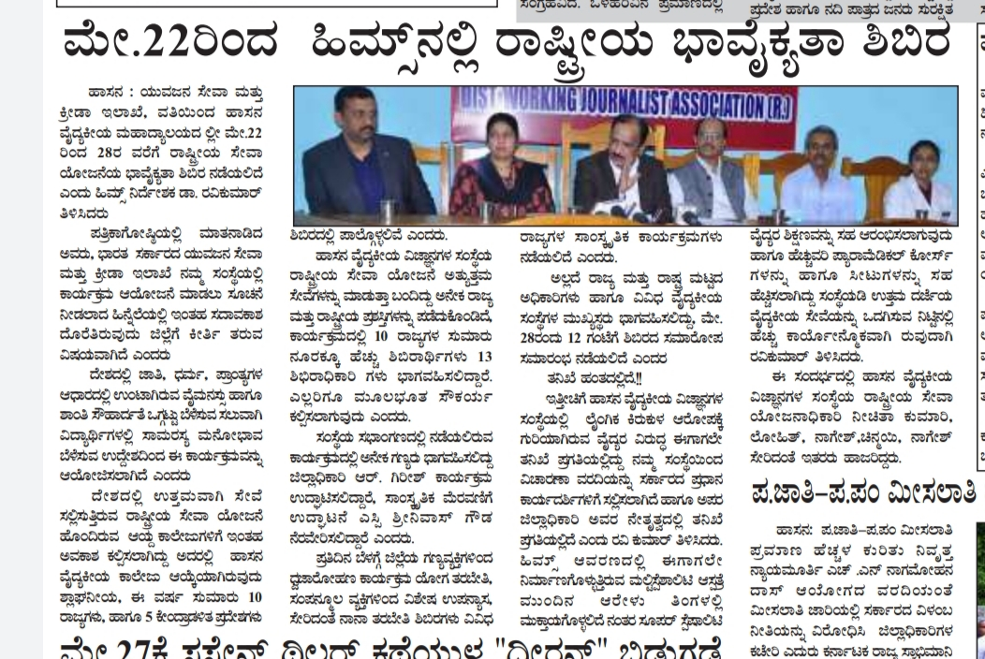
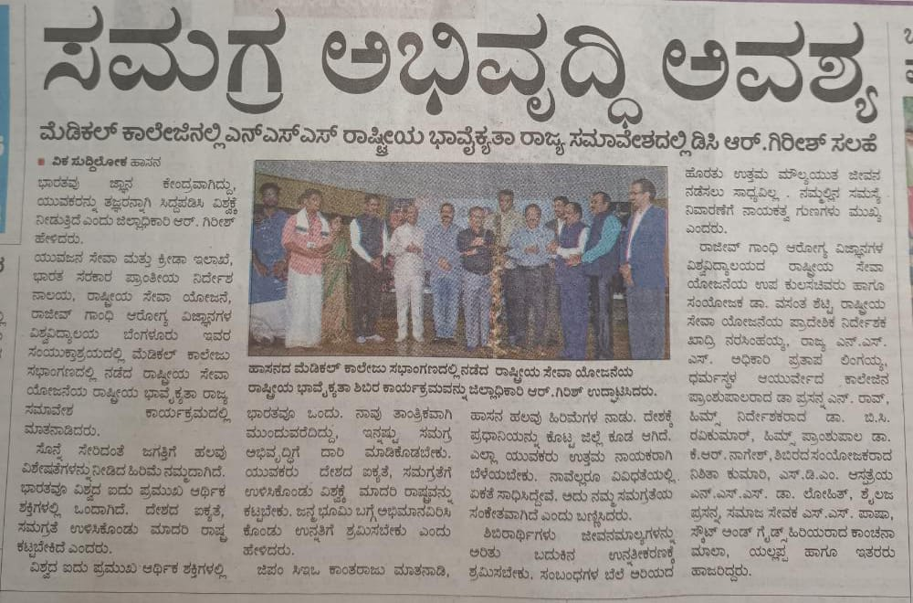
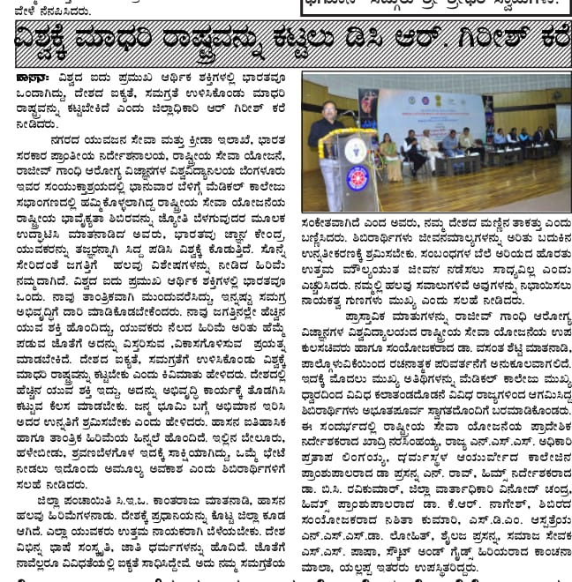
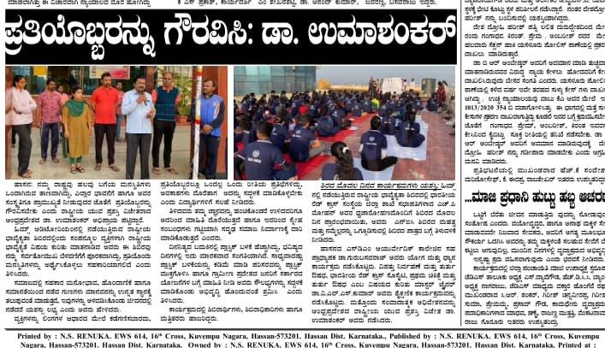
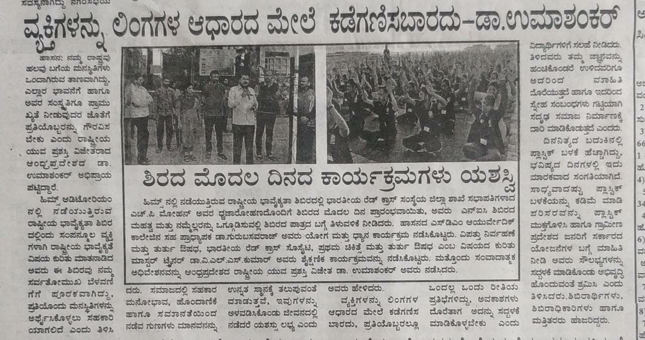
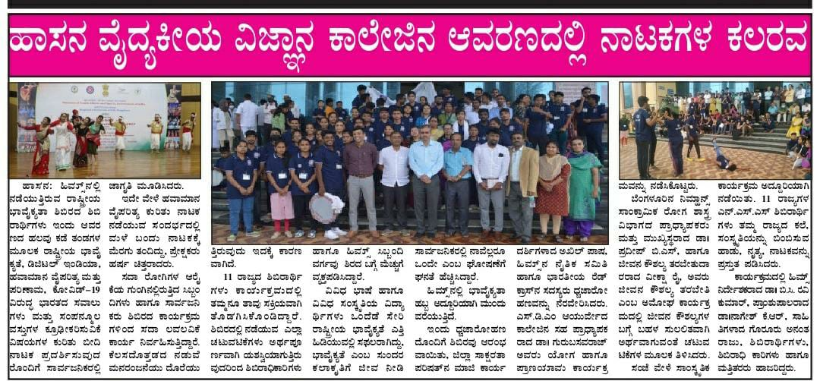
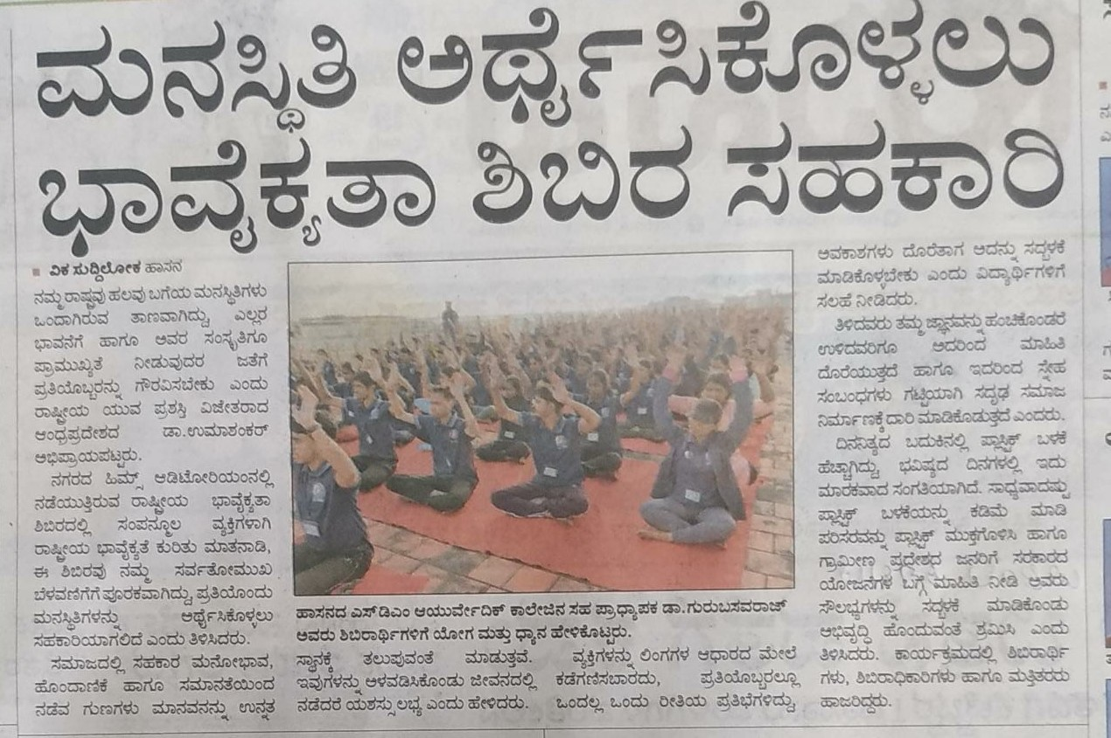
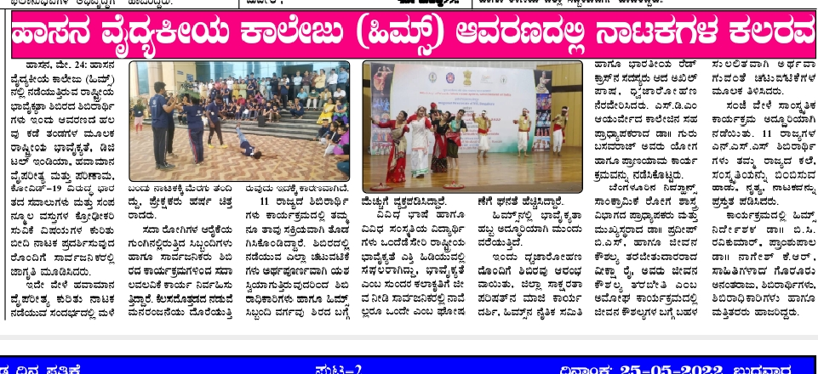
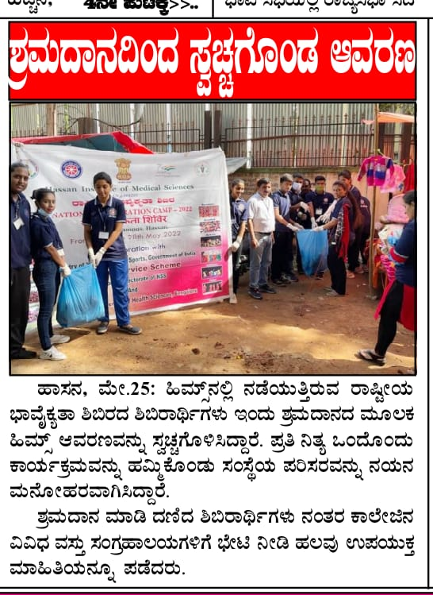
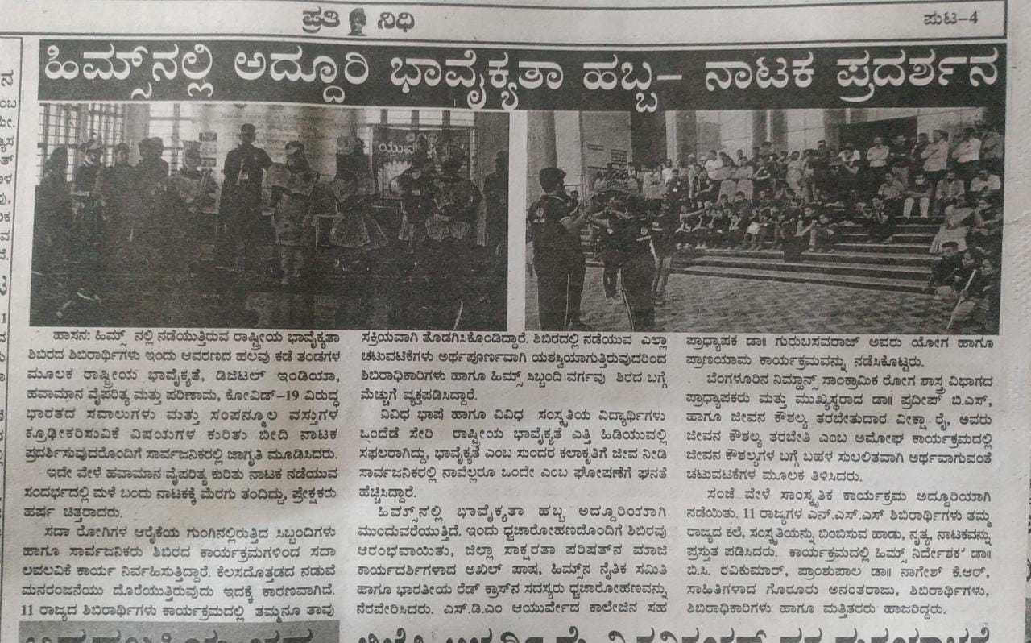
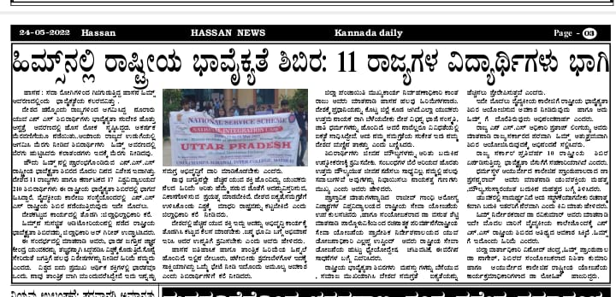
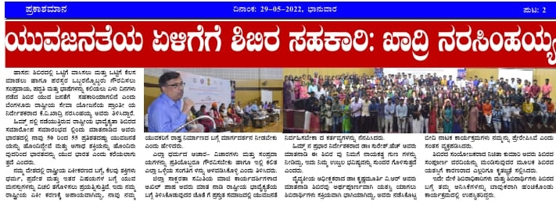
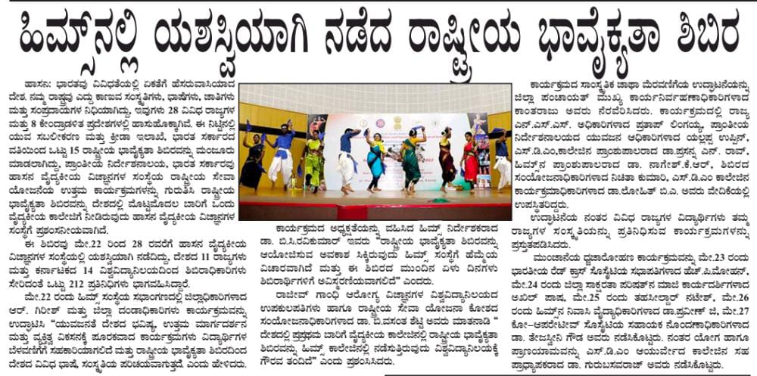
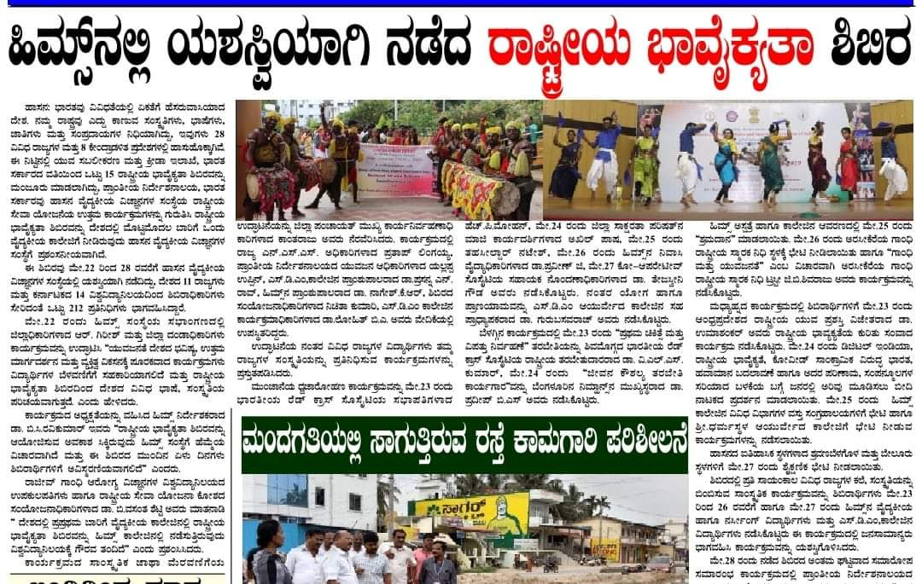
PARTICIPANTS LIST
State | University | Sl. No | Name of the Student | Sex
KERALA |  | 1 | Mr. Vishnu (C) | M
 |  | 2 | Cliya Rose | F
 |  | 3 | Shine Mathew | M
 |  | 4 | Layana Valsan | F
 |  | 5 | Aaby Mariam Mathew | F
 |  | 6 | Iqujakrishna K Santhosh | F
 |  | 7 | Surya Jayachandran | F
 |  | 8 | Albin Biju | M
 |  | 9 | Karthik Binu | M
 |  | 10 | A S Keerthana Iyer | F
 |  | 11 | Joseph Varghese | M
CHANDIGHAR |  | 12 | Dr Rohit Sharma (C) | M
 |  | 13 | Mukesh Kumar | M
 |  | 14 | Nitesh | M
 |  | 15 | Sagar Roy | M
 |  | 16 | Yuvraj | M
 |  | 17 | Rahul | M
 |  | 18 | Kanika | F
 |  | 19 | Prakriti | F
 |  | 20 | Shruti Goel | F
 |  | 21 | Avneet Kaur | F
 |  | 22 | Ayushi Anand | F
TAMIL NADU |  | 23 | Dr.N.A.Saravanan
 |  | 24 | K Azhagukumar | M
 |  | 25 | N. Vijay | M
 |  | 26 | B. Vigneshwari | F
 |  | 27 | M. Sowmiya | F
 |  | 28 | K.S. Ananyashri | F
 |  | 29 | B.K. Subal | M
 |  | 30 | T.K. Pranes | M
 |  | 31 | S. Priyadharshni | F
 |  | 32 | Thamarai Karthikaa V.K | F
 |  | 33 | S.Pavithra | F
GUJARAT |  | 34 | Dr. Sanjay Joshi (C) | M
 |  | 35 | Turi Nimishaben | F
 |  | 36 | Bhagora Mahendrabhai | M
 |  | 37 | Malivad Premilaben | F
 |  | 38 | Muniya Anilkumar | M
 |  | 39 | Valand Rupesh | M
 |  | 40 | Makwana Chandni | F
 |  | 41 | Rabari Chirag | M
 |  | 42 | Vasava Kinjalben | F
 |  | 43 | Shaikh Muskan | F
 |  | 44 | Baria Jayeshkumar | M
UTTRA PRADESH |  | 45 | Ashok Kumar Verma (C) | M
 |  | 46 | Mohit | M
 |  | 47 | Monu Diwakar | M
 |  | 48 | Kanhiya | M
 |  | 49 | Premanand Rawath | M
 |  | 50 | Erick | M
 |  | 51 | K M Shalu | F
 |  | 52 | Shreya Parashar | F
 |  | 53 | Madhavi Dubey | F
 |  | 54 | Amreen Usmani | F
 |  | 55 | Niharika Sharma | F
DELHI |  | 56 | Dr.Deepmala (C) | F
 |  | 57 | Garv Dubey | M
 |  | 58 | Anshuman Tiwary | M
 |  | 59 | Aniruddha Saha | M
 |  | 60 | Khushee | F
 |  | 61 | Jasleen Kaur | F
 |  | 62 | Sejal Aggarwal | F
ASSAM |  | 63 | Porag Pachoni (C) | F
 |  | 64 | Rajdip Barua | M
 |  | 65 | Sudarshan Bhattacharjee | M
 |  | 66 | Manisha Deka | F
 |  | 67 | Shraboni Choudhury | F
 |  | 68 | Nurul Amin | M
 |  | 69 | Baharul Islam | M
 |  | 70 | Mehfuz Ali | M
 |  | 71 | Gaurav Mech | M
 |  | 72 | Kritika Bordoloi | F
 |  | 73 | Joonmoni Roy | F
JAIPUR |  | 74 | Meenu Singh (C) | F
 |  | 75 | Aaradhya Singh | F
 |  | 76 | Tamanna Soni | F
 |  | 77 | Khanak Kumawat | F
 |  | 78 | Rajkanwar Sisodia | F
 |  | 79 | Shraddha Chouhan | F
 |  | 80 | Kuldeep Singh Rathore | M
 |  | 81 | Mudit Soni | M
 |  | 82 | Shubham Jain | M
JHARKHAND |  | 83 | Johny Ruphina Tirkey (C) | F
 |  | 84 | Abhishek Ranjan | M
 |  | 85 | Dharmendar Tiwari | M
 |  | 86 | Deepesh Pradhan | M
 |  | 87 | Kargil Choubey | M
 |  | 88 | Anjali Sharma | F
 |  | 89 | Shravani Manna | F
 |  | 90 | Srishti Pranjal | F
 |  | 91 | Manisha kumari | F
 |  | 92 | Sujata Kumari | F
WEST BENGAL |  | 93 | Dr.Tulika Chakravorty(C) | F
 |  | 94 | Rakesh Barui | M
 |  | 95 | Md Afridi | M
 |  | 96 | Arindam Biswas | M
 |  | 97 | Uday Karmakar | M
 |  | 98 | Sutirtha Mazumdar | F
 |  | 99 | Rashida Khatun | F
 |  | 100 | Piyali Panja | F
 |  | 101 | Mouni Chowdhury | F
 |  | 102 | Ipta Dutta | F
 |  | 103 | Anshikha Majumdar | F
Andhara Pradesh |  | 104 | K Siva Sai Tilak Reddy | M
Karnataka | RGUHS | 105 | Mrs. Shylaza (C) | F
 |  | 106 | Mr.Ravi (C) | M
 |  | 107 | Adnan Ahmed | M
 |  | 108 | Ganesh Singh M | M
 |  | 109 | Kiran S B | M
 |  | 110 | Karthik S Gowda | M
 |  | 111 | Mounesh Panchal | M
 |  | 112 | Manthesh Hiremath | M
 |  | 113 | Nesara G Gowda | M
 |  | 114 | Ayushi Nayak | F
 |  | 115 | Kumari Sandal | F
 |  | 116 | Chinmayi V K | F
 |  | 117 | Dushyanth C B | M
 |  | 118 | Akash D Swami | M
 |  | 119 | Mirza Asim Ali Baig | M
 |  | 120 | Ruchitha Shastry | F
 |  | 121 | Hrithik Bhan | M
 |  | 122 | Chinmay Kumar K | M
 |  | 123 | Rahul Kumar | M
 |  | 124 | Sangamesh | M
 |  | 125 | Agsar Yasin | M
 |  | 126 | Vinod S | M
 |  | 127 | Vasanth Kumar H N | M
 |  | 128 | Sneha C Shekar | F
 |  | 129 | Rohini K P | F
 |  | 130 | Srusti M V | F
 |  | 131 | Bhoomika Sathish Bhat | F
 |  | 132 | Sudhamshu Koodur | M
 |  | 133 | Ajith H V | M
 |  | 134 | Soumya P | F
 |  | 135 | Santhosh Salodagi | M
 |  | 136 | Mousinabanu Kolakar | F
 | Mangalore University | 137 | Akshatha V Shetty (C) | F
 |  | 138 | Edward Michael Dsouza | M
 |  | 139 | Pratham Mallya | M
 |  | 140 | Akash Rao | M
 |  | 141 | Pranam Bhandary | M
 |  | 142 | Swathi M | F
 |  | 143 | Divyashree K N Bhat | F
 |  | 144 | Divya | F
 |  | 145 | Raksha | F
 | Mysuru University | 146 | Chandrika A V | F
 |  | 147 | Priyanka B C | F
 |  | 148 | Gouramini T B | F
 |  | 149 | Lavanya Urs H K | F
 |  | 150 | Mahanthesha M J | M
 |  | 151 | Dharmapal Jain C | M
 |  | 152 | Prajwalraj K N | M
 |  | 153 | Mahadeva Swamy M | M
 | Maharani Cluster university | 154 | Pallavi L | F
 |  | 155 | Bhavya N | F
 |  | 156 | Madhumitha A | F
 | Yenepoya university | 157 | Mohammed Noushin | F
 |  | 158 | Mohammed Nishwan U | M
 | Adichunchagiri University | 159 | Abhishek K R | M
 |  | 160 | Surabhi H M | F
 | University of Agriculture and Horticulture | 161 | Anchitha D Jain | F
 |  | 162 | Shreya J Rai | M
 |  | 163 | Pradeep Kumar N | M
 |  | 164 | Revanna N Gurammanavar | M
 |  | 165 | Basavaraj Hiremath | M
 | Bangalore City | 166 | Ajay S | M
 |  | 167 | Jeevan B | M
 |  | 168 | Ravishankar H | M
 |  | 169 | Chethan S | M
 |  | 170 | Subhashree B | F
 |  | 171 | AkhalyaVijayalakshmi | F
 |  | 172 | Anjinamma | F
 |  | 173 | Nandhini K | F
 | Kuvempu Shivmogga | 174 | Ankita R Pyati | F
 |  | 175 | Chandana M | F
 |  | 176 | Dhanya D | F
 |  | 177 | Bhoomika S | F
 |  | 178 | Jeevan N | M
 |  | 179 | Manoj Kumar P M | M
 |  | 180 | Harish S V | M
 |  | 181 | Vinod B L | M
 | Sanskrit | 182 | Soundarya K C | F
 |  | 183 | Chidananda B | M
 |  | 184 | Amar R Udupa | M
 | Bangalore North | 185 | Rakesh C J | M
 |  | 186 | Venkatesh A N | M
 |  | 187 | Deekshitha K | F
 |  | 188 | Puneeth A M | M
 |  | 189 | Harshitha | F
 |  | 190 | Priyanka N | F
 |  | 191 | Shivaranjan N | M
 |  | 192 | Rakesh L | M
 | REVA | 193 | Suhas Patil B | M
 |  | 194 | Vajreshwari V | F
 |  | 195 | Ajaib Kumar C M | M
 |  | 196 | P Anitha Reddy | F
 | Bangalore | 197 | Mahesh Kumar V | M
 |  | 198 | Rudraling | M
 |  | 199 | Vinutha Yadav I R | F
 |  | 200 | Pallavi J | F
 |  | 201 | Chandana H M | F
 |  | 202 | Bharathi H H | F
 |  | 203 | Manjunath R | M
 |  | 204 | Prasanna Shanker | M
 | VTU,Belgaum | 205 | Vasantha M S | F
 |  | 206 | Sowndarya M S | F
GROUP FOR ALL THE ACTIVITIES
S.N | BRAHMAPUTRA | NARMADA | KRISHNA | YAMUNA | KAVERI
1 | ABISHEK RANJAN | A S KEERTHANA | ABHISHEK K R | B SUHAS PATIL | MADHUMITHA A
2 | AKHALAYA VIJAYLAKSHMI | ADNAN AHMAD | AJAY S | BAHARUL ISLAM | AABY MARION MATHEW
3 | ALBIN BIJU | AMREEN USMANI | AJITH H V | BASAVRAJ HIREMATH | AJAIB KUMAR C M
4 | AMAR R UDUPA | ANJINAMMA | AKASH RAO | BHOOMIKA S | ANITHAREDDY P
5 | ANISHIKHA MAJUNDAR | ANKITHA R PYATI | ANCHITHA D JAIN | CHETHAN S | ANJALI SHARMA
6 | ARADHYA SINGH | ANSHUMAN TEWARY | ANIRUDDHA SAHA | CHINMAYI V K | BARI JAYESH KUMAR
7 | AYUSHI ANAND | AVNEET KAUR | ARINDAM BISWAS | DEEPESH PRADHAN | CHIDANANDA B
8 | AYUSHI NAYAK | DHARMENDRA TIWARI | B K SUBAL | DHARMAPAL JAIN C | DHANYA D
9 | B VIGNESHWARI | DIVYA | BHARATHI H H | GURUDEVA M C | ERICK
10 | BHAGORA MAHENDRABHAI | IPTA DUTTA | BHOOMKA S BHAT | JEEVAN N | GAURAV MECH
11 | BHAVYA N | JASLEEN KAUR | CHANDANA H M | JOONMONI ROY | IQUAJAKRISHNA K SANTOSH
12 | CHANDANA M | KARTHIK BINU | CHANDRIKA A V | KARTHIK S GOWDA | JEEVAN B
13 | DIVYASHREE | KIRAN S B | CLIYA ROSE | KHUSHEE | K V SHALU
14 | EDWARD MICHEAL DSOUZA | KULDEEP SINGH RATHORE | HARISH S V | LAYANA VALSON | KANIKA
15 | GANESH SINGH M | LAVANYA URS H K | JOSEPH VARGHESE | MANOJ KUMAR PM | KARGIL CHOUBEY
16 | GARV DUBY | M SOWMIYA | K S ANANYASHRI | NANDINI K | MAHANTHESH M J
17 | GOURAMANI TB | MAHESH KUMAR V | KANHIYA | PALLAVI J | MEHFUZ ALI
18 | K AZHAGUKUMAR | MALIVAD PREMILDAR | KHANAK KUMAWAT | PIYALI PANJA | MOHAMMAD NISHWAN U
19 | MAHADEV SWAMY M | MANJUNATH R | KRITIKA BORDOLOI | PRAKRITI | MOUNESH PANCHAL
20 | MANISHA DEKA | MANU DIWAKAR | KUMARI SANDAL | PREMONAND RAWAT | NESARA G GOWDA
22 | MANISHA KUMARI | MD AFRIDI | LIKITHA A | PRIYANKA B C | PRADEEP KUMAR N
23 | MEENAKSHI L R | MOHAMMED NOUSHIN | MADHAVI DUBY | RABARII CHIRAG | PRATHAM MALLYA
24 | MOHIT | MUNIYA ANILKUMAR | MAKWANA CHANDRU | RAJKANWAR SISODIA | RAHUL
25 | MOUNSINABANU KOLAKAR | MUTHURAJ B | MANTHESH HIREMATH | ROHINI K P | RAKSHA
26 | MUKESH KUMAR | N VIJAY | MANISHA DEKA | SPRIYADHARSHINI | RASHIDA KHATUM
27 | NIHARIKA SHARMA | NITESH | MOUMI CHOWDHURY | SANTOSH SALODAGI | REVANNA N GURAMMANAVAR
28 | RAJDIP BARUA | PALLAVI L | MUDIT SONI | SHINE MATHEW | S PAVITHRA
29 | RAKESH BARUI | PRAJAWAL RAJ K N | NURUL AMIN | SHREYA PARASHAR | SHEKH MUSKAN
30 | SEJAL AGGARWAL | PRANAM BHANDHARY | RUDRALING | SUDHAMSHU KOODAR | SHRADDHA CHOUHAN
31 | SHRAVANI MANNA | RAVISHANKAR H | SAGAR ROY | SUJATA KUMARI | SHUBHAM JAIN
32 | SHREYAS J RAI | SHRABONI CHOUDHURY | SNEHA C SHEKHAR | SURABHI H M | SIVA SAI TILAK REDDY
33 | SURYA JAYACHANDRAN | SRISHTI PRANJAL | SHRUTI GOEL | SWATHI M | SOUMYA P
34 | TURI NIMISHABEN | SRUSTI M V | SOUNDARYAK C | T K PRANES | SUBHASHREE B
35 | VASANTH KUMAR H M | SUDARSHAN BHATTACHARJEE | SOWNDARYA M S | UDAY KASMOKAR | SUTIRTHA MAZUMDAR
36 | VINODH BL | TAMANNA SONI | VAJRESHWARI V | VASAVA KINJALBA | VINUTHA YADAV I R
37 | RAKESH C J | VASANTHA M S | VALAND RUPESH | YUVRAJ | V K THAMARI
38 | PRIYANKA N | PUNITH A M | VENKATESH A M | DEEKSHITHA K | HARSHITHA
39 | PRASANNA SHANKAR | SHIVARANJAN N | RAKESH L
FOOD CHART
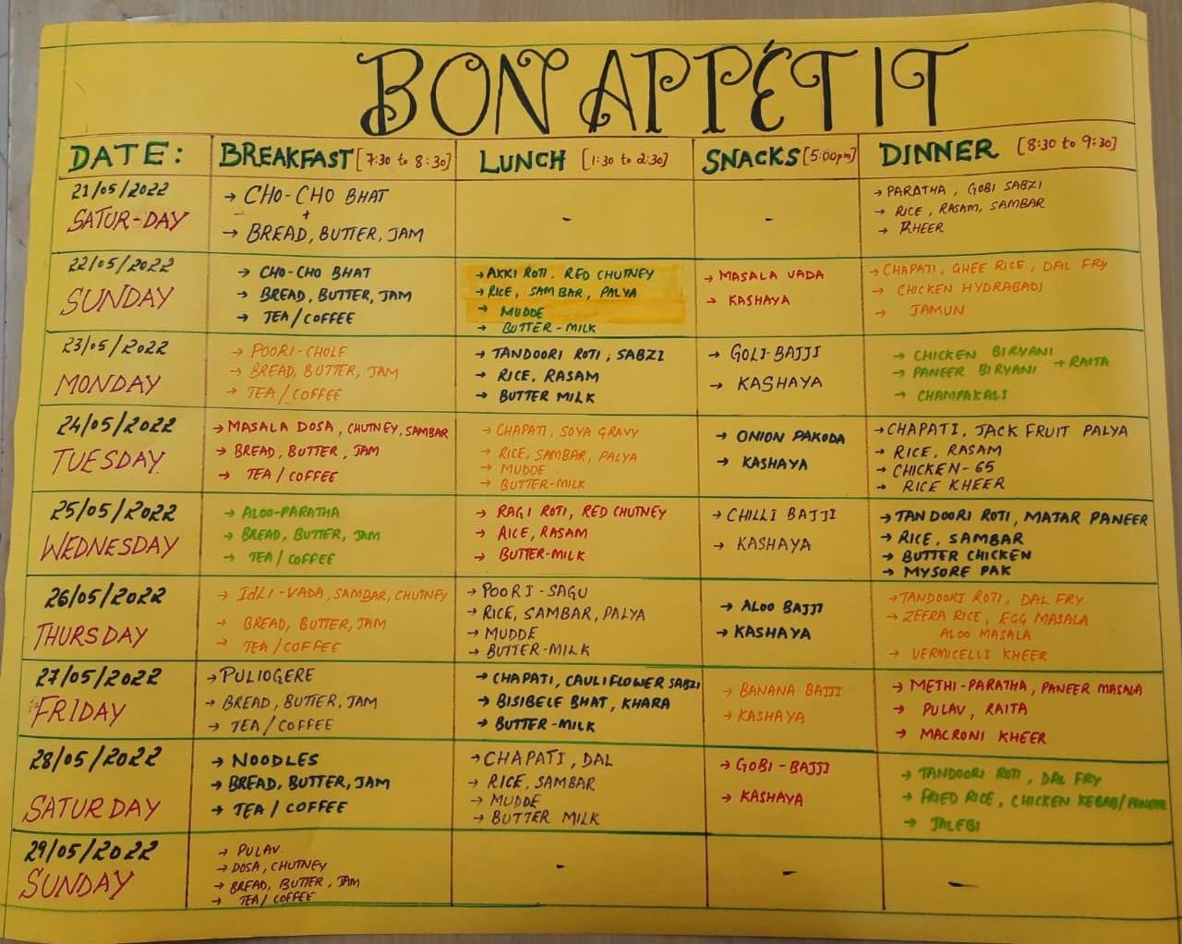
EXPEREINCE AND FEEDBACK OF VOLUNTEERS/TEAM LEADER
I would like to thank you all for the wonderful period we had at NIC 2022, Hassan. We enjoyed the exciting activities and visits very much. Met new friends of different races, cultures from all over India. Everything went perfectly. NIC 2022 camp was safe and well organised. But I personally feel that there could be some fun games among volunteers for the people get gel each other with their skills and personalities. The staff especially NSS volunteers of HIMS are very supportive and caring. We felt always very relaxed in all seven day of NIC 2022.
Dr.N.A. Saravanan,
NSS Programme Officer,
Tamilu Nadu contingent
This is Ananya from Tamilnadu.
To start with, this camp made us learn many things, starting with time management and till managing our works and doing it in more effectivr and efficient way. We adopted and survived in a such a prone environment and this made us more stable to get fitted in any other places and such like atmosphere , situation , people and things. I would like to thank the whole HIMS team for guiding and coordinating us because without them our survival would definitely become harder and we would have faced hurdles in time being. The accommodation, food was so comfortable and very well served for the purpose. We also enjoyed a lot, had fun with our fellow mates and also integrated among other state friends. Finally an heartfelt thanks to the whole team for recognizing us and giving us this great opportunity.
Thank you.
With love,
Team TAMILNADU🇮🇳
NIC 2022 at Hasaan, was very memorable for me and also for our team. It was a great platform not only for exhibiting our talents rather it was a learning platform as how to interact with the people of various class,caste,race, colour etc.,. Really got many friends all around India. The hospitality, accomodation and the facilities provided were so much satisfactory and good.But I personally feel, instead of visit to museum, SDM College, there could be some interactive sessions as we could have acquainted more with the cultures of other state contingents.The overall camp was satisfactory and very memorable.Thanks for all HIMS volunteers,who toiled all the 7 days.
B.K.Subal, NSS volunteer,
Tamilnadu Agricultural University,Team Tamilnadu
The camp gave us so much memories and taught us so many different cultures and was a very good platform for knowing different parts of India. It gave us a great circle of friends from different parts of country which is priceless and the memory that the camp gifted too is priceless which remains forever in our heart. Thank you NSS , thank you for all those lessons we have learned together. Thanks for the moments we have created together. And thank you so much to all the people who worked behind this camp from the planning till to end. Love you all and will remember you all for the rest of my life.Thanks to all the organizers of NIC Hassan with a heart full of gratitude for your warm hospitality. A great salute for your amazing hospitality and kindness. My special thanks to HIMS volunteers for being so friendly and generous.
Iqujakrishna k santhosh, NSS volunteer
Kerala University of health and science, Team Kerala
राष्ट्रीय सेवा योजना क्षेत्रीय निदेशालय बेंगलुरु की ओर से हासन में आयोजित राष्ट्रीय एकीकरण शिविर वास्तव में मेरे जीवन का एक अद्भुत और अनोखा प्रयोग रहा है मैं यह महसूस करता हूं कि भारत मॆं इतनी विविधताओं के बावजूद हम लोग इमोशनली सब एक दूसरे के साथ एक परिवार की तरह ही साथ रहे। वहां का मैनेजमेंट, खानपान की व्यवस्था, रहने की व्यवस्था वाकई उच्च क्वालिटी की और स्मरणीय रही। मैं HIMS और हासन की पूरी टीम को बहुत-बहुत साधुवाद देता हूं कि उन्होंने इतने लोगों के बीच हम लोगों की सुख सुविधाओं का ध्यान रखा और अपनी पूरी क्षमताओं का प्रयोग करते हुए हम सब की सेवा में 24 घंटे तत्पर रहे। पुणे पुणे आयोजक मंडल की पूरी टीम का बहुत-बहुत आभार एवं राधे-राधे।
अशोक कुमार वर्मा (कंटिंजेंट लीडर- टीम यूपी)
NIC 2022 हासन मैं मूझे और मेरी टीम को बहुत कुछ नया सीखने को और देखने को मिला। मुझे वहां सब लोगो से एक रिश्ता सा बन गया था। वहां के खाने की भी व्यवस्था अच्छी थी मुझे वहां काफी राज्य की संस्कृति देखने को मिली और नए friends भी बने। मैंने वहा की साफ सफाई को भी देखा की वहां कितनी साफ सफाई है मुझे वहां का कल्चर बहुत अच्छा लगा। और वहां का मैनेजमेंट की व्यवस्था अच्छी थी मुझे और आप सब का कोटि कोटि धन्यवाद आप लोगो ने इतना सब कुछ हम सब लोगो का बहुत ख्याल रखा Thank you for HIMS Volenteer सच में आप लोगो ने हम सब का बहुत ख्याल रखा thank you everyone और हा मुझे हासन बहुत अच्छा लगा once again thank you for the all team HIMS
🙏🙏 Radhey Radhey
Niharika Sharma, NSS volunteer
Dr. Bhimrao Ambedkar University, Team Uttar Pradesh
Jai Hind
This is Pratham mallya from Mangalore university, karnataka.
Really it was my pleasure to be the part of NIC .first of all I liked the hospitality that was provided by HIMS Hassan. And coming to the sessions it was really amazing one which thought us several lessons which we need to follow throughout our life .All the cultural activities performed by various states was marvelous and we came to know about the culture and traditions of various states . This was one of great opportunity to express our states tradition and also communicate to various peoples of the state and create a bond of friendship between us . This camp thought us how to face various problems when we shift from one place to another place .Last but not the least I thank mangalore university for providing such a great opportunity to express our own talents.
Thank you
The experience of participating in National Integration Camp held at Hassan Institute of Medical Science was absolutely wonderful. Getting to mingle with volunteers of other states, learning their language, food, traditions, culture etc was really a good opportunity. Educational sessions, training programmes and the concepts taught there were very good and are applicable to our daily life as well. Visit to historical places near Hassan was my favorite. Knowing history and importance of those places made me feel proud about my motherland. HIMS college, campus, volunteers, staff, Hassan city and the seven days I spent there are unforgettable moments of my life. I wished that the camp lasted for longer period. If I get such an opportunity again I would grab it without any hesitation.
Swathi M
Hassan Institute Of Medical Sciences, Hassan, Bangalore, invited me to participate in a National Integration Camp. I come from Chandigarh, a Union territory where we don't get to observe or experience other cultures. This programme was like a seven-day movie in which I was exposed to various cultures, ceremonies, foods, and attires. The camp was not only about cultural exchange; it also aided in the development of some life skills.It was a joy to travel through Karanataka, the land of the Gods. When the youth were separated into five groups, true integration occurred, allowing us to venture outside of our comfort zones and learn to work together. I am grateful to the host college and its volunteers for organising such a wonderful camp.
Ayushi Anand
NSS volunteer, Chandigarh
Coming from a distant northern city of India, I came to participate in the National Integration Camp, Hassan, Bangalore with many hopes and apprehensions. But soon, I realised that our host team was as pleasant as the weather of Hassan. Except negligible glitches that come naturally to an event of such magnitude, everything was very well taken care of. I availed the chance to meet people from other states, became familiar with their languages, customs, and cultures, thus the mandate of the NIC was well served in all aspects. The way host team strived to make this event successful was commendable.
Dr Rohit Sharma
Contingent Leader, Chandigarh
Integration means unity, Unity in diverse culture,unity in various languages, unity in peoples mind and soul.This integration camps is a true example of to build a unity and peace with spritual harmony between different states and cultures of India.We as a team of Assam enjoy a lot during every educational session along with cultural events.The NSS unit of HIMS were also co operative and so friendly to us and we really make a good bond with them.We really enjoyed a lot and take all the trice in our memory bag and will keep this trip fresh for lifetime.
Manisha Deka
NSS Volunteer, Assam Team
It is our great pleasure to be the part of National Integration Camp, HIMS Hassan. Coming all the way from the beautiful North Eastern State of Assam to another beautiful southern state of Karnataka, we are thrilled & surprise with your great hospitality - Atithi Deva Bhava. National Integration Camp is the great platform for the youth to unite the diverse culture, tradition and Custom of Indian states. This is the big stage for NSS volunteer to reimbibe the feeling of "Not Me But You" to serve the nation through community work. In this seven days camp participants have learned and developed various skills through different brain storming sessions which will enrich them to serve the nation in coming days. We got the opportunity to experience the beauty & heritage of Hassan - Kasturba Seva Sadan, HIMS museum, SDM college of Ayurveda & Hospital, beautiful coconut trees, Bahubali Temple, Belur Temple & memmerizing views of rural Hassan during our field trip. We are grateful to all the team members of HIMS, Hassan for organising such a wonderful NIC. We are proud Indian -by birth & by heart and reunited by NIC Hassan.
Porag Pachoni, Contingent Leader, Assam Team
NIC organised at Hassan Institute of Medical Sciences, Hassan by NSS, Regional Directorate of NSS, Bengaluru jointly with Rajiv Gandhi University of Health Sciences, Bengaluru was the right decision to select HIMS as a Venue for it. Wonderful premises, wonderful accommodation, outstanding hospitality provided by HIMS family. It was golden opportunity to see HIMS and SDM College of Ayurveda. Technical sessions "First Aid & Disaster management and Training" and "Life skill education" were very fruitful for every individual. Selection of resource persons were also very appropriate for the topics selected for sessions. I personally appreciate the visit to Gandhi National Memorial Trust, Arsikere and enjoyed listening Prof. B. Shivaraju sir. Selection of Historical places were very nice. Involvement of various NSS Volunteers through group division and their group wise performances during flag hoisting and street play as well as during shramdaan was very inspiring. Overall I can say HIMS did wonderful job. No one can forget the care, coordination and cooperation of NSS Volunteers of HIMS. Once again I congratulate Smt. Nichitha Kumari mam and Dr. Lohith B A sir for successful NIC and thank you for all the things you did for us.
Regards
Johny Ruphina Tirkey
Contingent Leader, Team Jharkhand, (Bihar)
West Bengal contingent
Contingent leader:
Experience - The hospitality experienced was beyond words. The arrangements made in terms of transport and accommodation were unparalleled. The early morning yoga sessions were rejuvenating not only for the students but also for the contingent leaders. A day dedicated for Shramadana was extremely thoughtful as it helped in inculcating the values of humility and cleanliness in the minds of the young NSS volunteers. The emphasis on punctuality and discipline was an integral takeaway from the camp. The ramp walk in which all the contingent leaders participated on one of the days was a unique thought. A visit to the historical places helped in expanding our knowledge and refreshing our minds.
Expectations - A seminar on Gender Sensitization and Environmental Awareness would be useful.

Participant:
Experience - It offered a splendid forum to interact with participants hailing from myriads of socio-cultural and linguistic backgrounds. The ready support and encouragement provided by the NIC Hassan Volunteers and seniors was phenomenal. The session on life skills especially was thoroughly interesting and informative. We got to learn some important lessons as to how to cope with stress and anxiety which seem to have become a part and parcel of our lives. Last but not the least, all the cultural activities were designed in such a manner so that maximum involvement by all the states could be ensured. Therefore, the National Integration Camp at Hassan proved to be an ideal platform to exhibit the leadership skills in the youth of this great nation.
Expectations - The food could have been a tad more versatile and inclusive of the culinary habits of different states and cultures. Besides yoga, a training programme on self-defense techniques would be beneficial.
Team Uttar Pradesh
Jai Hind
My overall experience of 7days NIC,held in Hassan was amazing. Thanks to all the volunteers who have been planning for this camp since a very long time. Everything ranging from accommodation to food that they fed us was amazing. All the volunteers and respective coordinators were kind hearted and supportive. All their efforts and hardwork was visible. The hostels in which we stayed in was neat and clean and on top of that we got the domestic help as well. A big thumbs up to the volunteers of Hims.
Thanks a ton!
Jasleen Kaur
Volunteer Delhi contingent
I think what I got from NSS cannot be put in a few words. I'm so grateful for myself that I decided to be an NSS volunteer and it was more special. This year because of HIMS Team. All thanks to your affection, your million dollar smiles. The bond with them is something like an asset to me. They all treated us and welcomed us as if I were a family member of HIMS. The management system, the behavior, the experience were overall excellent. They made us learn that, the motto of NSS "Not Me But You " reflects the essence of democratic living and upheld the need for self less service. NSS (HIMS volunteers) helps the development and appreciation to other's point of view and also show consideration towards other living beings. My best experience in the NSS in HIMS which I attended for 7 days was they helped us primarily focus on personality development through community service. Although a great experience in discipline, learn to work as a team, understanding ground realities, time management, leadership qualities, learn to socialize etc and many more thank you.
Thanking you HIMS.
Anjali Sharma, Volunteer Jharkhand
Thank you NSS, Thank you for all those lessons we have learned, unlearned and relearned together. Thanks for the moments we have created together. And thank you, thank you so much dear people, I will love you all for the rest of my life. We shall all keep the momentum.Thank you to All organizers of NIC ,Hassan with heart full of gratitude for your warm hospitality. A great salute for your amazing hospitality and kindness. My special thanks to HIMS Volunteers for being so friendly and generous.
Thanks For Everything!
AlbinBiju, Kerala Contingent
nic 2022 Hassan gai to Aisa Laga ki mano ham kahan a gaye hain vahan per itni swachhata aur vahan ka culture vahan ke log vahan is camp ke dwara dekhne ka mauka Mila aur is camp ki vajah se humne अलग-अलग cultures Ko dekha aur bahut sare Apne नए-नए dost banae aur bahut sari Masti ke aur vahan humne jana unity kya hoti hai yah sikha ki NSS सही-सही mayne mein kam kya hai aur Hasan jab ham pahunche to ek alag hi hamen Anubhav Mila vahan ki aitihasik imaraten Mandir aur prachin pahad bhai bahut hi acchi jagah hai yah aur Hasan main jo volunteers the unke sath ek achcha bond ban gaya aur vahan Apna pan sa mahsus hua Mano mano ki lag raha tha ki ham apne ghar mein hi baithe Hain ya apne ghar mein hi ghoom rahe ho kha rahe ho aur sab vahan ke Jo bhi volunteers bhai the unhone hamara bahut hi Sahyog Kiya hamari madad ki iski vajah se hamen unke sath hi Kala lagav sa Ho Gaya aur unki jab unse alag ho rahe the to Aisa man lag raha tha ki ham apni bhaiyon se alag ho rahe hain ki aap kabhi mil payenge ya nahin to ek alag hi feeling a rahi thi dilon mein to Hasan walon thank u humko yah mauka dene ke liye😊🙏😘😘🥰 aur vahan ki aasan ki har chij humko acchi lagi vahan ka khana culture vahan ke log sab acche the main chahta Hun ki har koi ek bar Bengaluru Hasan jarur ghoom ke aaye 😊😊😊thank u so Mach Hasan NIC camp humko ek sath laane ke liye aur ek bond mein bhadane ke liye
Thank you so💞👏🥰😊😊😊 much FOR HIMS volunteer
Premanand Rawat, Nss volunteer
Champa Agarwal inter College up
Thanks 😊😊 all of you 💞 everyone
Nic 2022 Hassan mere ko jo feel hua bhale hi hamari bhasha hamare rajya अलग-अलग the par ham sab ek team the ek Parivar the team India the
humko kuchh अलग-अलग sikhane ka mauka Mila hamne bahut enjoy Kiya new friends banaye
Jaise Adnan bhai Ganesh bhai Aakash bhai अलग-अलग rajya ke dost banae Gaurav Bhai asam se Afridi bhai Bengal se Shubham bhai Rajasthan se Rahul bhai Chandigarh se mahantesh bhai and bahut sare really miss you all ❤️miss you hims❤️♥️
Monu Diwakar, Uttar Pradesh
Nss volunteer
CHAMPA AGARWAL INTER college
"स्वच्छ पर्यावरण प्रकृति का अनमोल उपहार है- कार्यक्रम अधिकारी अशोक वर्मा-"
चंपा अग्रवाल की एनएसएस इकाई ने पौधारोपण कर मनाया पर्यावरण दिवस
संपूर्ण देशभर के साथ चंपा अग्रवाल इंटर कॉलेज की राष्ट्रीय सेवा योजना इकाई के तत्वाधान में विश्व पर्यावरण दिवस पर कार्यक्रम आयोजित किए। सर्वप्रथम कार्यक्रम अधिकारी अशोक कुमार वर्मा ने एनएसएस के सभी स्वयंसेवकों को पर्यावरण संरक्षण की शपथ दिलाई तत्पश्चात कॉलेज में वृहद स्तर पर पौधारोपण कार्यक्रम आयोजित किया गया। कार्यक्रम अधिकारी अशोक कुमार वर्मा ने बताया कि स्वच्छ पर्यावरण हमारे जीवन का एक अभिन्न अंग है जोकि प्रकृति द्वारा प्रदत्त हमारे लिए एक अनमोल उपहार की तरह है। इस हेतु प्रत्येक स्वयंसेवक को अपने आसपास के वातावरण को स्वच्छ बनाए रखने का संकल्प दिलाया गया। कॉलेज की राष्ट्रीय सेवा योजना इकाई के द्वारा वृक्षारोपण तथा पर्यावरण के प्रति जागरूकता अभियान चलाया जिसमें कार्यक्रम अधिकारी तथा स्वयंसेवकों ने विद्यालय में पौधोंरोपण कर उनको संरक्षण का संकल्प लिया। लोगों को पर्यावरण के महत्व के बारे में बताया कि पर्यावरण को प्रदूषित नहीं करना चाहिए बल्कि पर्यावरण को संतुलित रखना चाहिए। इसलिए पौधों की अंधाधुंध कटाई नहीं करनी चाहिए बल्कि पौधों को अधिक से अधिक लगाना चाहिए। जिससे हमारे पर्यावरण में संतुलन बना रहे और हम स्वस्थ हवा में सांस ले सके। विश्व पर्यावरण दिवस 2022 की थीम 'केवल एक पृथ्वी ' के प्रति लोगों को बताया कि पूरी पृथ्वी एक परिवार है और पूरे विश्व के लोग जो इस परिवार का एक हिस्सा है। सभी को एकजुट होकर पृथ्वी को संतुलित रखना बहुत आवश्यक है अन्यथा की स्थिति में प्रकृति के दोहन से होने वाले हानिकारक प्रभावों जैसे जलवायु परिवर्तन, पर्यावरण प्रदूषण, ग्रीन हाउस प्रभाव, ग्लोबल वार्मिंग, ब्लैक होल आदि परिस्थितियों के हानिकारक परिणाम सभी को भुगतने पङेंगे। इस अवसर पर एनआईसी कर्नाटक में उत्तर प्रदेश का प्रतिनिधित्व करने वाले मोहित पाल, कन्हैया चौधरी, प्रेमानंद रावत, मोनू दिवाकर एवं एरिक सहित सभी एनएसएस स्वयंसेवक उपस्थित रहे।
National Integration Camp at HIMS an incredible opportunity occupied with wonderful experiences. Included NSS volunteers from various other states of India. It was really a great initiative and platform provided students with a lot of exposure to expose their talents and represent their own state. It was an immense privilege to me and all of our students to represent Karnataka State. Being given the task to participate in various cultural & social activities. We gained experience & were aptly convinced by our achievements. My special gratitude to HIMS & Dr.Nichitha for providing an infrastructured campus to organise the camp. It will surely inspire many other organised camps in future. As a conteagant head of Karnataka. I spent a memorable moments with 200 NSS volunteers and 10 conteagant heads. It was splended & an innovative organised programme
Akshatha V
Mangalore University
Karnataka Conteagant Head
